COVERAGE REPORT
Topic of the release: Corning opens Optical Fiber Manufacturing Plant in Poland to meet growing demand for High-Speed Connectivity in Europe

Market: Poland
Date: 9 Sep 2022
Media: Rzeczpospolita
Media circulation: 45 535 copies
Article title: Corning Incorporated has officially opened a new fiber optic manufacturing plant in Mszczonów, Poland
Print screen:
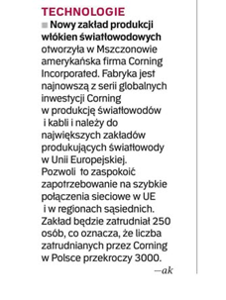

Date: 9 Sep 2022
Media: Puls Biznesu
Media circulation: 17 000 copies
Article title: Corning has opened a factory in Mszczonów
Print screen:
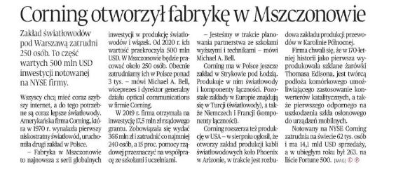

Date: 12 Sep 2022
Media: Gazeta Polska Codziennie
Media circulation: 48 158 copies
Article title: New fiber optics plant launched
Print screen:

Date: 8 Sep 2022
Media: telepolis.pl
Media circulation: 4.300.000 (monthly visitor traffic)
Article title: Corning opens fiber optics factory in Poland
Link: https://www.telepolis.pl/wiadomosci/wydarzenia/corning-polska-fabryka-swiatlowodow
Print screen:
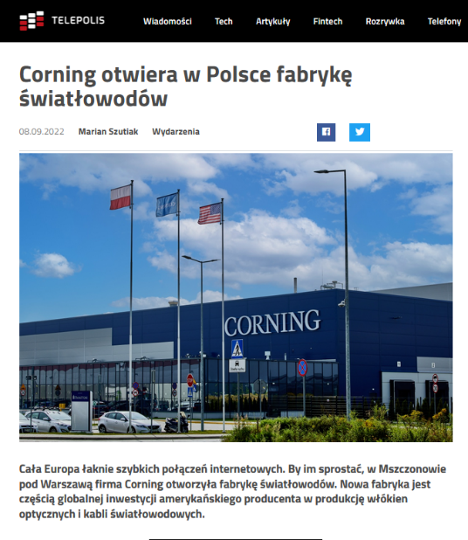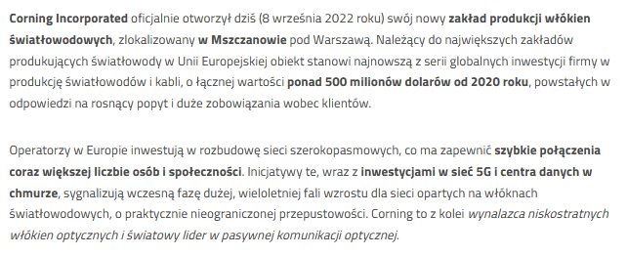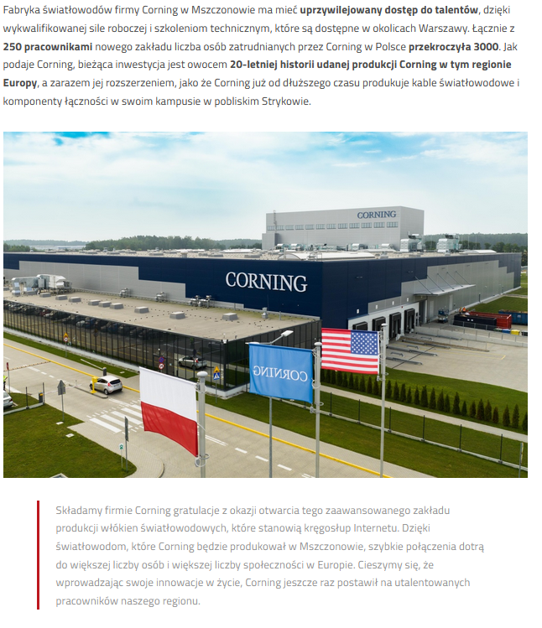

Date: 8 Sep 2022
Media: grodzisknews.pl
Media circulation: 235.900 (monthly visitor traffic)
Article title: Fiber optics plant in Mszczonów opened
Link: https://grodzisknews.pl/zaklad-produkcji-swiatlowodow-w-mszczonowie-otwarty/
Print screen:
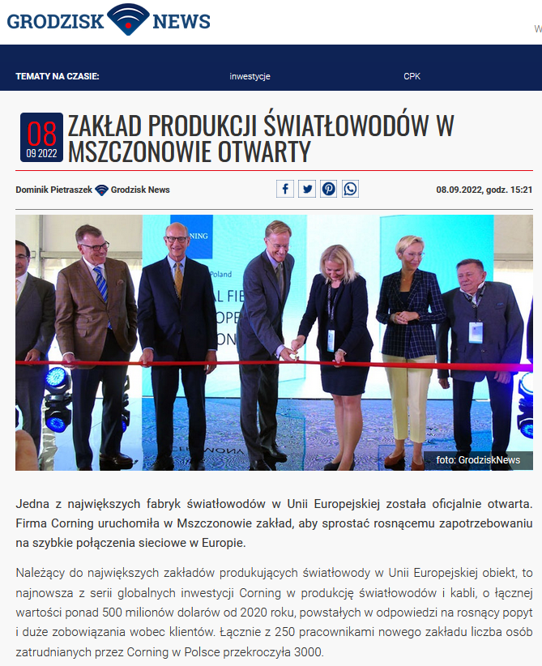

Date: 8 Sep 2022
Media: isbtech.pl
Media circulation: 29.500 (monthly visitor traffic)
Article title: Corning opens fiber optics factory in Poland
Link: https://www.isbtech.pl/2022/09/corning-otwiera-w-polsce-zaklad-produkcji-swiatlowodow/
Print screen:
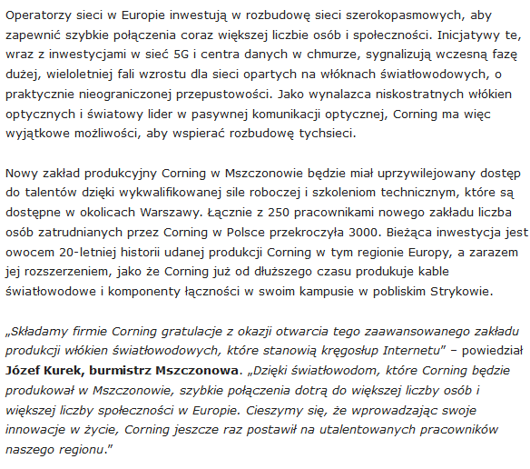

Date: 8 Sep 2022
Media: polskaprasa.pl
Media circulation: N/A
Article title: Fiber optics plant in Mszczonów opened
Link: http://www.polskaprasa.pl/3048980-Corning-otwiera-w-Polsce-fabryke-swiatlowodow.html
Print screen:
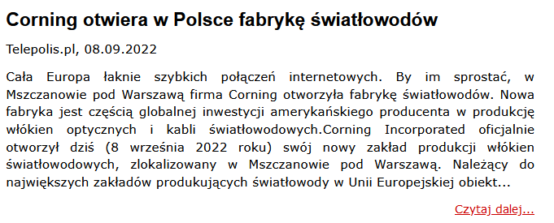

Date: 8 Sep 2022
Media: biznes.polskaprasa.pl
Media circulation: N/A
Article title: American fiber optics in Mszczonów
Link: http://www.biznes.polskaprasa.pl/3049028-Amerykanskie-swiatlowody-w-Mszczonowie.html
Print screen:

Date: 8 Sep 2022
Media: humanmag.pl
Media circulation: 7.700 (monthly visitor traffic)
Article title: Corning is opening a fiber optics plant in Poland to meet growing demand for high-speed...
Link: https://www.humanmag.pl/corning-otwiera-fabryke-swiatlowodow-w-polsce-aby-sprostac-rosnacemu-zapotrzebowaniu-na-szybkie-aktualnosci/
Print screen:
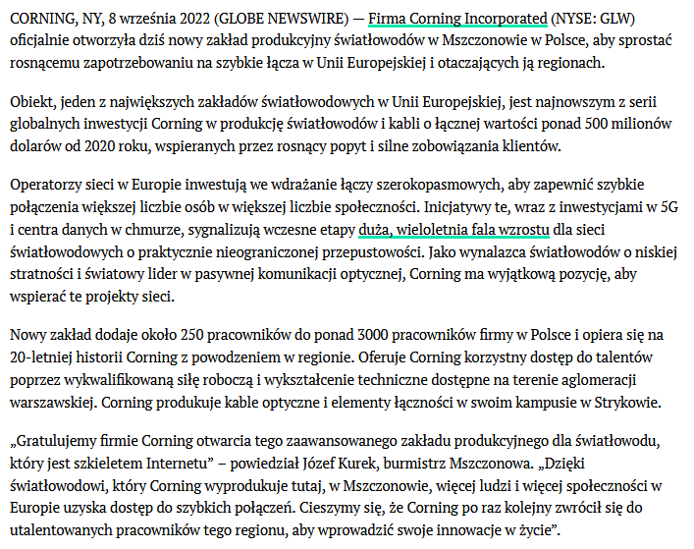
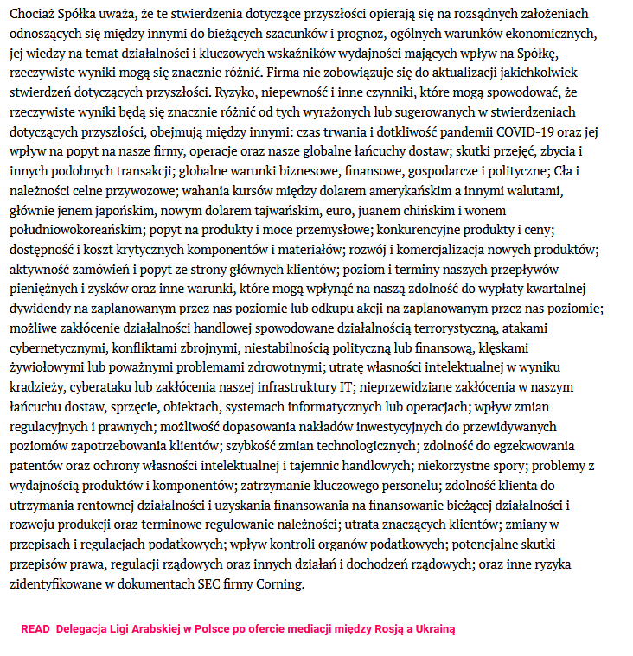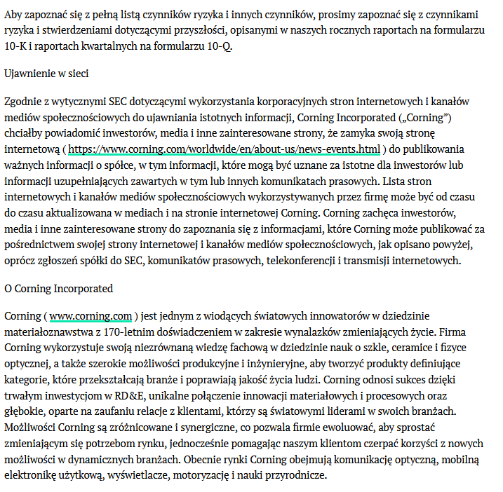

Date: 8 Sep 2022
Media: tworzywa.pl
Media circulation: 28.200 (monthly visitor traffic)
Article title: Corning Opens Fiber Optic Manufacturing Plant in Poland
Link: https://www.tworzywa.pl/news/biznes-info/corning-otwiera-w-polsce-zaklad-produkcji-swiatlowodow,2312.html
Print screen:
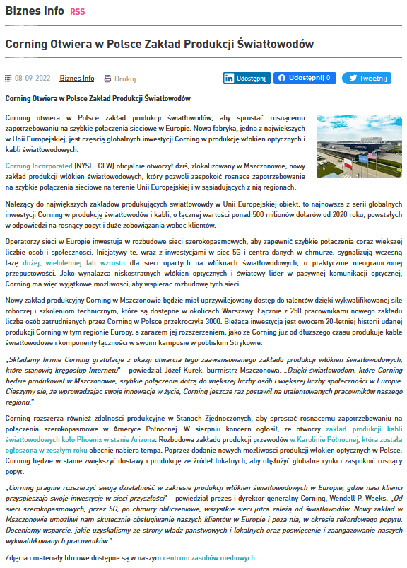
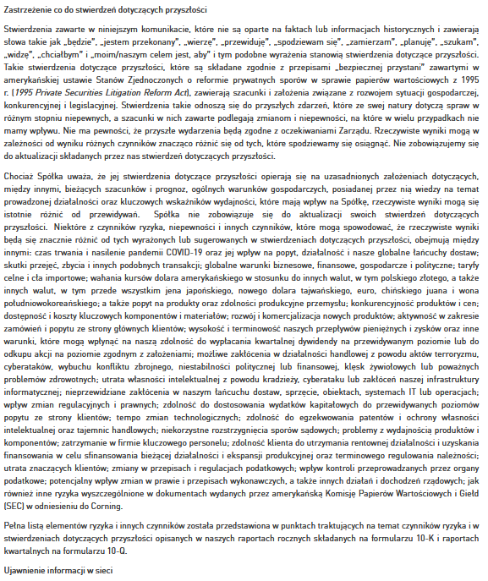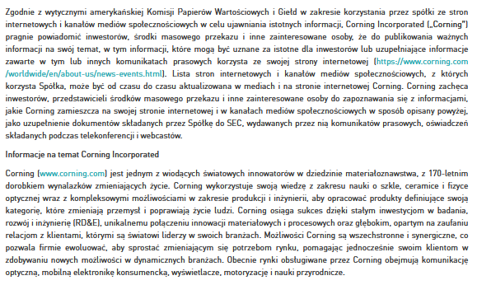

Date: 8 Sep 2022
Media: gsm.biz.pl
Media circulation: 2.700 (monthly visitor traffic)
Article title: Corning opens fiber optics plant in Poland to meet growing demand for high-speed network connections in Europe
Link: https://gsm.biz.pl/2022/09/08/corning-otwiera-w-polsce-zaklad-produkcji-swiatlowodow-aby-sprostac-rosnacemu-zapotrzebowaniu-na-szybkie-polaczenia-sieciowe-w-europie/
Print screen:
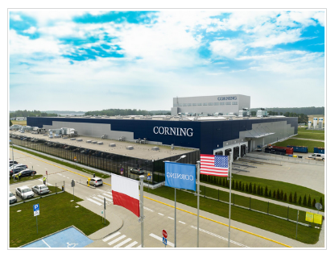

Date: 8 Sep 2022
Media: inwestycje.pl
Media circulation: 8.600 (monthly visitor traffic)
Article title: U.S.-based Corning to open fiber optics manufacturing plant in Mszczonów
Link: https://inwestycje.pl/biznes/amerykanski-corning-otworzyl-zaklad-produkcji-swiatlowodow-w-mszczonowie/
Print screen:
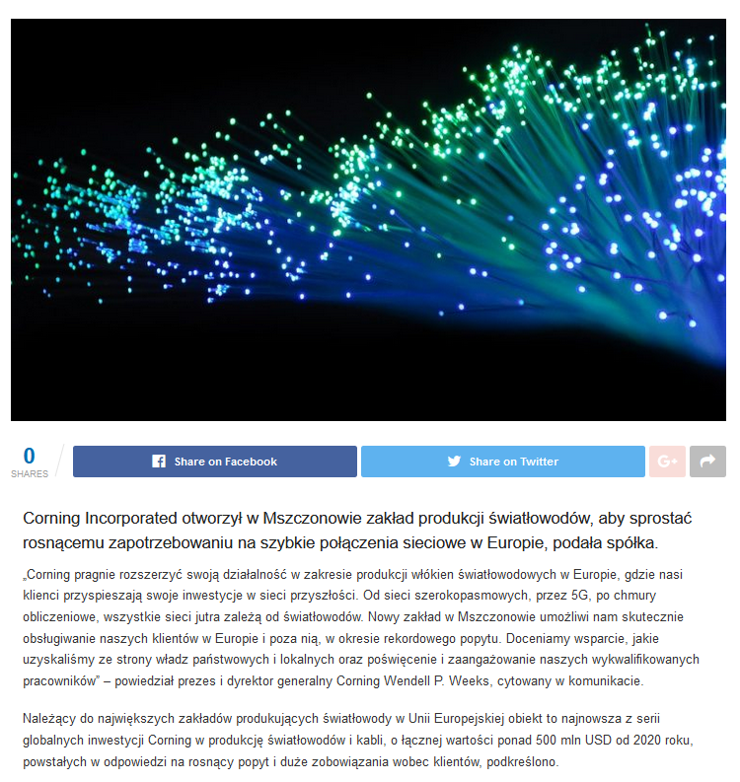
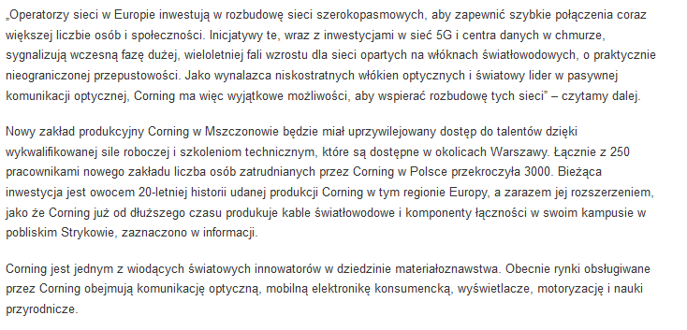

Date: 8 Sep 2022
Media: satinfo24.pl
Media circulation: 16.200 (monthly visitor traffic)
Article title: Corning has opened a fiber optics factory in Mszczonów - one of the largest in the EU
Link: http://satinfo24.pl/corning-otworzyl-w-mszczonowie-fabryke-swiatlowodow-jedna-z-najwiekszych-w-ue/
Print screen:
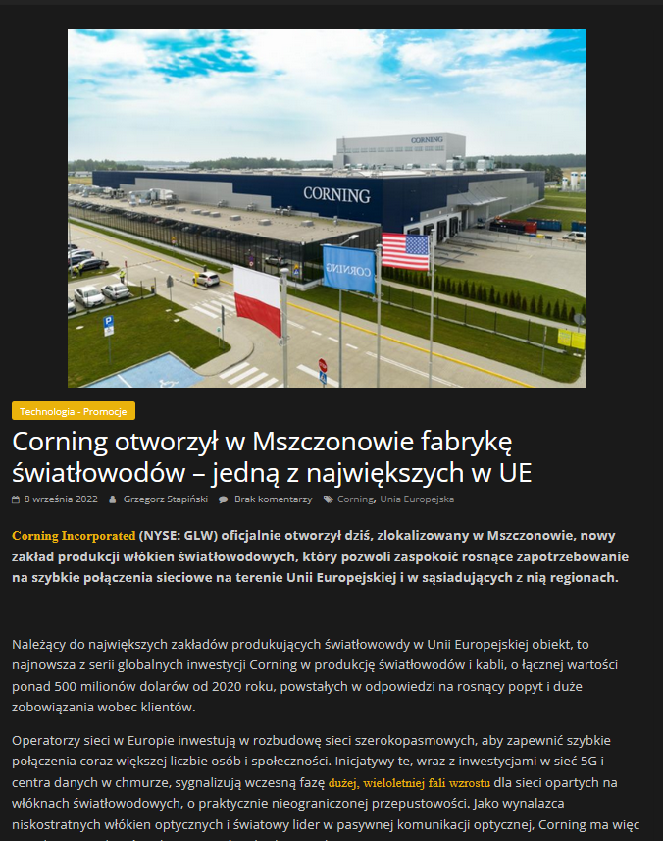
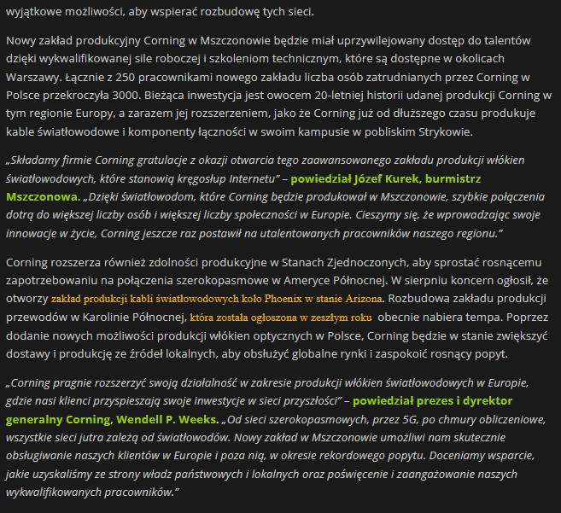

Date: 8 Sep 2022
Media: biznes.newseria.pl
Media circulation: 87.500 (monthly visitor traffic)
Article title: Corning opens fiber optics manufacturing plant in Poland
Link: https://biznes.newseria.pl/biuro-prasowe/it_i_technologie/corning-otwiera-w-polsce,b853971579
Print screen:
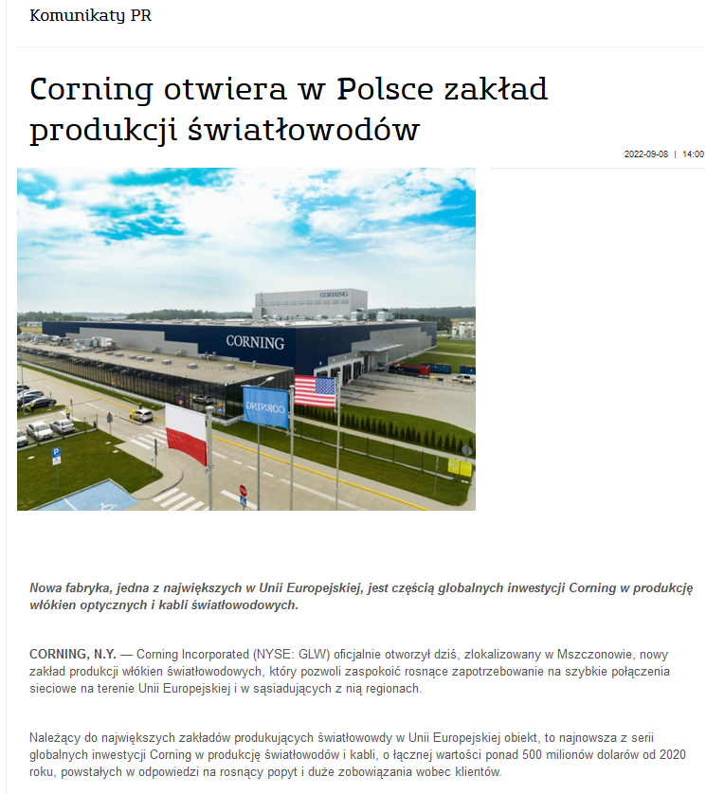
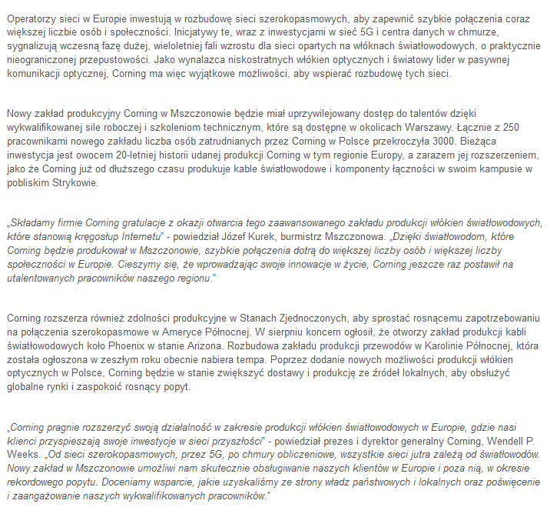

Date: 8 Sep 2022
Media: biznes.polskaprasa.pl
Media circulation: N/A
Article title: A fiber optics factory has opened in Mszczonów
Link: http://www.biznes.polskaprasa.pl/3048960-W-Mszczonowie-otwarto-fabryke-swiatlowodow.html
Print screen:
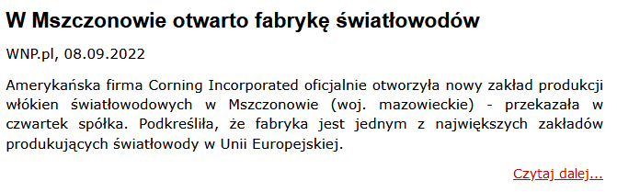

Date: 8 Sep 2022
Media: bomega.pl
Media circulation: 23.100 (monthly visitor traffic)
Article title: A state-of-the-art fiber optics manufacturing plant has been launched in Poland
Link: https://bomega.pl/w-polsce-ruszyla-nowoczesna-fabryka-produkujaca-swiatlowody/
Print screen:
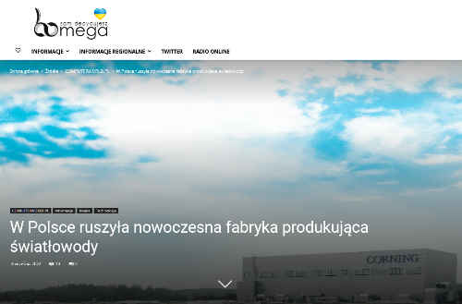

Date: 8 Sep 2022
Media: ceo.com.pl
Media circulation: 66.100 (monthly visitor traffic)
Article title: Corning is opening an optical fiber manufacturing plant in Poland. The new plant is one of the largest in the EU
Link: https://ceo.com.pl/corning-otwiera-w-polsce-zaklad-produkcji-swiatlowodow-nowa-fabryka-jest-jedna-z-najwiekszych-w-ue-38091
Print screen:
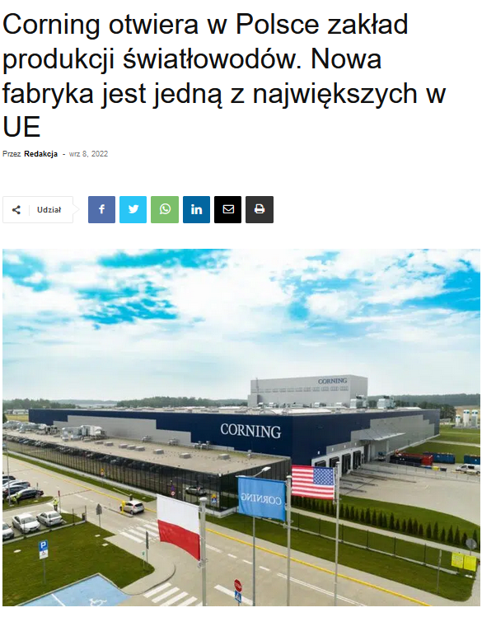
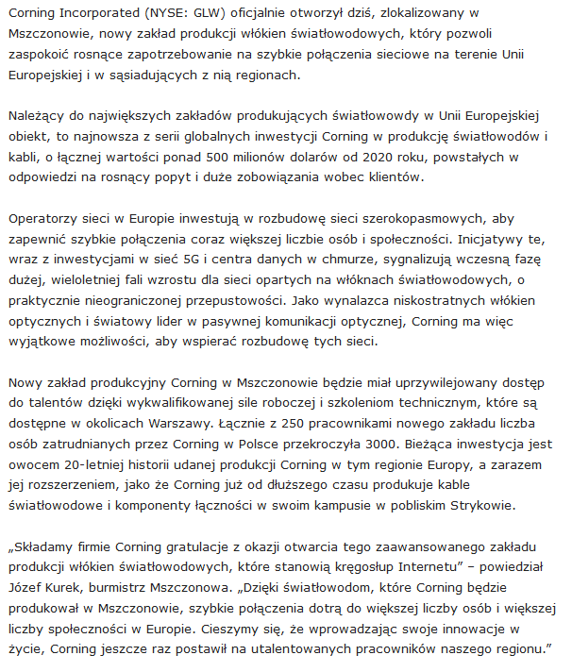

Date: 8 Sep 2022
Media: chemiaibiznes.com.pl
Media circulation: 35.000 (monthly visitor traffic)
Article title: New fiber plant
Link: https://www.chemiaibiznes.com.pl/artykuly/nowy-zaklad-wlokien-swiatlowodowych
Print screen:
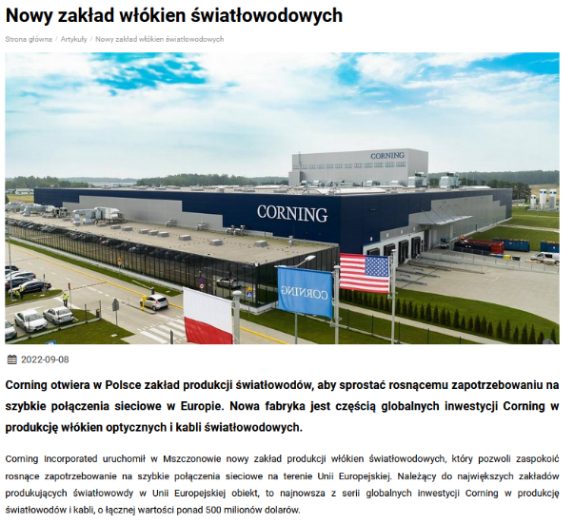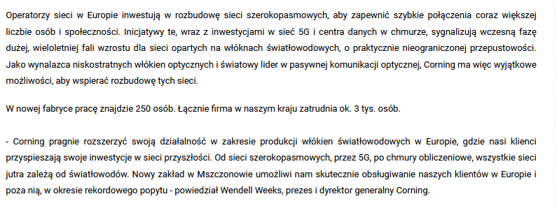
Date: 8 Sep 2022
Media: dziennik365.pl
Media circulation: 32.000 (monthly visitor traffic)
Article title: Corning has opened a factory in Mszczonów
Link: https://dziennik365.pl/corning-otworzyl-fabryke-w-mszczonowie
Print screen:
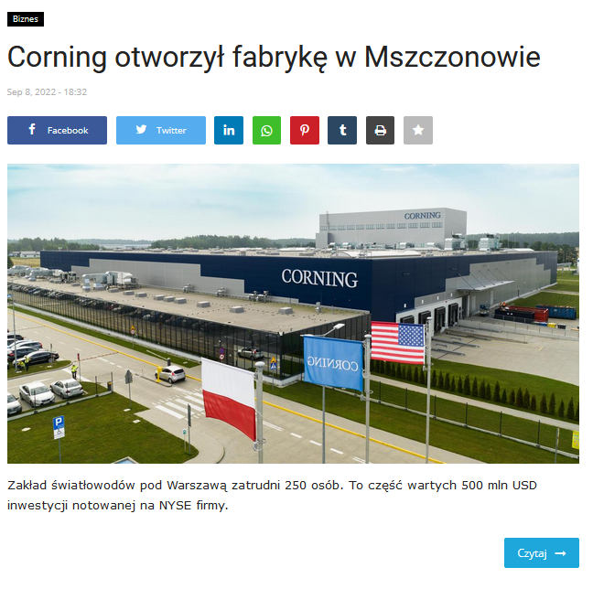

Date: 8 Sep 2022
Media: elektronikab2b.pl
Media circulation: 111.900 (monthly visitor traffic)
Article title: Corning opens fiber optics manufacturing plant in Poland
Link: https://elektronikab2b.pl/biznes/55076-corning-otwiera-w-polsce-zaklad-produkcji-swiatlowodow
Print screen:
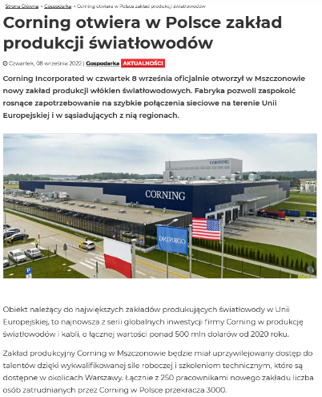
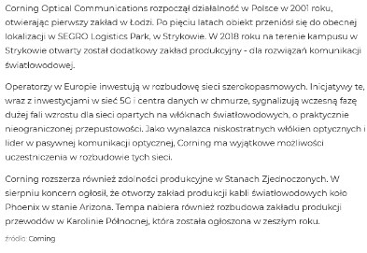
Date: 8 Sep 2022
Media: elektrotechnikautomatyk.pl
Media circulation: 2.800 (monthly visitor traffic)
Article title: Corning opens fiber optics manufacturing plant in Poland
Link: https://elektrotechnikautomatyk.pl/artykuly/corning-otwiera-w-polsce-zaklad-produkcji-swiatlowodow
Print screen:
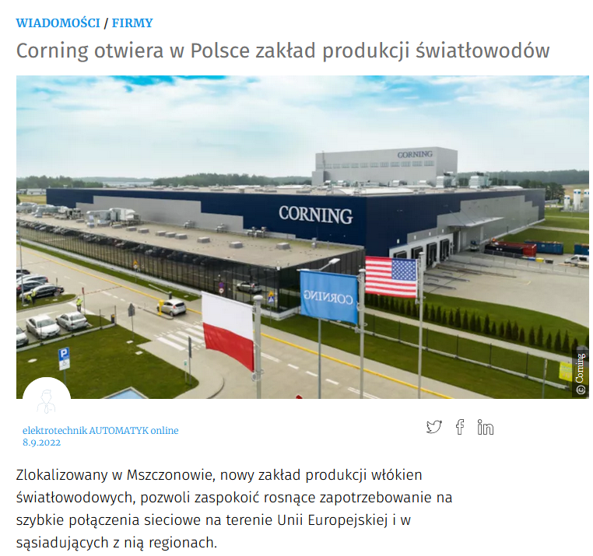
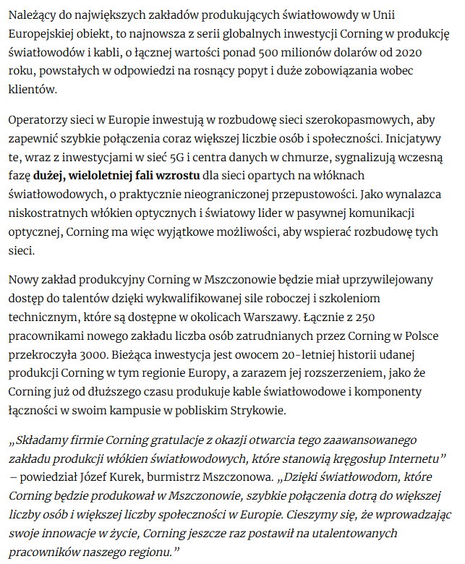
Date: 8 Sep 2022
Media: zyciezyrardowa.pl
Media circulation: N/A
Article title: World leader in fiber optics production in Mszczonów
Link: https://zyciezyrardowa.pl/swiatowy-lider-produkcji-swiatlowodow-w-mszczonowie/
Print screen:
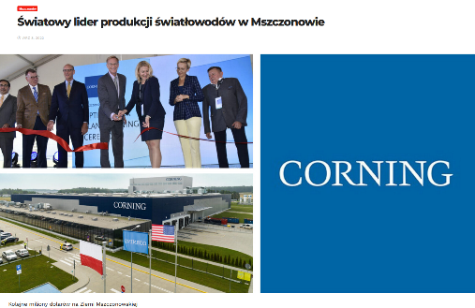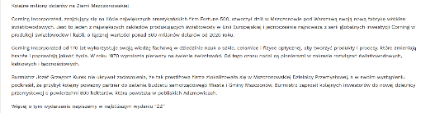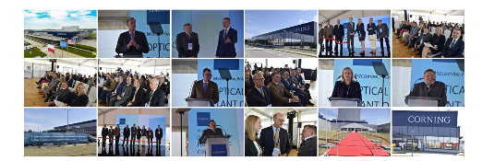

Date: 8 Sep 2022
Media: zyrardow.eglos.pl
Media circulation: 405.900 (monthly visitor traffic)
Article title: One of Europe's largest fiber optics plants begins production near Mszczonow
Link: https://zyrardow.eglos.pl/aktualnosci/item/41072-uroczyste-otwarcie-zakladu
Print screen:
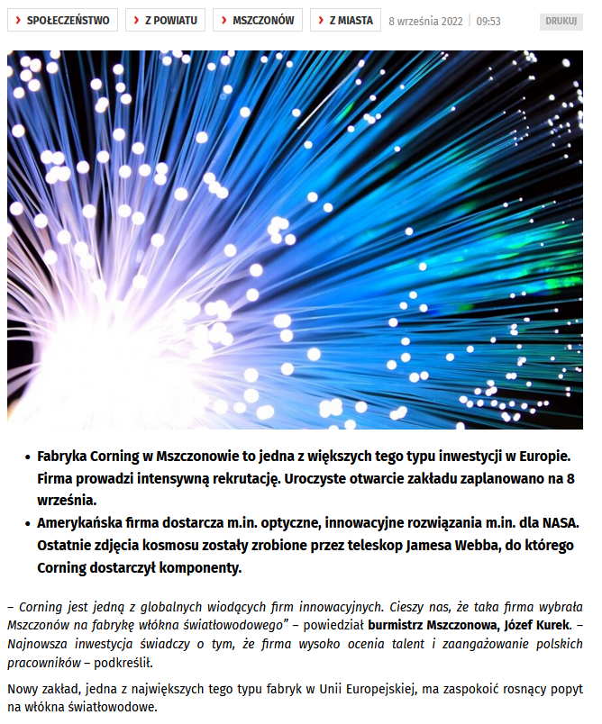
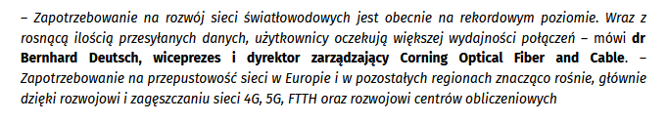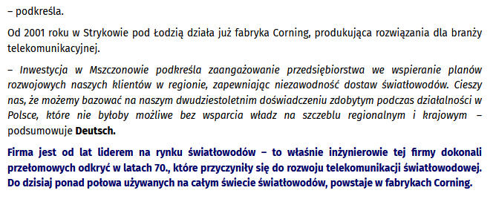

Date: 8 Sep 2022
Media: stooq.com
Media circulation: 28.400.000 (monthly visitor traffic)
Article title: U.S.-based Corning to open fiber optics manufacturing plant in Mszczonów
Link: https://stooq.com/n/?f=1508453&c=1&p=0
Print screen:
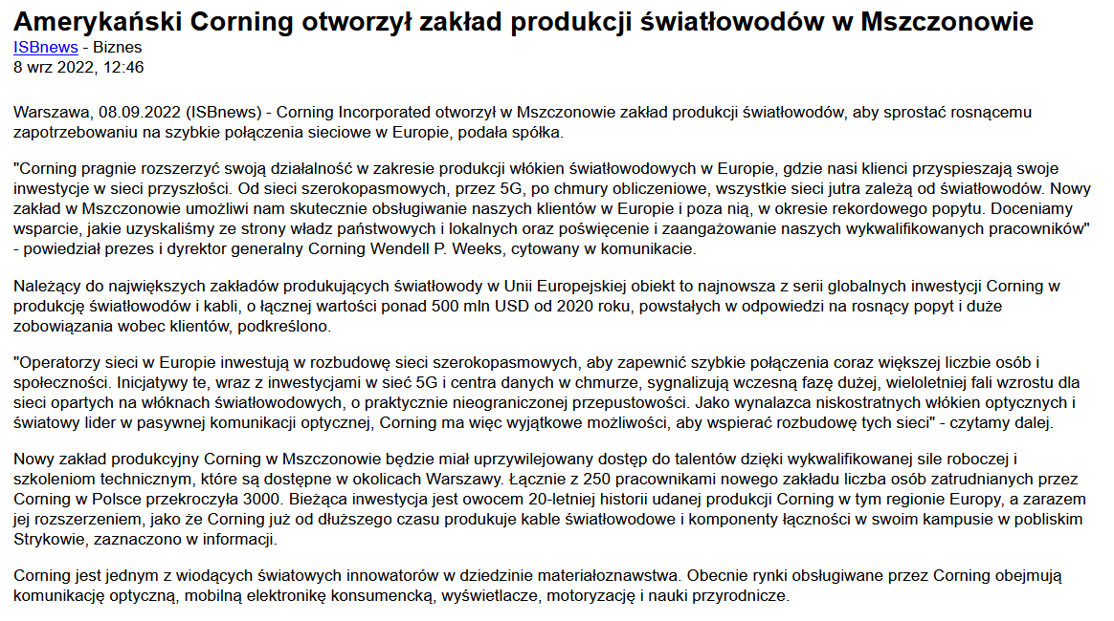

Date: 8 Sep 2022
Media: stooq.pl
Media circulation: 185.200.000 (monthly visitor traffic)
Article title: U.S.-based Corning to open fiber optics manufacturing plant in Mszczonów
Link: https://stooq.pl/n/?f=1508453&c=1&p=0
Print screen:
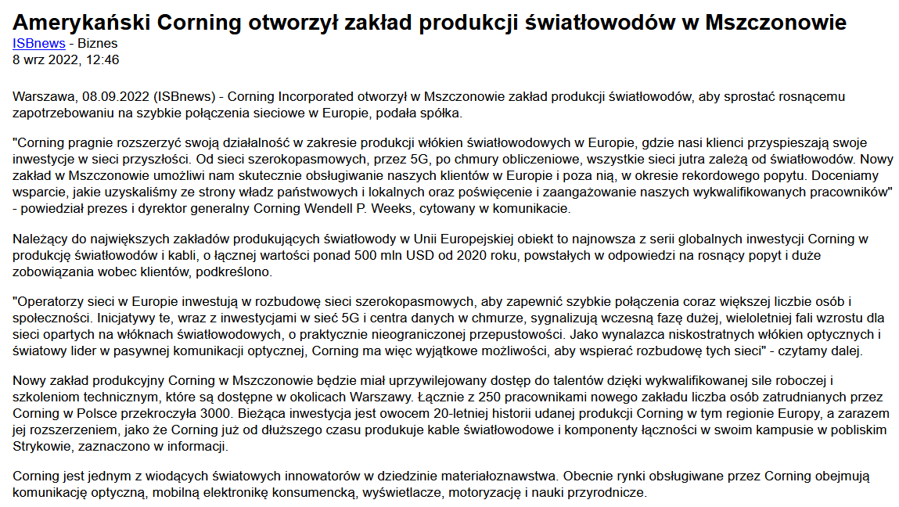

Date: 8 Sep 2022
Media: pl.investing.com
Media circulation: 384.700.000 (monthly visitor traffic)
Article title: U.S.-based Corning to open fiber optics manufacturing plant in Mszczonów
Link: https://pl.investing.com/news/stock-market-news/amerykanski-corning-otworzyl-zaklad-produkcji-swiatlowodow-w-mszczonowie-337474
Print screen:
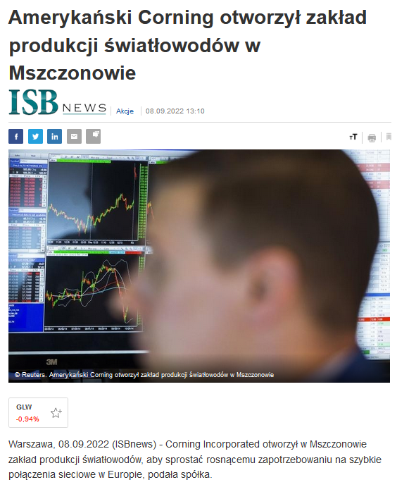
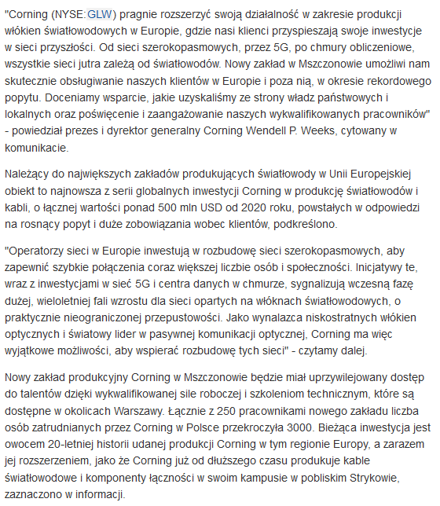

Date: 8 Sep 2022
Media: stooq.pl
Media circulation: 185.200.000 (monthly visitor traffic)
Article title: Mazowieckie - A fiber optics factory has opened in Mszczonów
Link: https://stooq.pl/n/?f=1508484&c=1&p=0
Print screen:
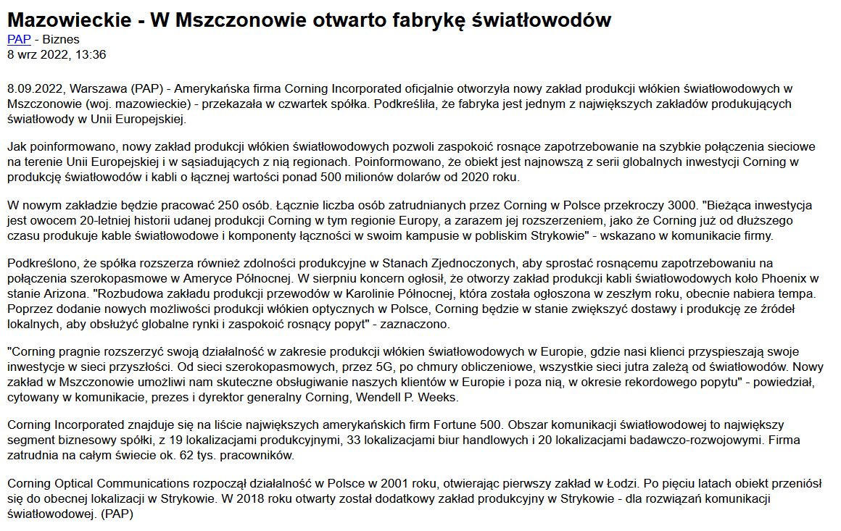

Date: 8 Sep 2022
Media: stooq.com
Media circulation: 28.400.000 (monthly visitor traffic)
Article title: Mazowieckie - A fiber optics factory has opened in Mszczonów
Link: https://stooq.com/n/?f=1508484&c=1&p=4+22
Print screen:
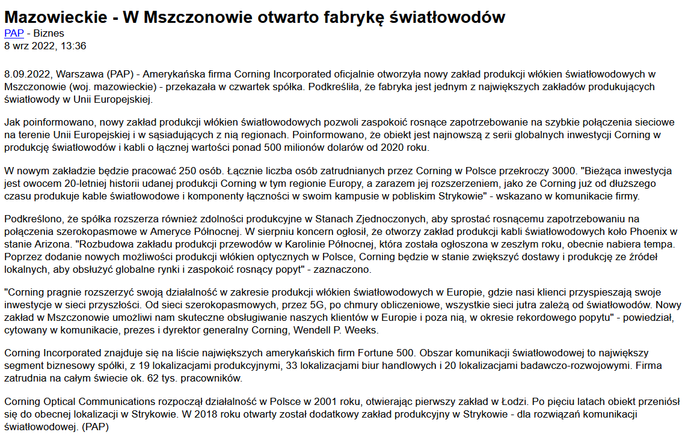

Date: 8 Sep 2022
Media: propertynews.pl
Media circulation: 135.100 (monthly visitor traffic)
Article title: Mazowieckie - A fiber optics factory has opened in Mszczonów
Link: https://www.propertynews.pl/magazyny/mazowieckie-w-mszczonowie-otwarto-fabryke-swiatlowodow,104940.html
Print screen:
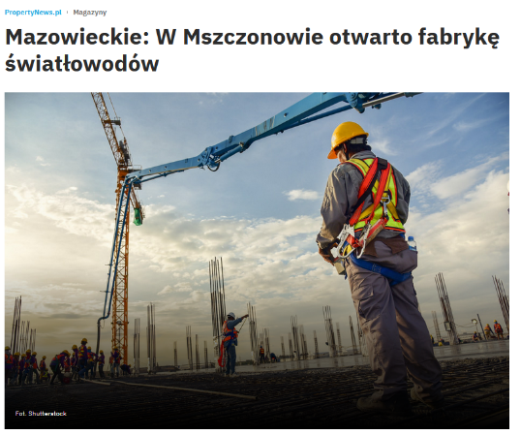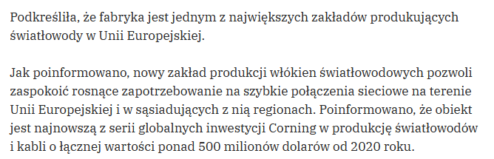

Date: 8 Sep 2022
Media: wnp.pl
Media circulation: 4.000.000 (monthly visitor traffic)
Article title: A fiber optics factory has opened in Mszczonów
Link: https://www.wnp.pl/tech/mazowieckie-w-mszczonowie-otwarto-fabryke-swiatlowodow,620291.html
Print screen:
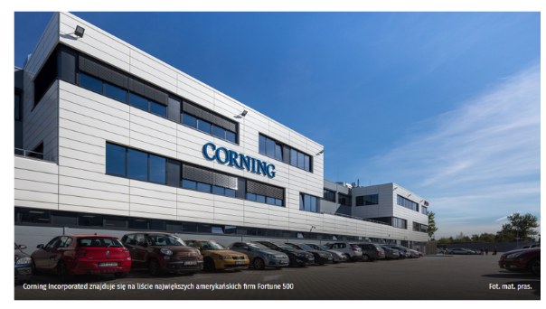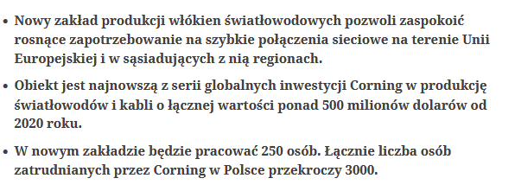

Date: 8 Sep 2022
Media: mainboard.pl
Media circulation: N/A
Article title: A fiber optics factory has opened in Mszczonów
Link: https://mainboard.pl/news/103/12103/w-mszczonowie-otwarto-fabryke-swiatlowodow.html
Print screen:

Date: 8 Sep 2022
Media: dzienna.pl
Media circulation: N/A
Article title: Corning opens fiber optics factory in Poland
Link: https://dzienna.pl/news/67/12870/Corning-otwiera-w-Polsce-fabryke-swiatlowodow.html
Print screen:
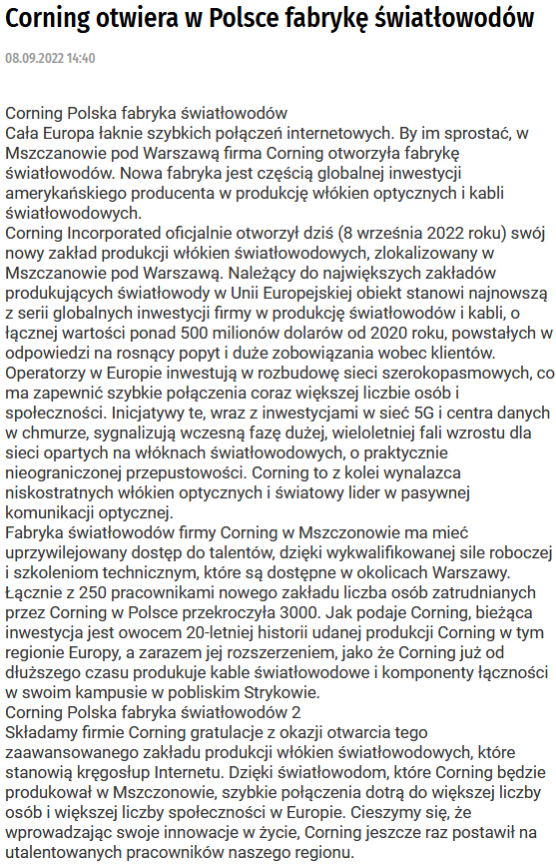

Date: 8 Sep 2022
Media: itblog24.pl
Media circulation: N/A
Article title: Corning opens fiber optics factory in Poland
Link: http://itblog24.com/news/110/23099/Corning_otwiera_w_Polsce_fabryk%C4%99_%C5%9Bwiat%C5%82owod%C3%B3w.html
Print screen:
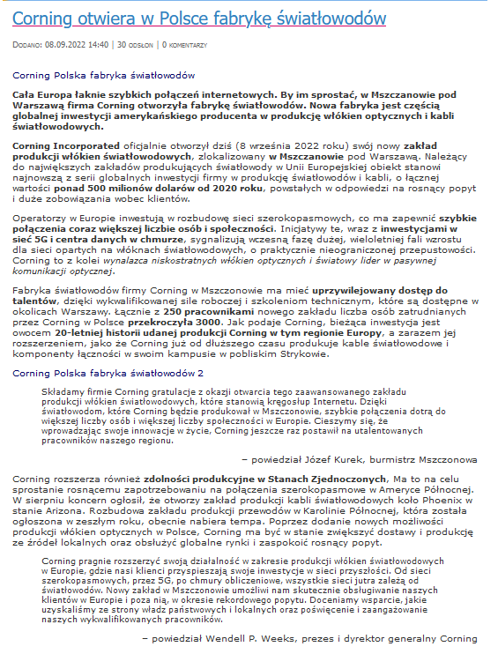

Date: 8 Sep 2022
Media: wgospodarce.pl
Media circulation: 1.300.000 (monthly visitor traffic)
Article title: American fiber optics in Mszczonów
Link: https://wgospodarce.pl/informacje/116761-amerykanskie-swiatlowody-w-mszczonowie
Print screen:
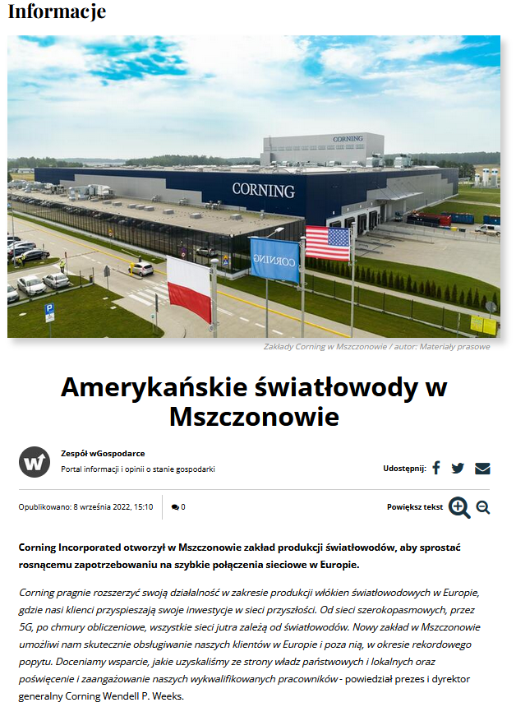
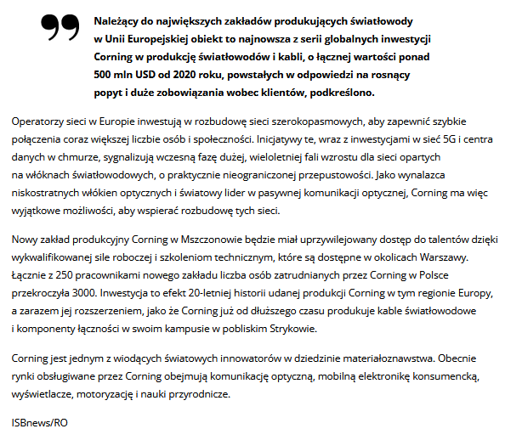

Date: 8 Sep 2022
Media: pb.pl
Media circulation: 2.800.000 (monthly visitor traffic)
Article title: Corning opens fiber optics factory in Poland
Link: https://www.pb.pl/corning-otworzyl-fabryke-w-mszczonowie-1163136#pb-has-paylock
Print screen:
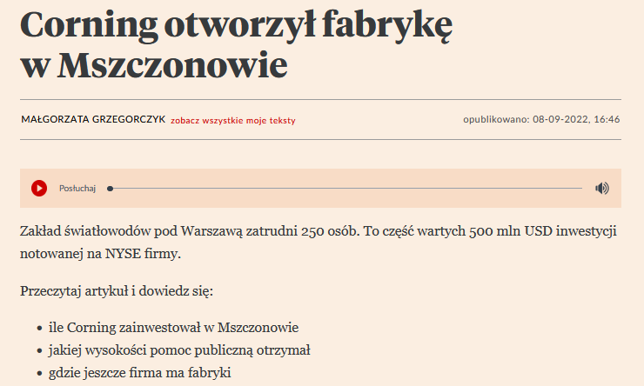

Date: 8 Sep 2022
Media: computerworld.pl
Media circulation: 171.900 (monthly visitor traffic)
Article title: A state-of-the-art fiber optics manufacturing plant has been launched in Poland
Link: https://www.computerworld.pl/news/W-Polsce-ruszyla-nowoczesna-fabryka-produkujaca-swiatlowody,441029.html
Print screen:
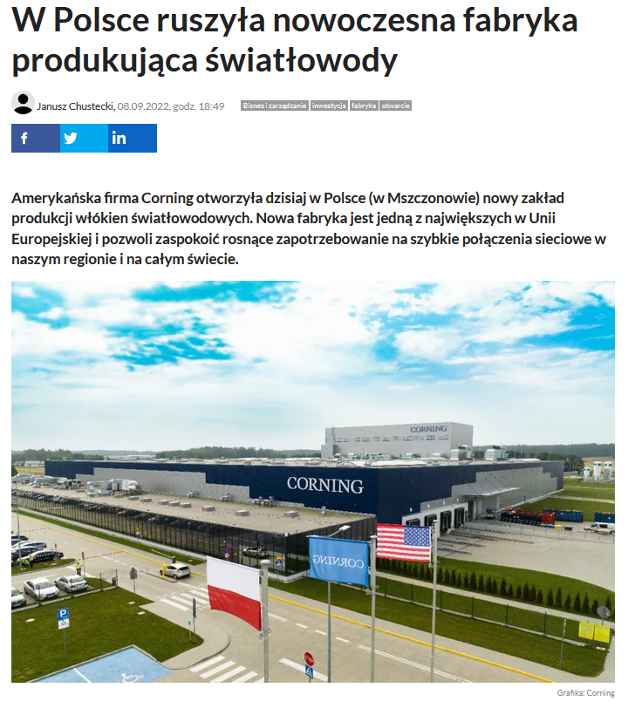
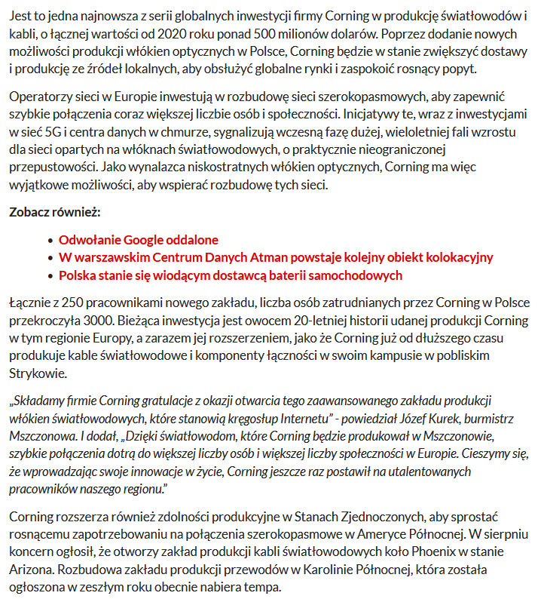

Date: 8 Sep 2022
Media: telko.in
Media circulation: 161.000 (monthly visitor traffic)
Article title: Corning opens fiber optics plant in Mszczonów
Link: https://www.telko.in/corning-otworzyl-zaklad-produkcji-wlokien-swiatlowodowych-w-mszczonowie
Print screen:

Date: 9 Sep 2022
Media: gsmonline.pl
Media circulation: 858.700 (monthly visitor traffic)
Article title: Corning opens another fiber optics manufacturing plant in Mszczonów
Link: https://gsmonline.pl/artykuly/corning-w-polsce-produkcja-swiatlowodow
Print screen:
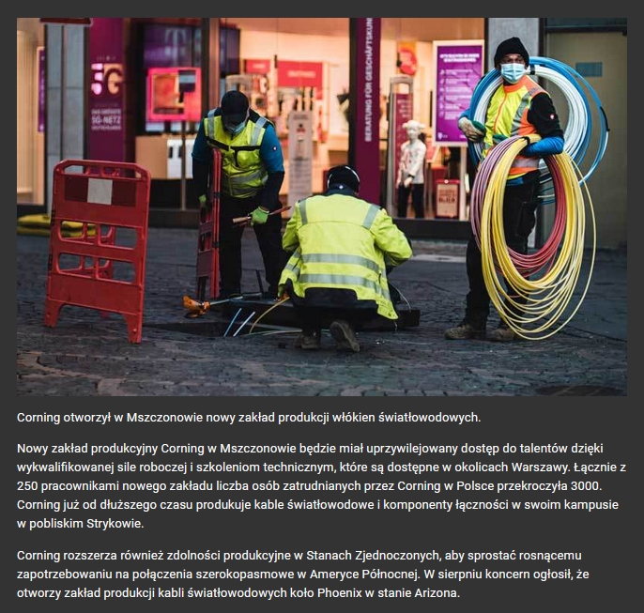

Date: 9 Sep 2022
Media: evertiq.pl
Media circulation: 18.500 (monthly visitor traffic)
Article title: Corning opens fiber optics manufacturing plant in Poland
Link: https://evertiq.pl/news/29869
Print screen:
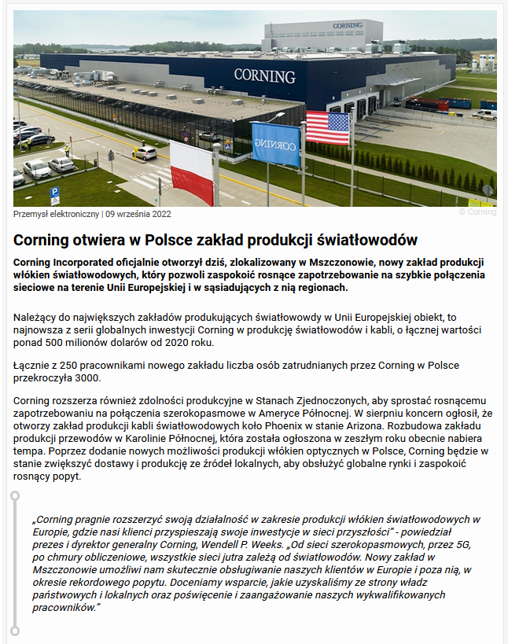

Date: 9 Sep 2022
Media: nowoczesny-przemysl.pl
Media circulation: N/A
Article title: New factory for Corning Incorporated - innovative manufacturer of optical fibers
Link: https://nowoczesny-przemysl.pl/nowa-fabryka-dla-firmy-corning-incorporated/
Print screen:
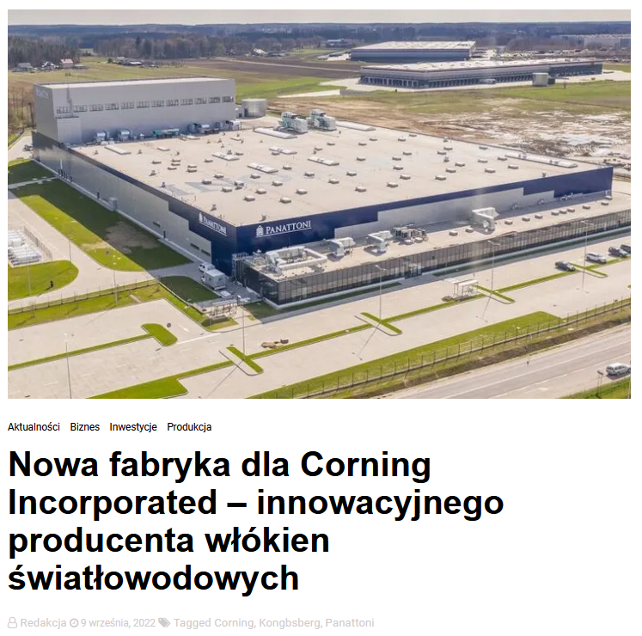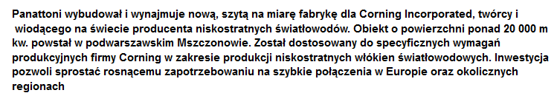
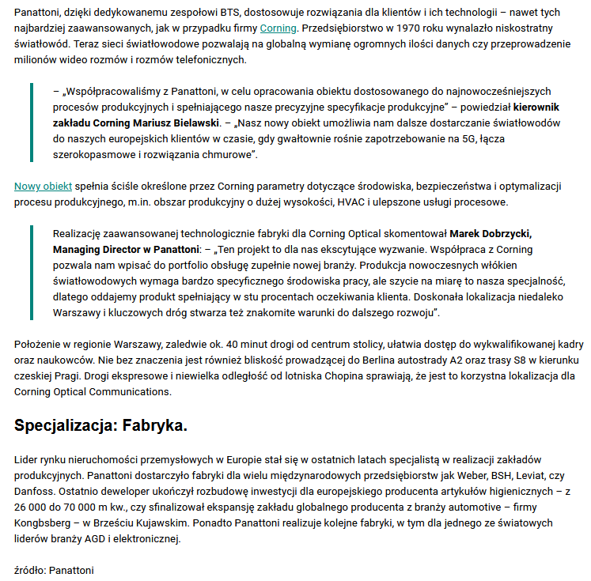

Date: 9 Sep 2022
Media: polskiprzemysl.pl
Media circulation: N/A
Article title: Corning to open fiber optics plant in Mszczonów
Link: https://polskiprzemysl.com.pl/wiadomosci/fabryka-swiatlowodow-w-mszczonowie/
Print screen:
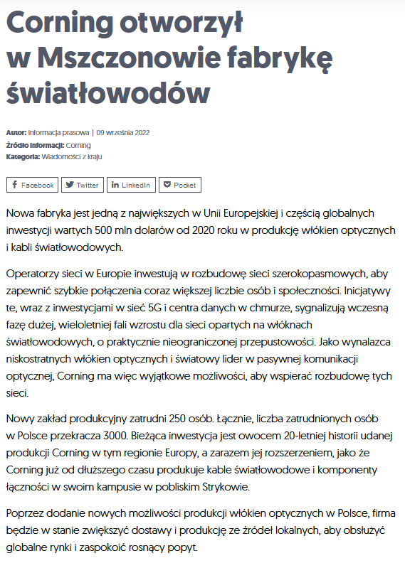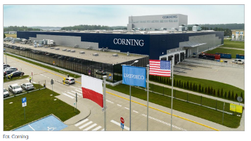

Date: 9 Sep 2022
Media: grojec24.net
Media circulation: 230.900 (monthly visitor traffic)
Article title: Corning has opened a fiber optics factory in Mszczonów - one of the largest in the EU
Link: https://www.grojec24.net/news-corning-otworzyl-w-mszczonowie-fabryke-swiatlowodow-jedna-z-najwiekszych-w-ue,9306.html
Print screen:
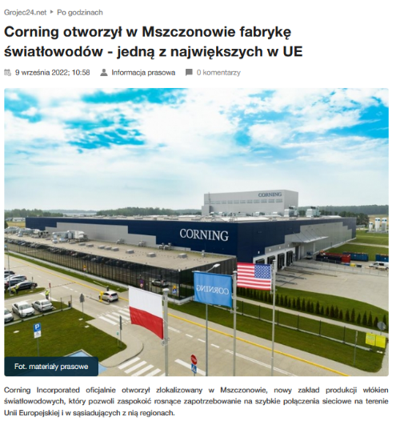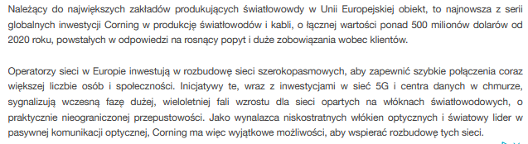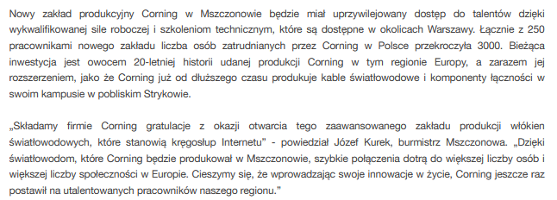

Date: 9 Sep 2022
Media: isbtech.pl
Media circulation: 29.500 (monthly visitor traffic)
Article title: Corning: 5G depends on fiber optics (interview)
Link: https://www.isbtech.pl/2022/09/corning-koncentruje-sie-na-laczach-szerokopasmowych-5g-i-centrach-danych-w-chmurze/
Print screen:´
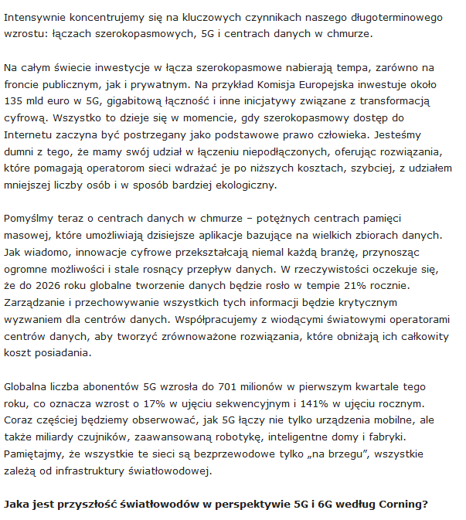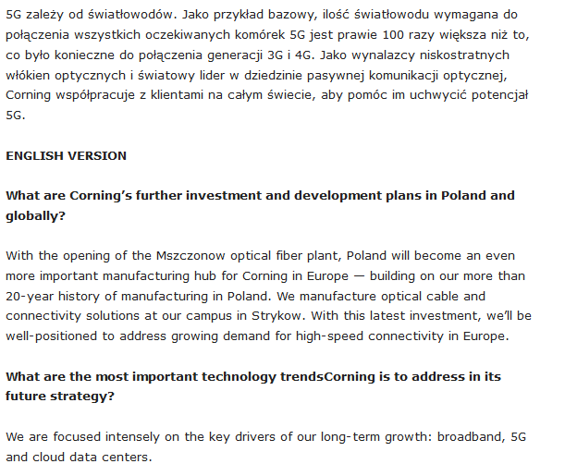
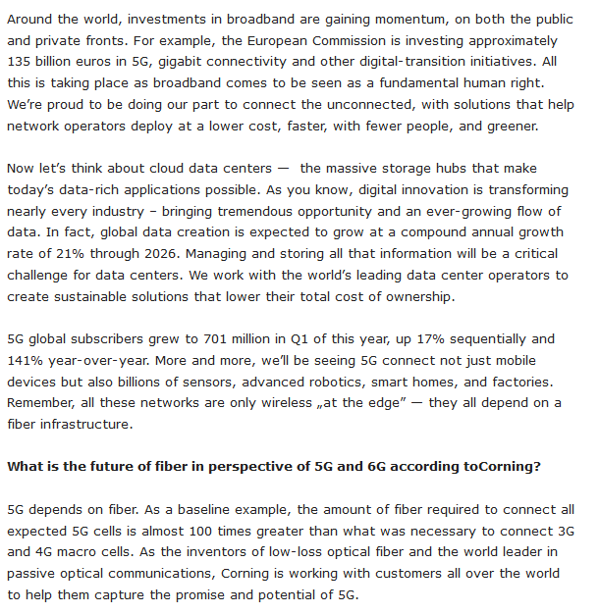

Date: 9 Sep 2022
Media: urbanity.pl
Media circulation: 337.900 (monthly visitor traffic)
Article title: Manufacturer of low-loss optical fibers has its new factory near Warsaw
Link: https://www.urbanity.pl/mazowieckie/zyrardowski/mszczonow/producent-niskostratnych-wlokien-swiatlowodowych-ma-swoja-nowa-fabryke-pod-warszawa,w21935
Print screen:
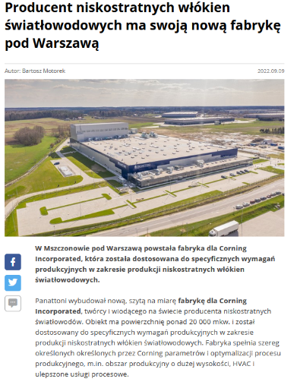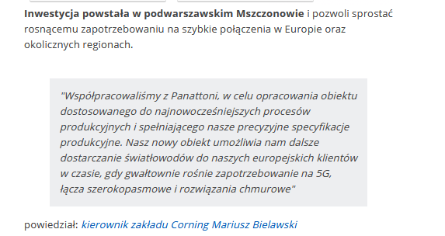

Date: 9 Sep 2022
Media: glowny-mechanik.pl
Media circulation: 10.900 (monthly visitor traffic)
Article title: Corning opens fiber optics manufacturing plant in Poland
Link: https://glowny-mechanik.pl/2022/09/09/corning-otwiera-w-polsce-zaklad-produkcji-swiatlowodow/?sfw=pass1662700710
Print screen:
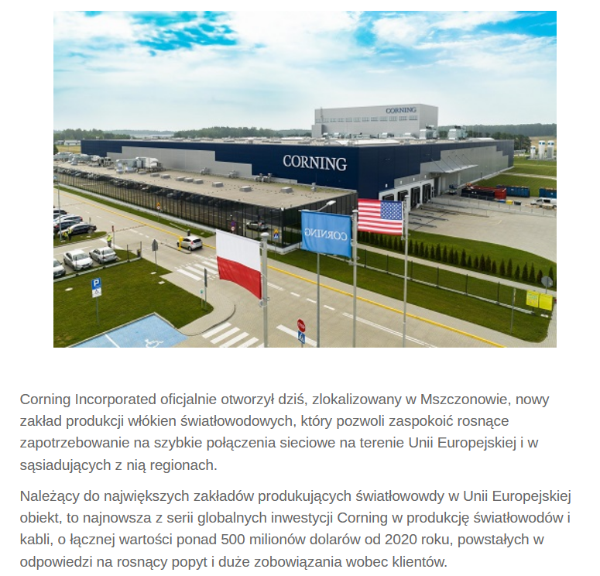
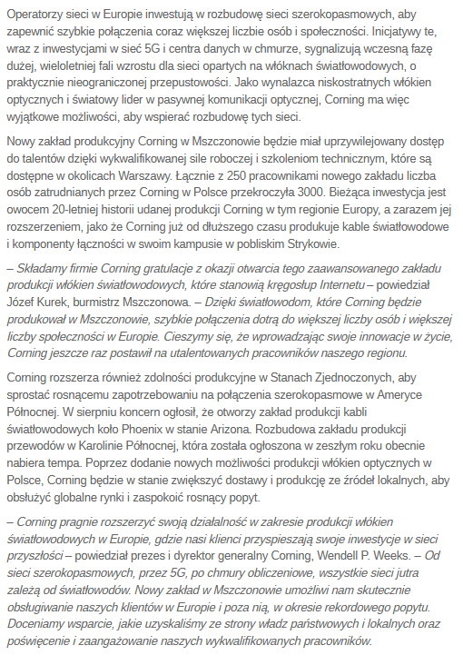

Date: 9 Sep 2022
Media: telix.pl
Media circulation: 120.100 (monthly visitor traffic)
Article title: Corning opens fiber optics manufacturing plant in Poland
Link: https://www.telix.pl/rynek/wydarzenia/2022/09/corning-otwiera-w-polsce-zaklad-produkcji-swiatlowodow/
Print screen:
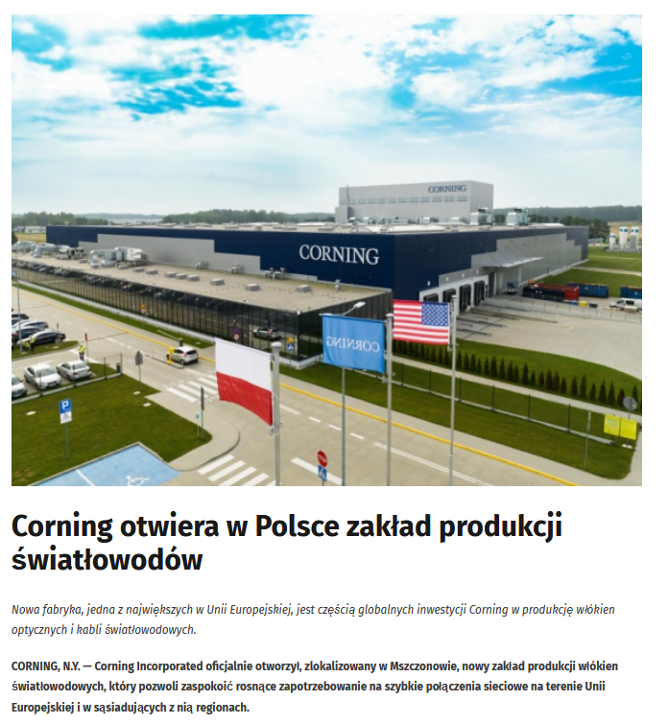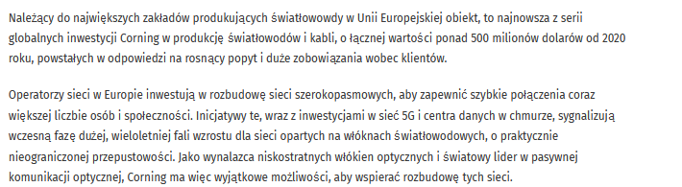
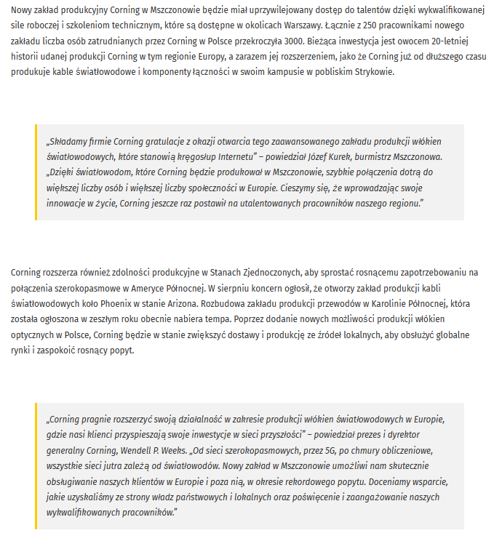

Date: 11 Sep 2022
Media: msn.pl
Media circulation: 44.900 (monthly visitor traffic)
Article title: Corning opens fiber optics manufacturing plant in Poland
Link: https://www.msn.com/pl-pl/wiadomosci/polska/corning-otworzy%C5%82-na-mazowszu-fabryk%C4%99-%C5%9Bwiat%C5%82owod%C3%B3w-to-jedna-z-najwi%C4%99kszych-w-europie/ar-AA11H7CI?ocid=EMMX
Print screen:
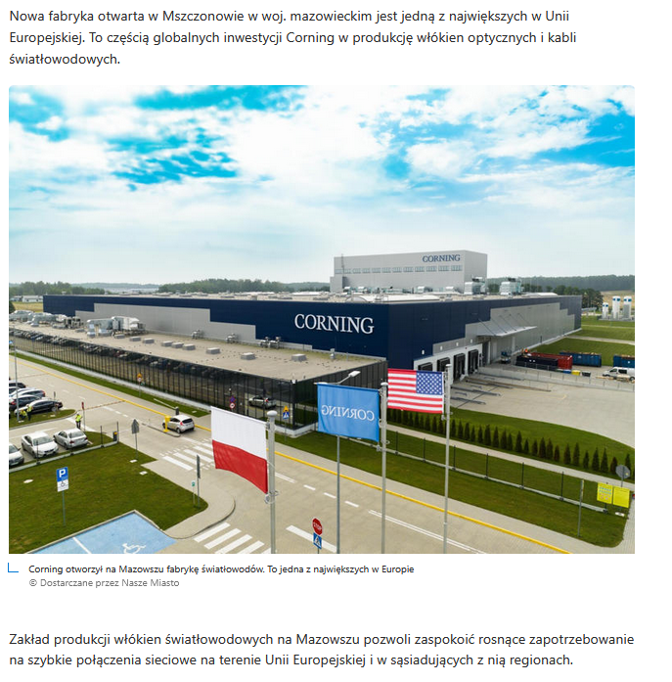
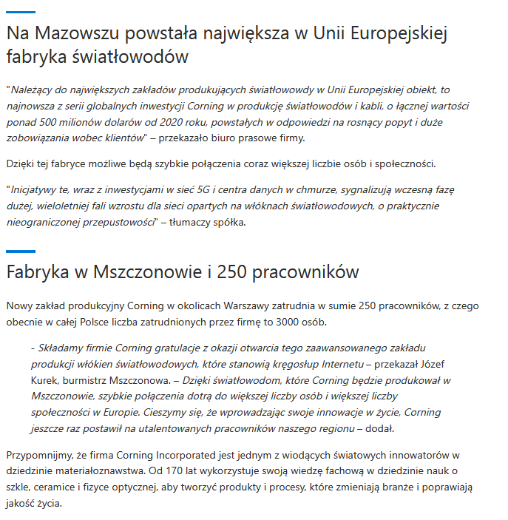

Date: 11 Sep 2022
Media: warszawa.naszemiasto.pl
Media circulation: 24.600.000 (monthly visitor traffic)
Article title: Corning has opened a fiber optics factory in Mazovia. It is one of the largest in Europe
Link: https://warszawa.naszemiasto.pl/corning-otworzyl-na-mazowszu-fabryke-swiatlowodow-to-jedna/ar/c1-8986695
Print screen:
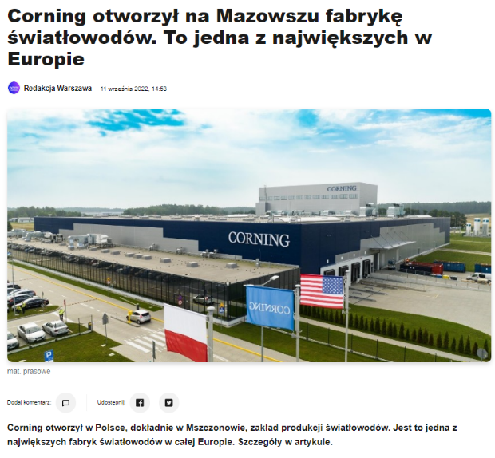

Date: 12 Sep 2022
Media: tuteraz.pl
Media circulation: 23.600 (monthly visitor traffic)
Article title: Corning has opened a fiber optics factory in Mazovia. It is one of the largest in Europe
Link: https://tuteraz.pl/warszawa/12/09/2022/corning-otworzyl-na-mazowszu-fabryke-swiatlowodow-to-jedna-z-najwiekszych-w-europie/
Print screen:

Date: 12 Sep 2022
Media: pim.pl
Media circulation: 8.600 (monthly visitor traffic)
Article title: Corning opens fiber optics manufacturing plant in Poland
Link: https://pim.pl/corning-otwiera-w-polsce-zaklad-produkcji-swiatlowodow/
Print screen:

Date: 12 Sep 2022
Media: gpcodziennie.pl
Media circulation: 93.000 (monthly visitor traffic)
Article title: New fiber optics plant launched
Link: https://gpcodziennie.pl/808838-uruchomiono-nowa-fabryke-swiatlowodow.html#gpcodziennie-has-paylock
Print screen:
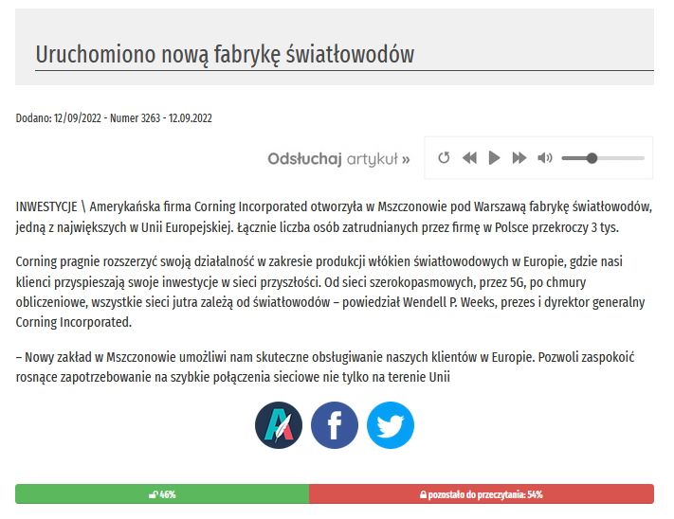

Date: 13 Sep 2022
Media: isportal.pl
Media circulation: 6.900 (monthly visitor traffic)
Article title: Corning factory in Mszczonów
Link: https://isportal.pl/fabryka-corning-w-mszczonowie
Print screen:
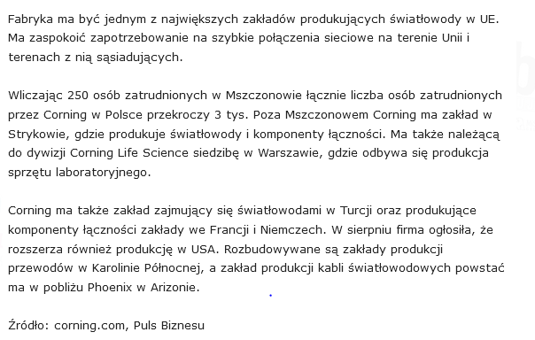

Date: 12 Sep 2022
Media: biznes.newseria.pl
Media circulation: 87.500 (monthly visitor traffic)
Article title: Expansion of 5G networks will drive demand for fiber optics. Their new factory in Mszczonów will serve Europe's largest customers (interview)
Link: https://biznes.newseria.pl/news/rozbudowa-sieci-5g,p2019184008
Print screen:
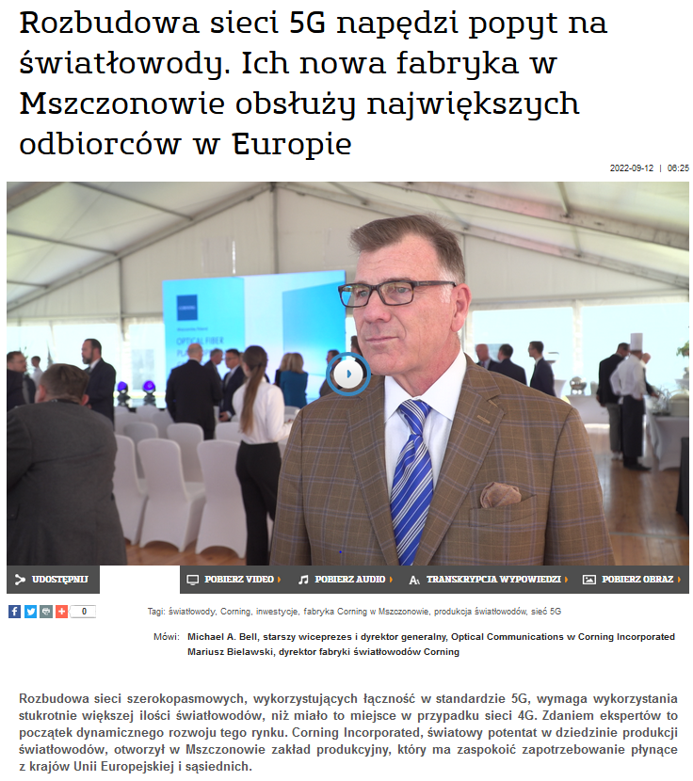
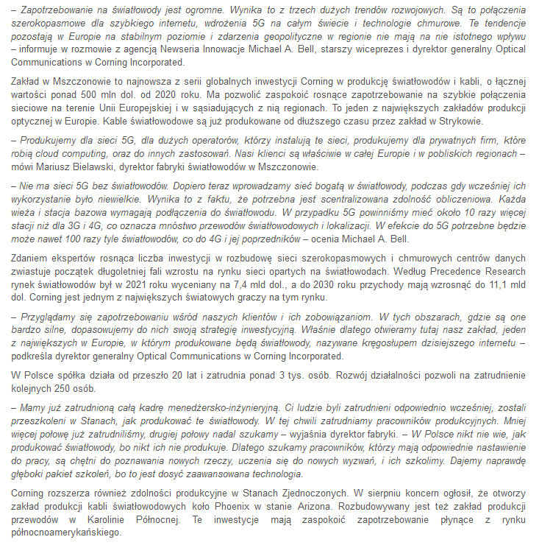

Date: 12 Sep 2022
Media: hurtidetal.pl
Media circulation: 42.100 (monthly visitor traffic)
Article title: Expansion of 5G networks will drive demand for fiber optics
Link: https://hurtidetal.pl/article/art_id,37109-97/rozbudowa-sieci-5g-napedzi-popyt-na-swiatlowody/
Print screen:
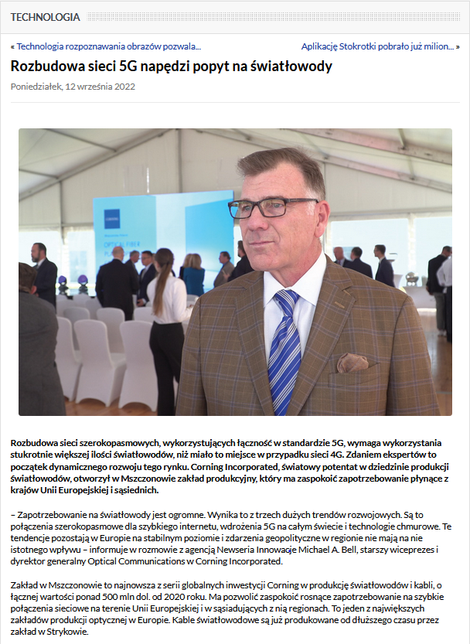
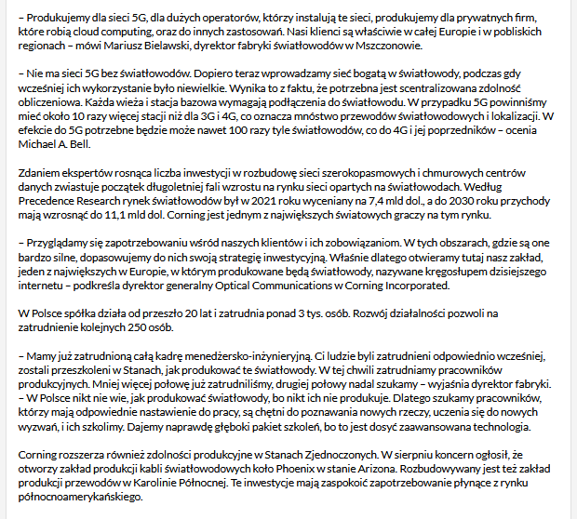

Date: 12 Sep 2022
Media: dziennik365.pl
Media circulation: 32.000 (monthly visitor traffic)
Article title: Expansion of 5G networks will drive demand for fiber optics. Their new factory in Mszczonów will serve Europe's largest customers
Link: https://dziennik365.pl/rozbudowa-sieci-5g-napedzi-popyt-na-swiatlowody-ich-nowa-fabryka-w-mszczonowie-obsluzy-najwiekszych-odbiorcow-w-europie
Print screen:
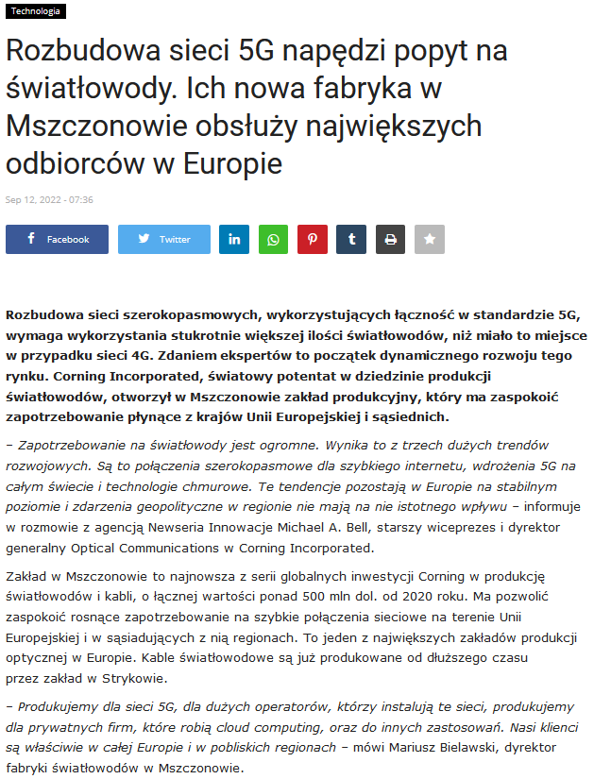
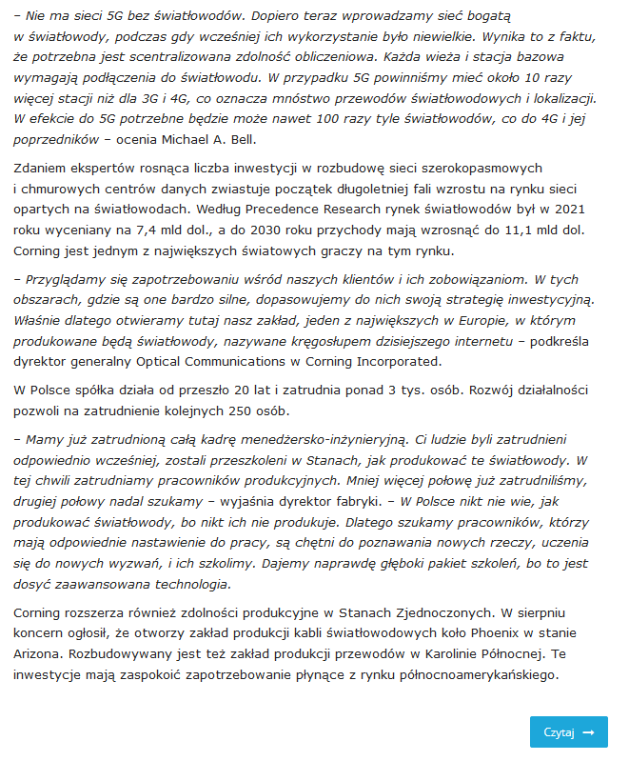

Date: 12 Sep 2022
Media: elektotechnikautomatyk.pl
Media circulation: N/A
Article title: Expansion of 5G networks will drive demand for fiber optics
Link: https://elektrotechnikautomatyk.pl/artykuly/rozbudowa-sieci-5g-napedzi-popyt-na-swiatlowody
Print screen:
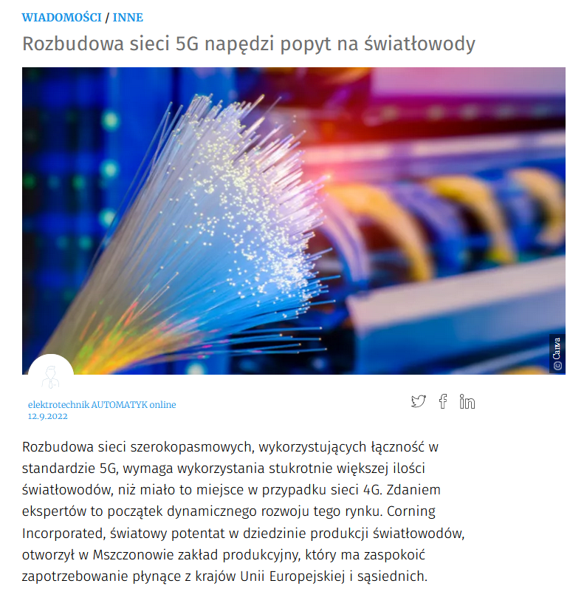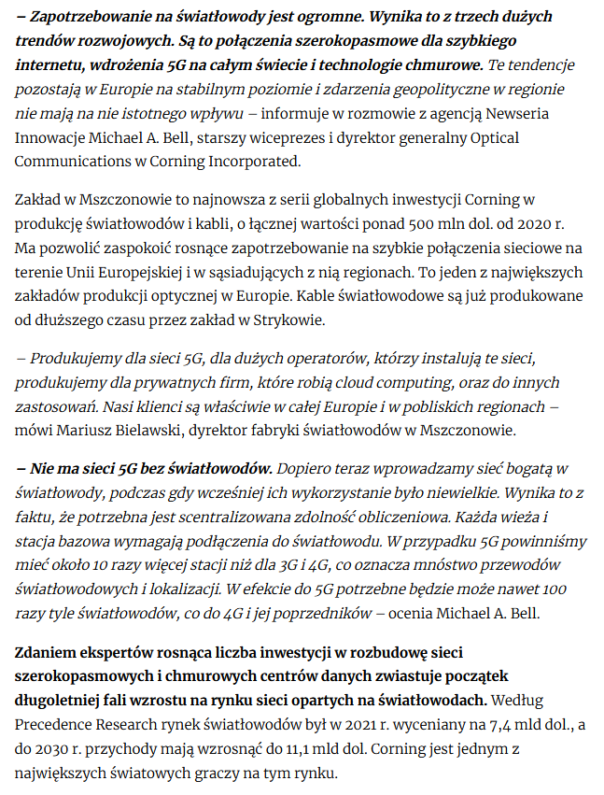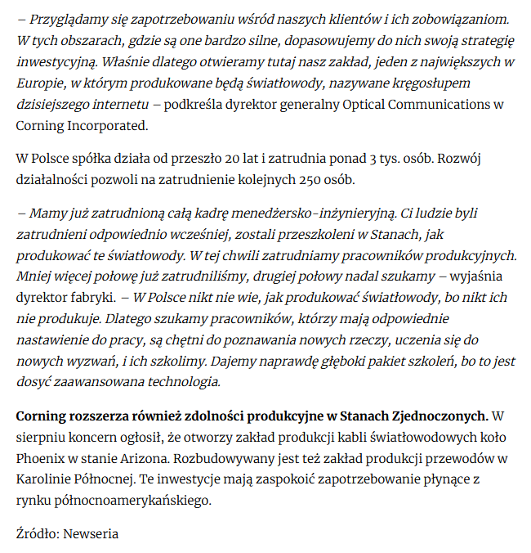

Date: 12 Sep 2022
Media: dlatego.pl
Media circulation: N/A
Article title: Expansion of 5G networks will drive demand for fiber optics. Their new factory in Mszczonów will serve Europe's largest customers
Link: https://www.dlatego.pl/rozbudowa-sieci-5g-napedzi-popyt-na-swiatlowody-ich-nowa-fabryka-w-mszczonowie-obsluzy-najwiekszych-odbiorcow-w-europie/
Print screen:
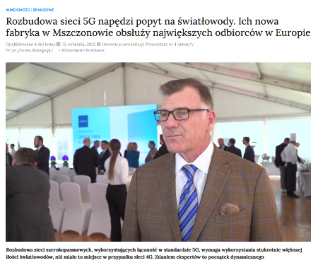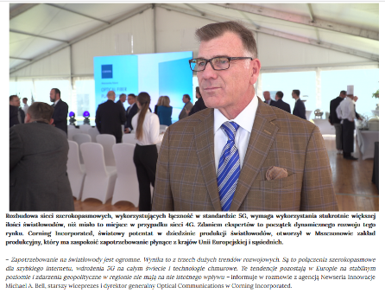
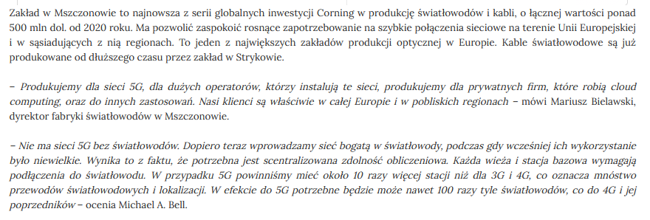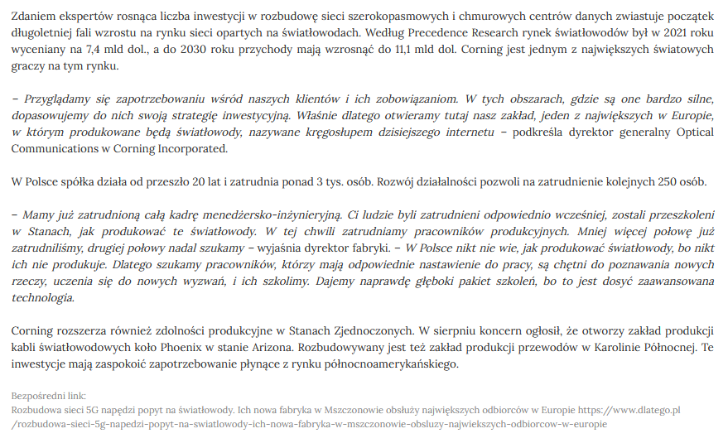

Date: 12 Sep 2022
Media: executivemagazine.pl
Media circulation: 2.600 (monthly visitor traffic)
Article title: Expansion of 5G networks will drive demand for fiber optics. Their new factory in Mszczonów will serve Europe's largest customers
Link: https://executivemagazine.pl/infrastruktura-budownictwo/rozbudowa-sieci-5g-napedzi-popyt-na-swiatlowody-ich-nowa-fabryka-w-mszczonowie-obsluzy-najwiekszych-odbiorcow-w-europie/
Print screen:
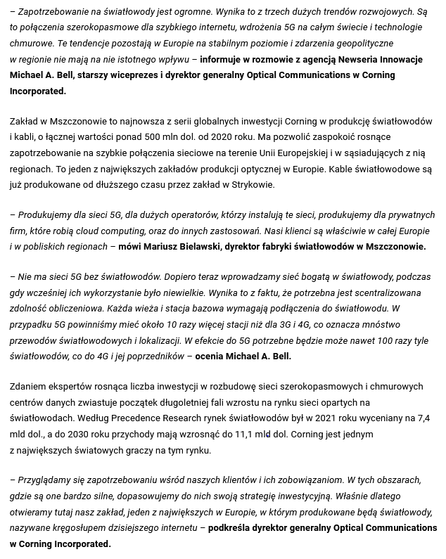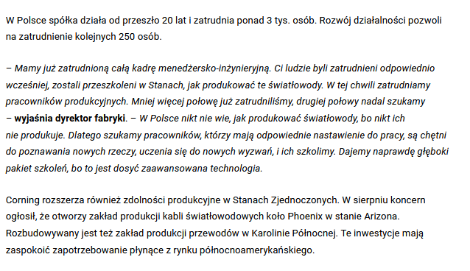
Date: 12 Sep 2022
Media: globaleconomy.pl
Media circulation: N/A
Article title: Expansion of 5G networks will drive demand for fiber optics. Their new factory in Mszczonów will serve Europe's largest customers
Link: https://globaleconomy.pl/cyfrowa-gospodarka/artykuly/39005-zapotrzebowanie-na-swiatlowody-jest-ogromne-rozbudowa-sieci-5g-napedzi-popyt-na-swiatlowody-z-mszczonowa-michael-a-bell-starszy-wiceprezes-i-dyrektor-generalny-optical-communications-w-corning-inc
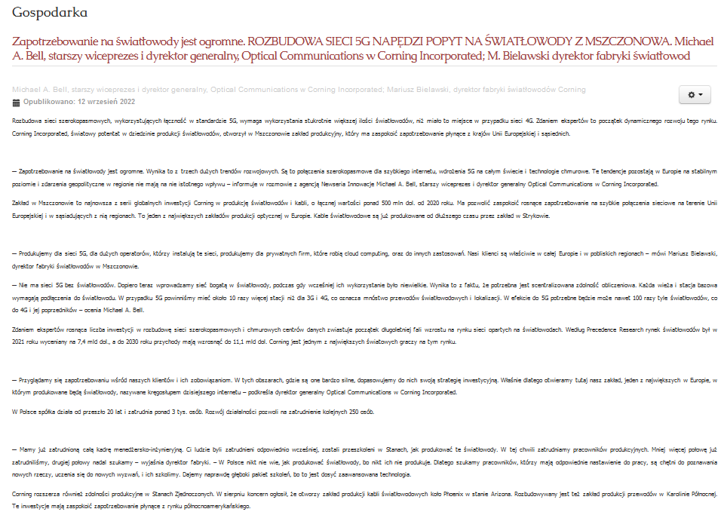

Date: 12 Sep 2022
Media: mikrokontroler.pl
Media circulation: 16.000 (monthly visitor traffic)
Article title: Expansion of 5G networks will drive demand for fiber optics. Their new factory in Mszczonów will serve Europe's largest customers
Link: https://mikrokontroler.pl/2022/09/12/rozbudowa-sieci-5g-napedzi-popyt-na-swiatlowody-ich-nowa-fabryka-w-mszczonowie-obsluzy-najwiekszych-odbiorcow-w-europie/
Print screen:
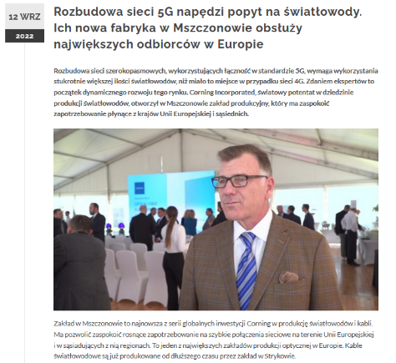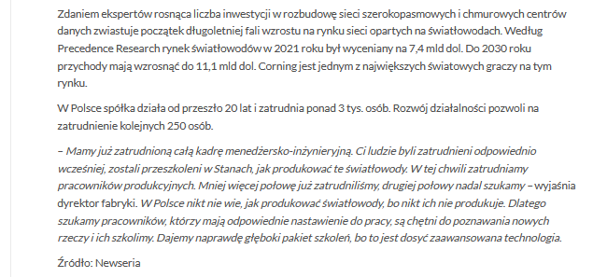

Date: 12 Sep 2022
Media: manager24.pl
Media circulation: N/A
Article title: Expansion of 5G networks will drive demand for fiber optics
Link: https://manager24.pl/rozbudowa-sieci-5g-napedzi-popyt-na-swiatlowody/?utm_source=rss&utm_medium=rss&utm_campaign=rozbudowa-sieci-5g-napedzi-popyt-na-swiatlowody
Print screen:
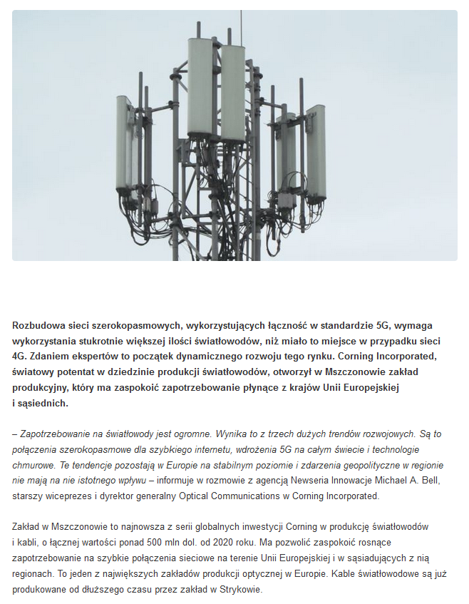
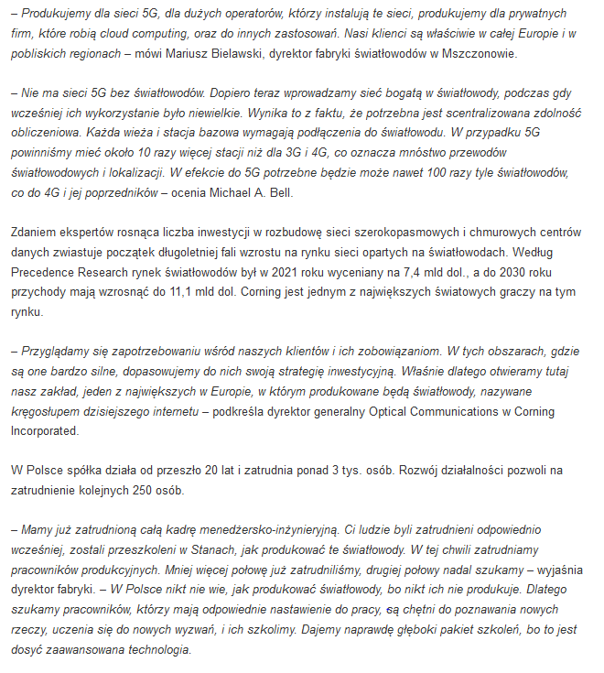

Date: 12 Sep 2022
Media: rzeczo.pl
Media circulation: N/A
Article title: Expansion of 5G networks will drive demand for fiber optics
Link: https://rzeczo.pl/rozbudowa-sieci-5g-napedzi-popyt-na-swiatlowody/
Print screen:
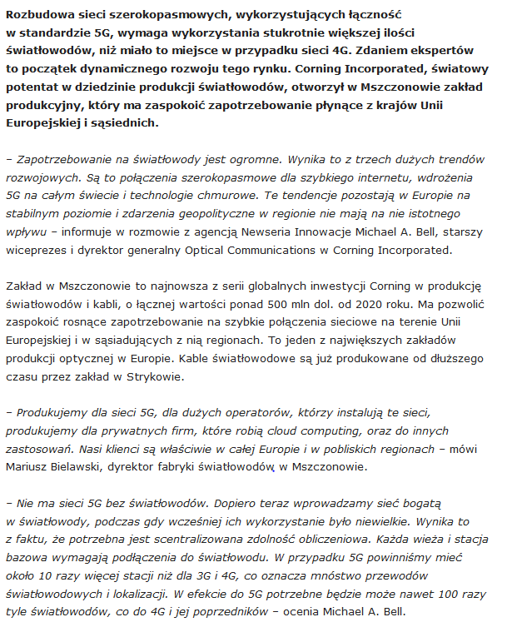

Date: 12 Sep 2022
Media: techno-senior.com
Media circulation: 37.000 (monthly visitor traffic)
Article title: Expansion of 5G networks will drive demand for fiber optics
Link: https://techno-senior.com/2022/09/12/polskie-5g-napedza-popyt-na-swiatlowody/
Print screen:
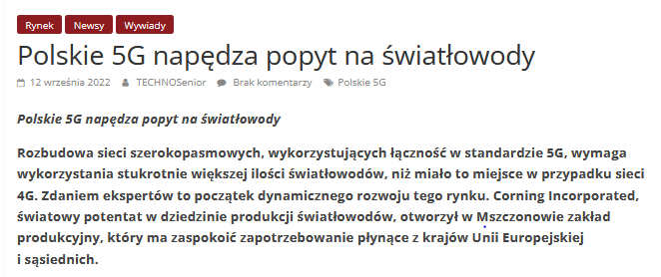
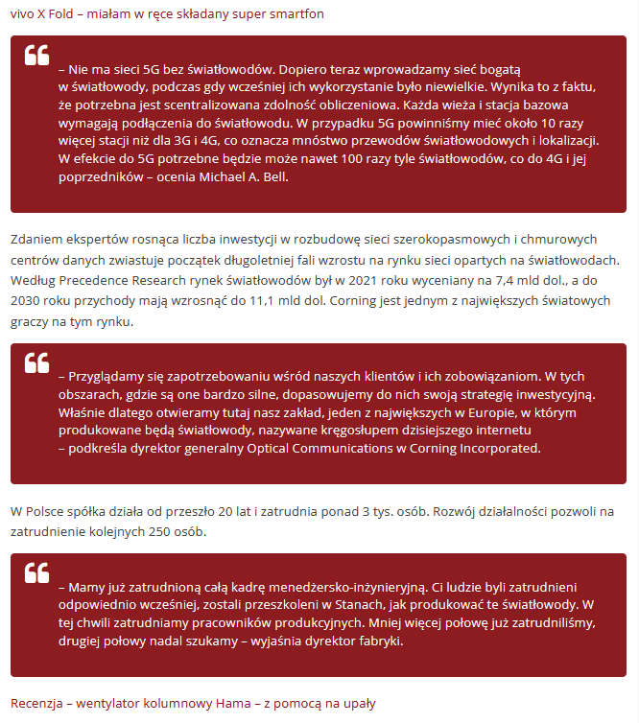
Date: 12 Sep 2022
Media: gsm.biz.pl
Media circulation: 2.700 (monthly visitor traffic)
Article title: Expansion of 5G networks will drive demand for fiber optics. Their new factory in Mszczonów will serve Europe's largest customers
Link: https://gsm.biz.pl/2022/09/12/rozbudowa-sieci-5g-napedzi-popyt-na-swiatlowody-ich-nowa-fabryka-w-mszczonowie-obsluzy-najwiekszych-odbiorcow-w-europie/
Print screen:
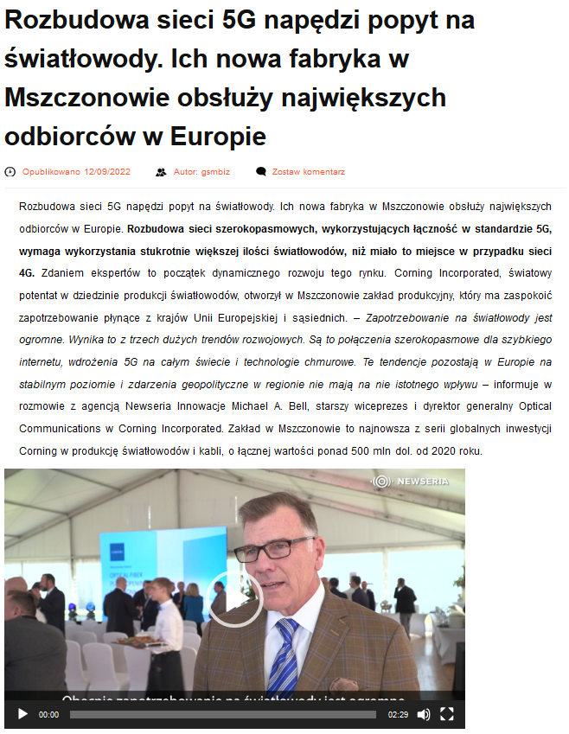
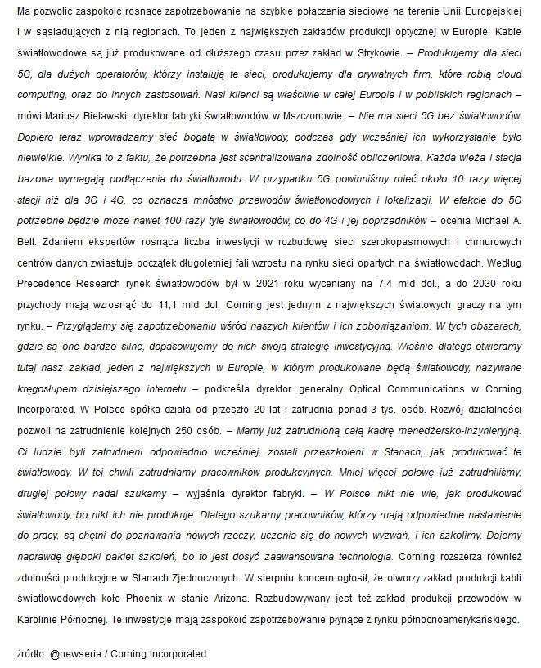

Date: 12 Sep 2022
Media: konto-oszczednosciowe.pl
Media circulation: N/A
Article title: Expansion of 5G networks will drive demand for fiber optics. Their new factory in Mszczonów will serve Europe's largest customers
Link: https://www.konto-oszczednosciowe.pl/rozbudowa-sieci-5g-napedzi-popyt-na-swiatlowody-ich-nowa-fabryka-w-mszczonowie-obsluzy-najwiekszych-odbiorcow-w-europie/
Print screen:
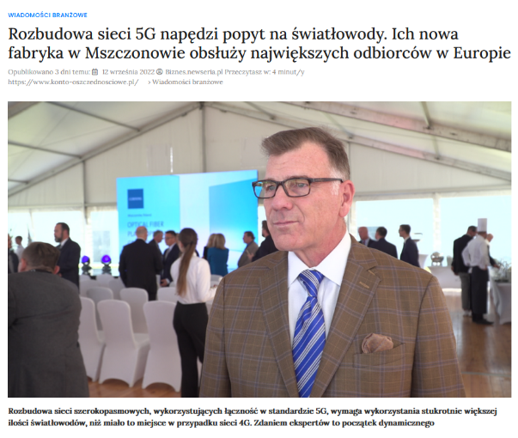
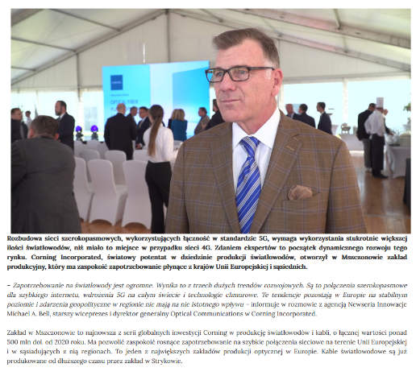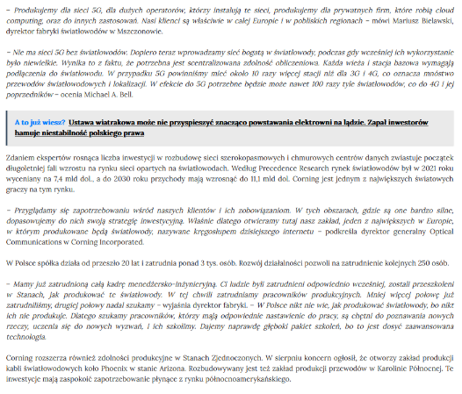

Date: 12 Sep 2022
Media: tei.pl
Media circulation: N/A
Article title: Expansion of 5G networks will drive demand for fiber optics. Their new factory in Mszczonów will serve Europe's largest customers
Link: https://www.tei.pl/rozbudowa-sieci-5g-napedzi-popyt-na-swiatlowody-ich-nowa-fabryka-w-mszczonowie-obsluzy-najwiekszych-odbiorcow-w-europie/
Print screen:
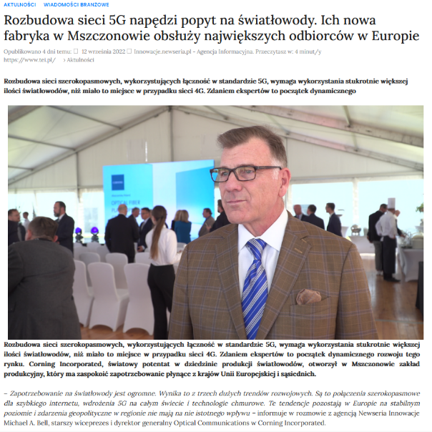
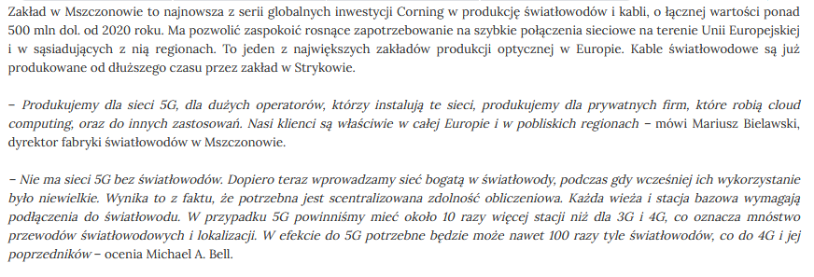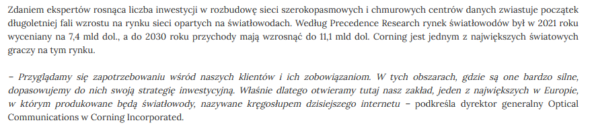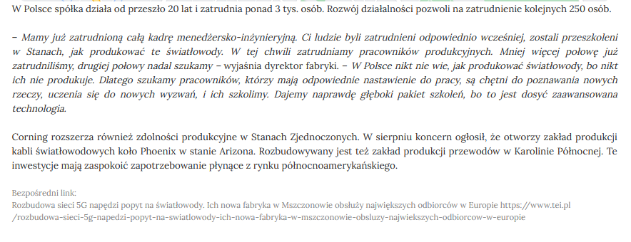

Date: 12 Sep 2022
Media: inzynierzy.pl
Media circulation: N/A
Article title: Expansion of 5G networks will drive demand for fiber optics. Their new factory in Mszczonów will serve Europe's largest customers
Link: https://www.inzynierzy.pl/inz/rozbudowa-sieci-5g-napedzi-popyt-na-swiatlowody-ich-nowa-fabryka-w-mszczonowie-obsluzy-najwiekszych-odbiorcow-w-europie/
Print screen:
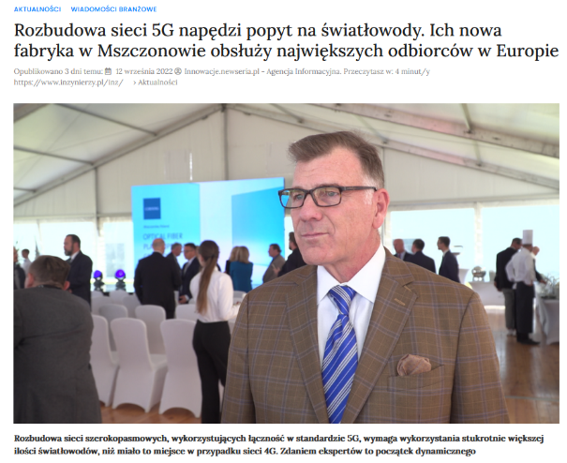
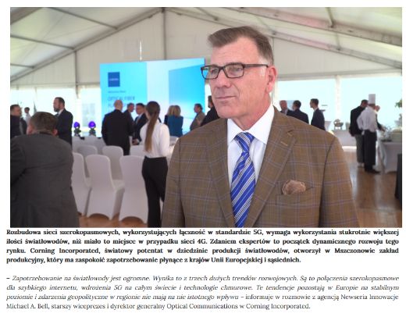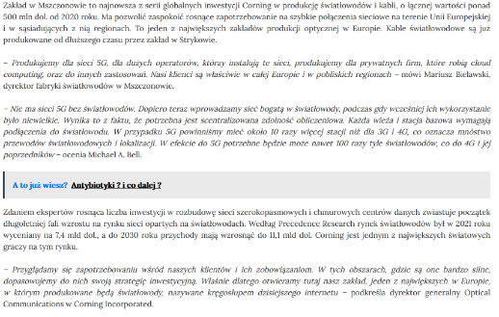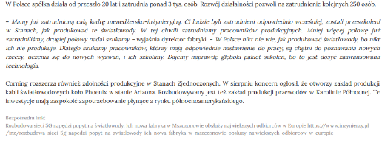

Date: 12 Sep 2022
Media: dlakobiet-info.pl
Media circulation: N/A
Article title: Expansion of 5G networks will drive demand for fiber optics. Their new factory in Mszczonów will serve Europe's largest customers
Link: https://www.dla-kobiet.info/uk/rozbudowa-sieci-5g-napedzi-popyt-na-swiatlowody-ich-nowa-fabryka-w-mszczonowie-obsluzy-najwiekszych-odbiorcow-w-europie-2/
Print screen:
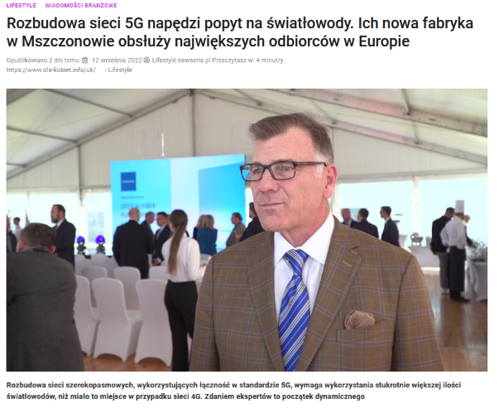
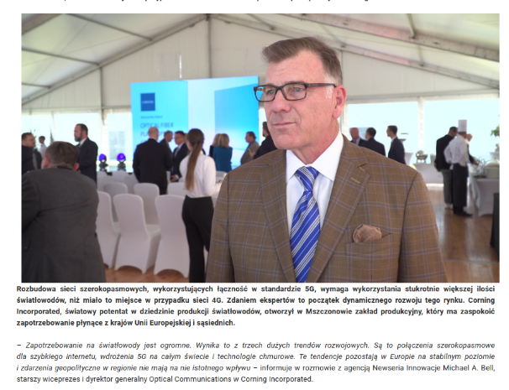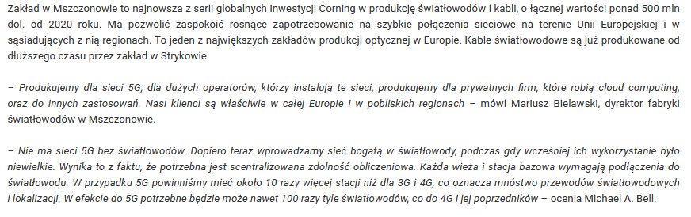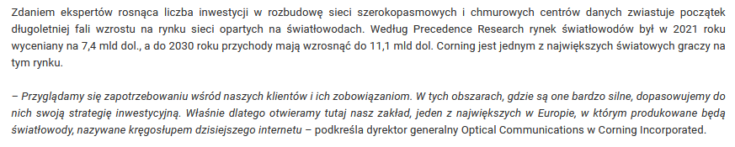

Date: 12 Sep 2022
Media: elektronicy.pl
Media circulation: N/A
Article title: Expansion of 5G networks will drive demand for fiber optics. Their new factory in Mszczonów will serve Europe's largest customers
Link: https://www.elektronicy.pl/rozbudowa-sieci-5g-napedzi-popyt-na-swiatlowody-ich-nowa-fabryka-w-mszczonowie-obsluzy-najwiekszych-odbiorcow-w-europie/
Print screen:
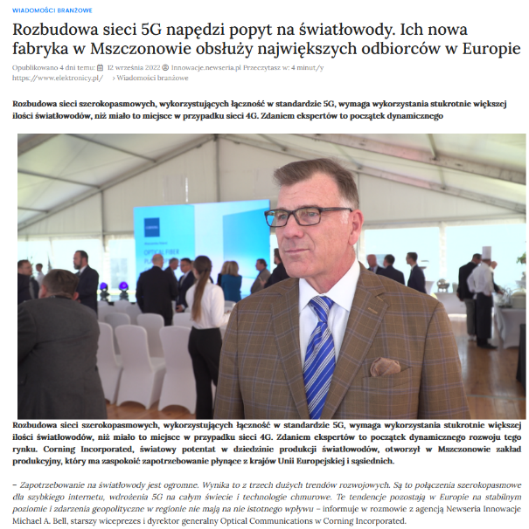
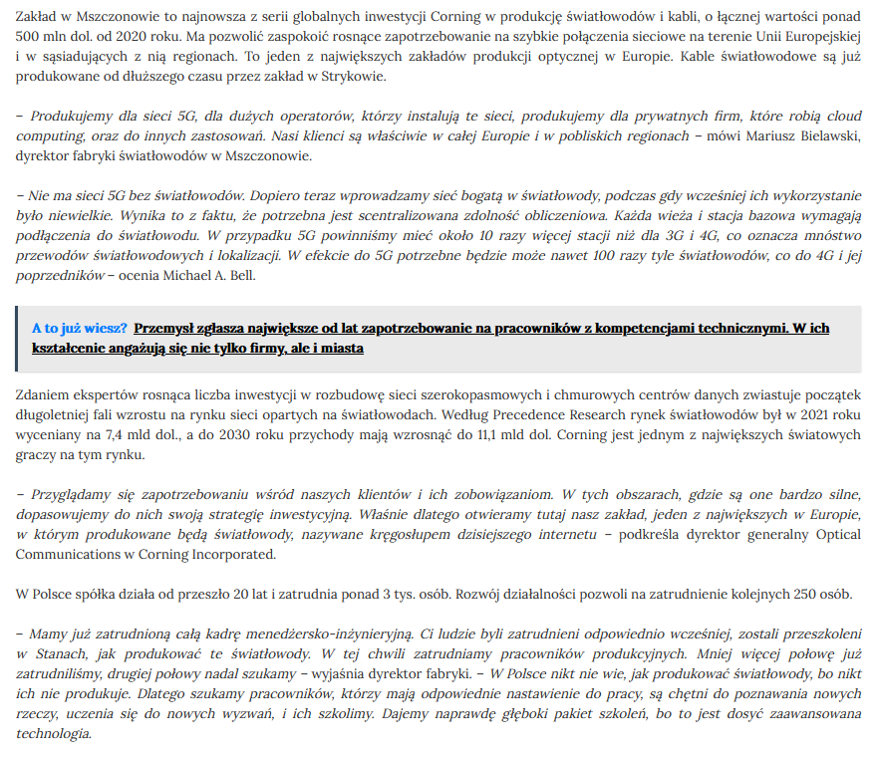

Date: 12 Sep 2022
Media: dpa.pl
Media circulation: N/A
Article title: Expansion of 5G networks will drive demand for fiber optics. Their new factory in Mszczonów will serve Europe's largest customers
Link: https://www.dpa.pl/rozbudowa-sieci-5g-napedzi-popyt-na-swiatlowody-ich-nowa-fabryka-w-mszczonowie-obsluzy-najwiekszych-odbiorcow-w-europie/
Print screen:
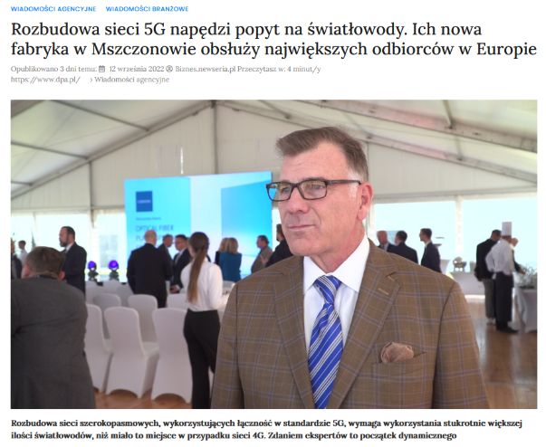
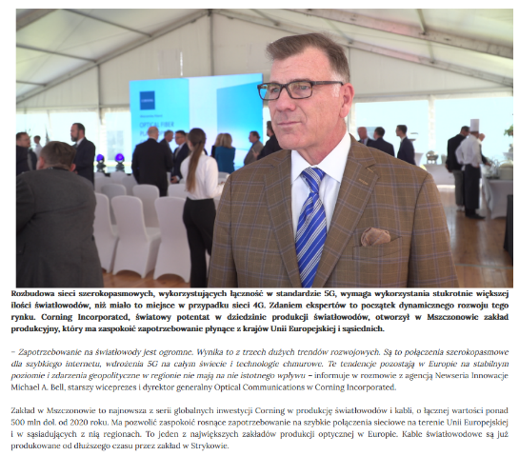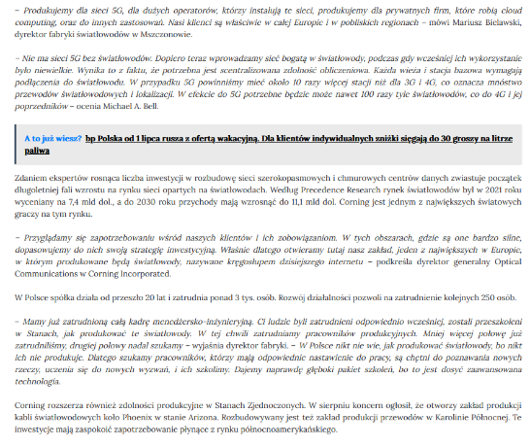

Date: 12 Sep 2022
Media: radioswinoujscie.pl
Media circulation: 4.200 (monthly visitor traffic)
Article title: Expansion of 5G networks will drive demand for fiber optics. Their new factory in Mszczonów will serve Europe's largest customers
Link: https://radioswinoujscie.pl/rozbudowa-sieci-5g-napedzi-popyt-na-swiatlowody-ich-nowa-fabryka-w-mszczonowie-obsluzy-najwiekszych-odbiorcow-w-europie/
Print screen:
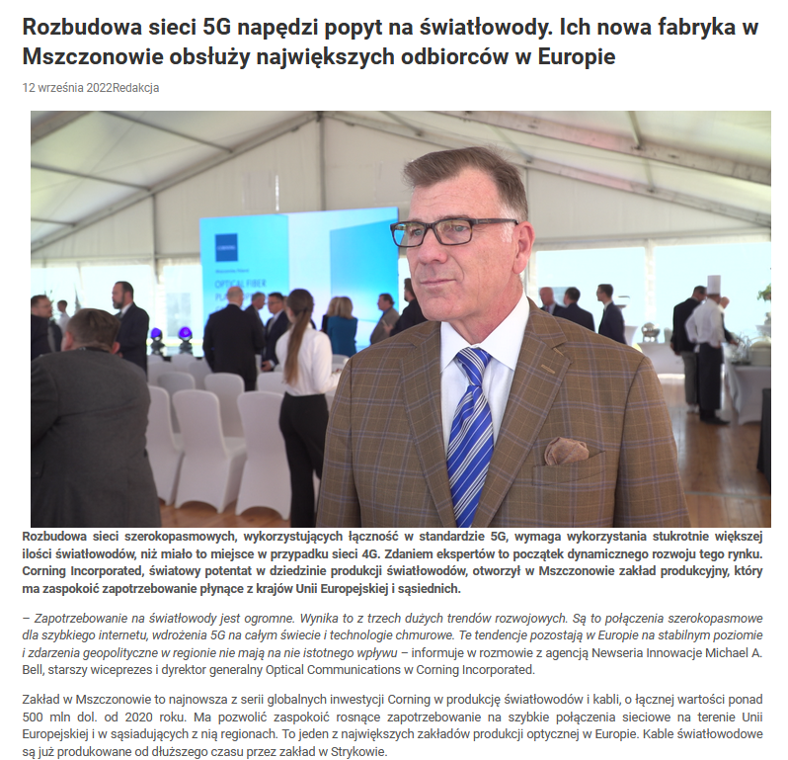
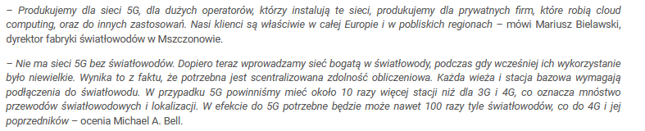
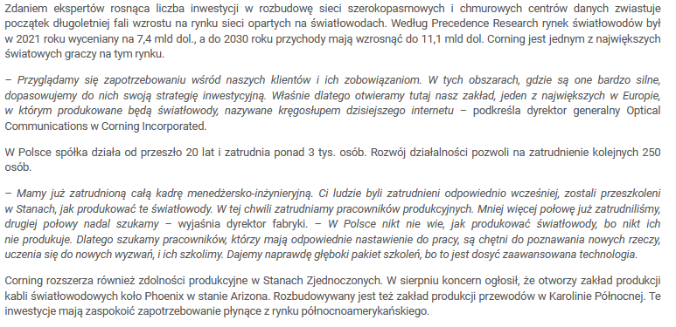

Date: 12 Sep 2022
Media: edytorstwo.pl
Media circulation: N/A
Article title: Expansion of 5G networks will drive demand for fiber optics. Their new factory in Mszczonów will serve Europe's largest customers
Link: https://www.edytorstwo.pl/rozbudowa-sieci-5g-napedzi-popyt-na-swiatlowody-ich-nowa-fabryka-w-mszczonowie-obsluzy-najwiekszych-odbiorcow-w-europie/
Print screen:
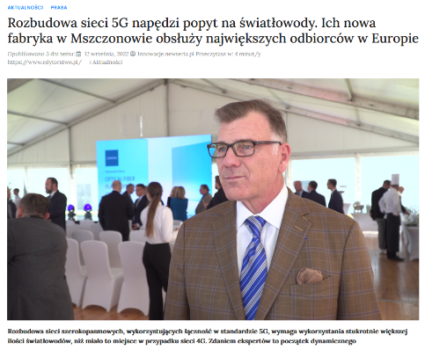
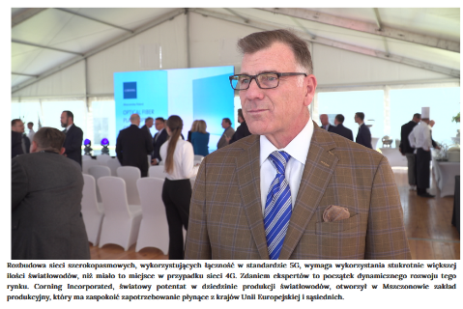
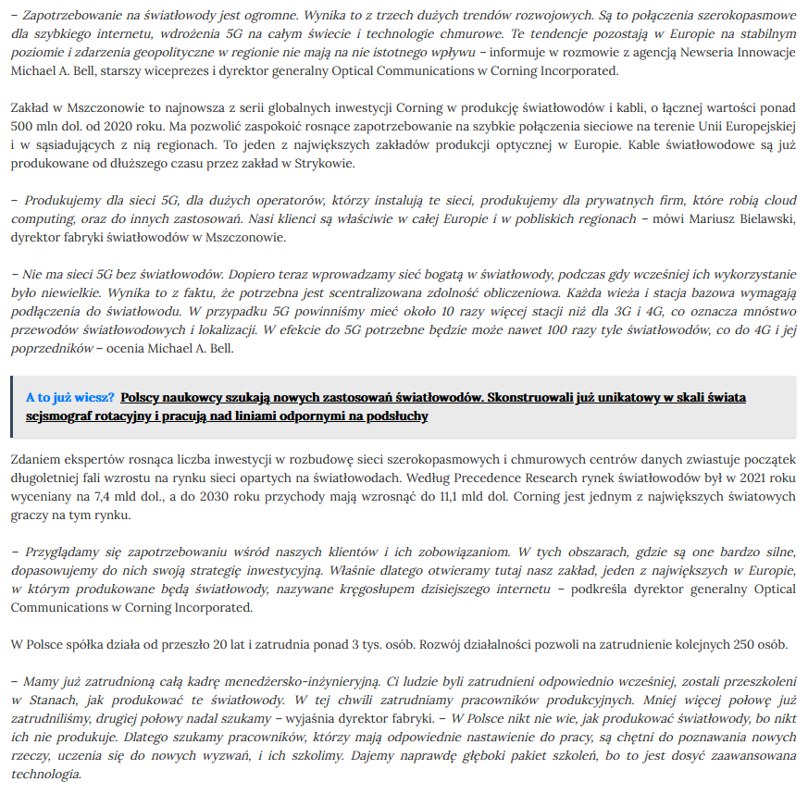

Date: 12 Sep 2022
Media: dionizy.pl
Media circulation: N/A
Article title: Expansion of 5G networks will drive demand for fiber optics. Their new factory in Mszczonów will serve Europe's largest customers
Link: https://www.dionizy.pl/rozbudowa-sieci-5g-napedzi-popyt-na-swiatlowody-ich-nowa-fabryka-w-mszczonowie-obsluzy-najwiekszych-odbiorcow-w-europie/
Print screen:
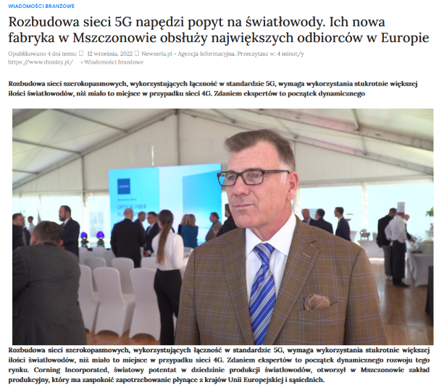
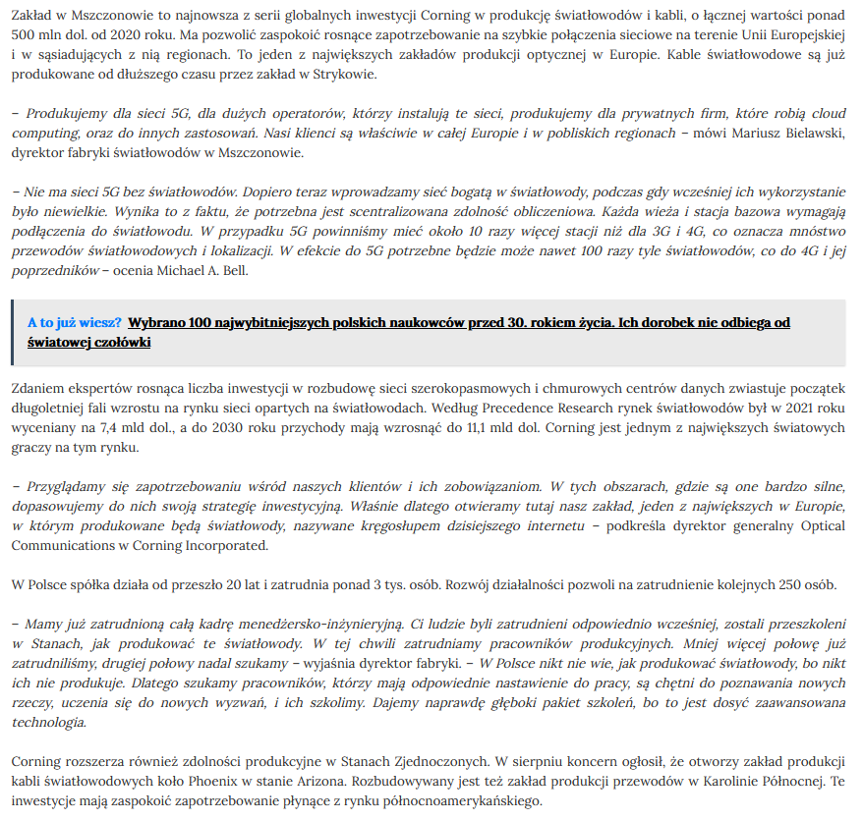

Date: 12 Sep 2022
Media: wiarygodni.pl
Media circulation: N/A
Article title: Expansion of 5G networks will drive demand for fiber optics. Their new factory in Mszczonów will serve Europe's largest customers
Link: https://www.wiarygodni.pl/w/rozbudowa-sieci-5g-napedzi-popyt-na-swiatlowody-ich-nowa-fabryka-w-mszczonowie-obsluzy-najwiekszych-odbiorcow-w-europie/
Print screen:
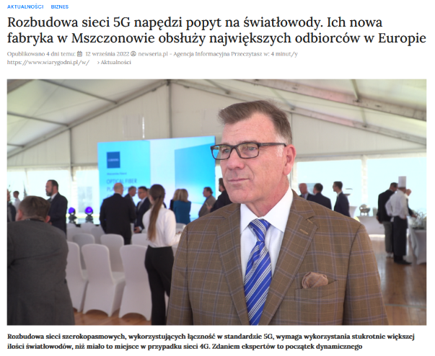
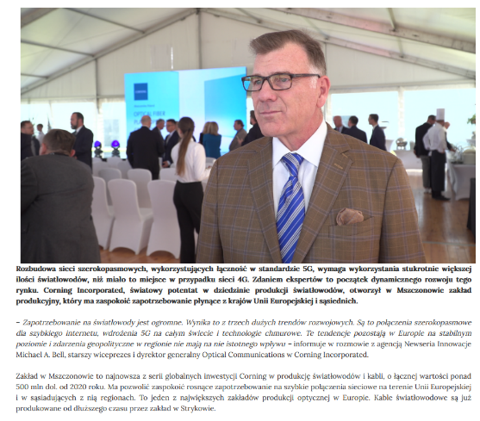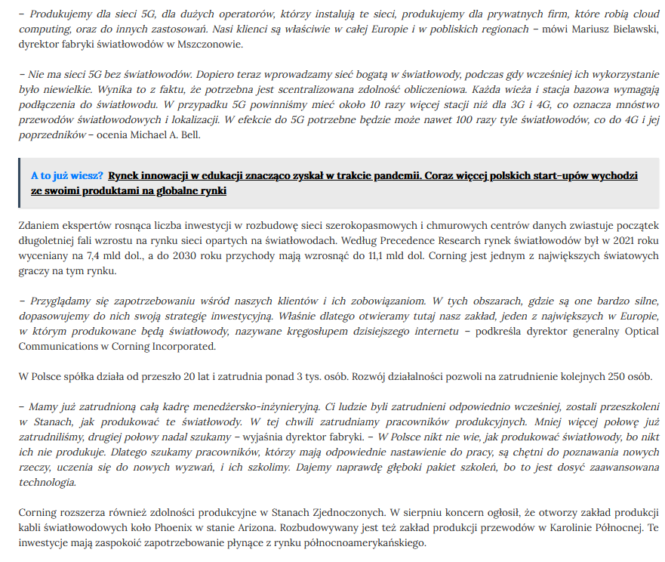

Date: 12 Sep 2022
Media: kontoonline.pl
Media circulation: N/A
Article title: Expansion of 5G networks will drive demand for fiber optics. Their new factory in Mszczonów will serve Europe's largest customers
Link: https://www.kontoonline.pl/rozbudowa-sieci-5g-napedzi-popyt-na-swiatlowody-ich-nowa-fabryka-w-mszczonowie-obsluzy-najwiekszych-odbiorcow-w-europie/
Print screen:
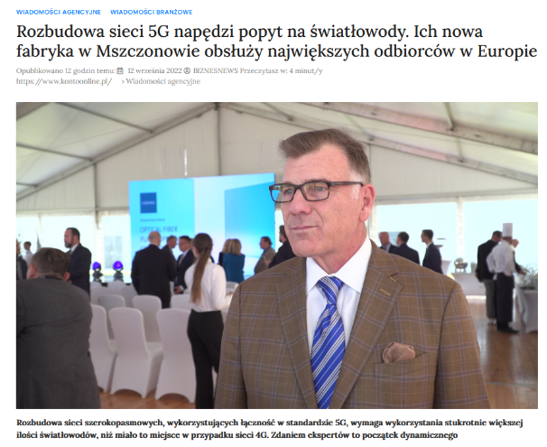
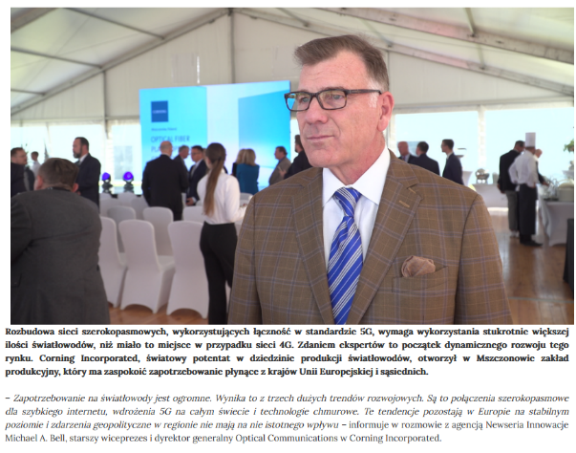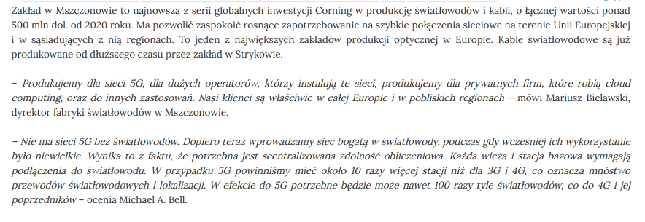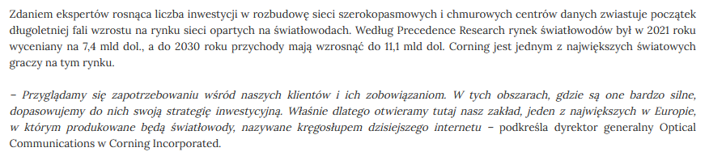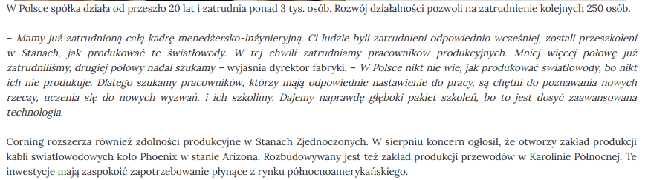
Date: 12 Sep 2022
Media: rbg.pl
Media circulation: N/A
Article title: Expansion of 5G networks will drive demand for fiber optics. Their new factory in Mszczonów will serve Europe's largest customers
Link: https://www.rbg.pl/biz/rozbudowa-sieci-5g-napedzi-popyt-na-swiatlowody-ich-nowa-fabryka-w-mszczonowie-obsluzy-najwiekszych-odbiorcow-w-europie/
Print screen:
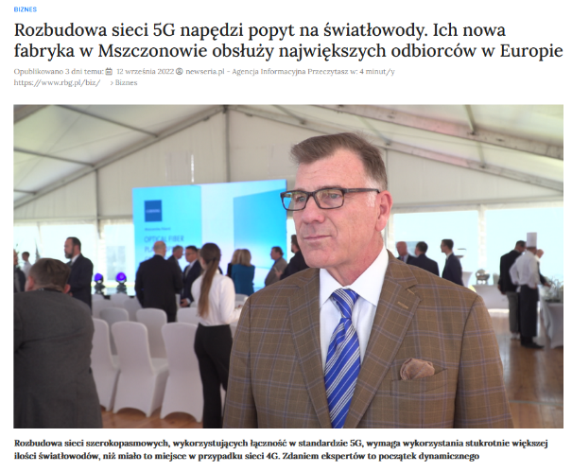
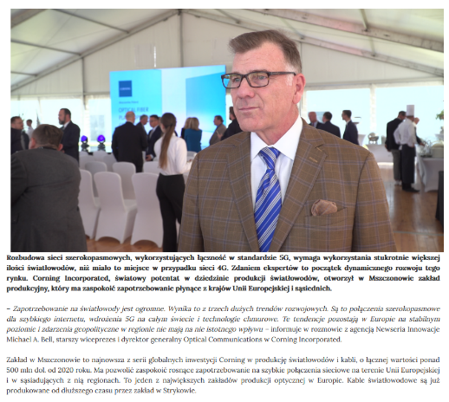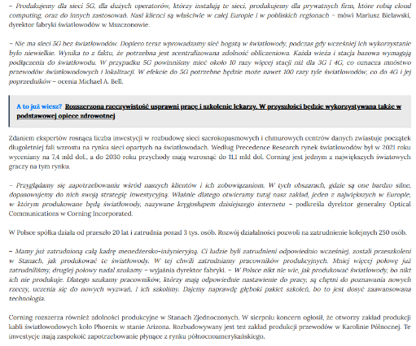

Date: 12 Sep 2022
Media: konto-inwestycyjne.pl
Media circulation: N/A
Article title: Expansion of 5G networks will drive demand for fiber optics. Their new factory in Mszczonów will serve Europe's largest customers
Link: https://www.konto-inwestycyjne.pl/rozbudowa-sieci-5g-napedzi-popyt-na-swiatlowody-ich-nowa-fabryka-w-mszczonowie-obsluzy-najwiekszych-odbiorcow-w-europie/
Print screen:
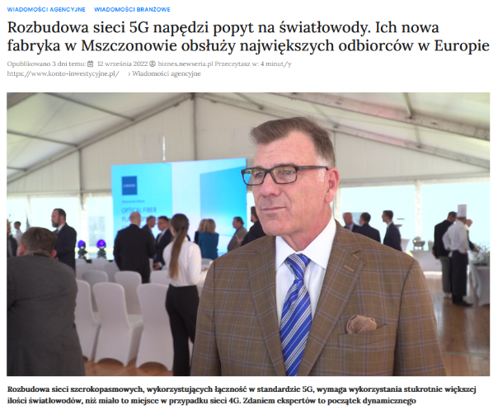
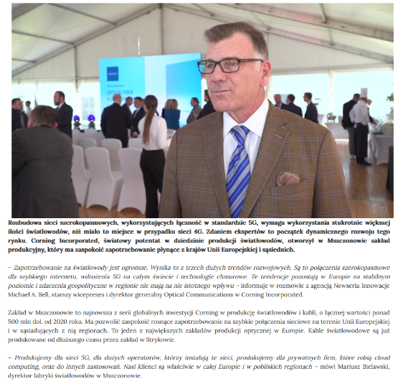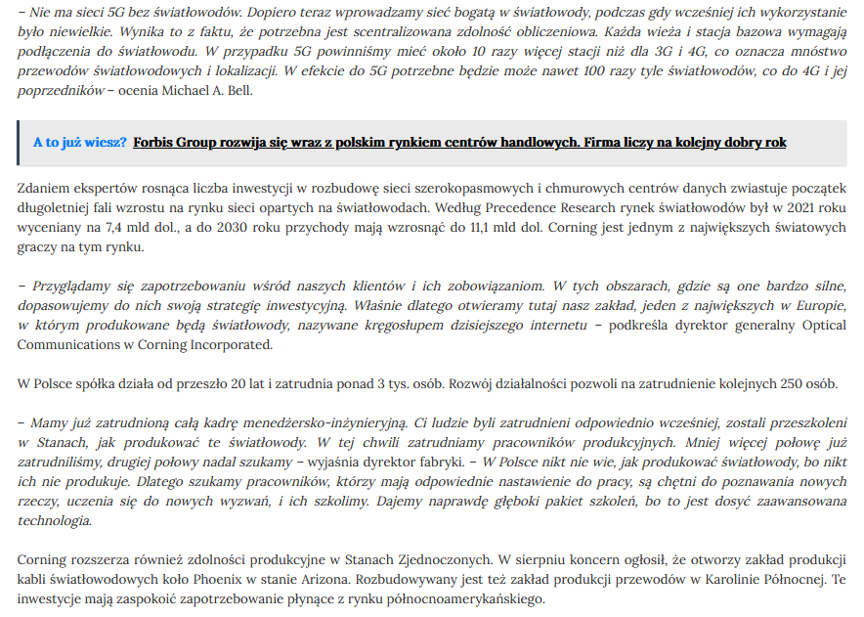

Date: 12 Sep 2022
Media: kontooszczednosciowe.pl
Media circulation: N/A
Article title: Expansion of 5G networks will drive demand for fiber optics. Their new factory in Mszczonów will serve Europe's largest customers
Link: https://www.kontooszczednosciowe.pl/rozbudowa-sieci-5g-napedzi-popyt-na-swiatlowody-ich-nowa-fabryka-w-mszczonowie-obsluzy-najwiekszych-odbiorcow-w-europie/
Print screen:
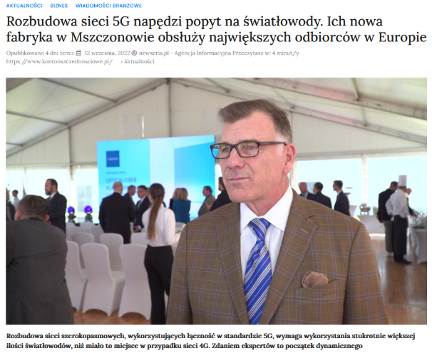
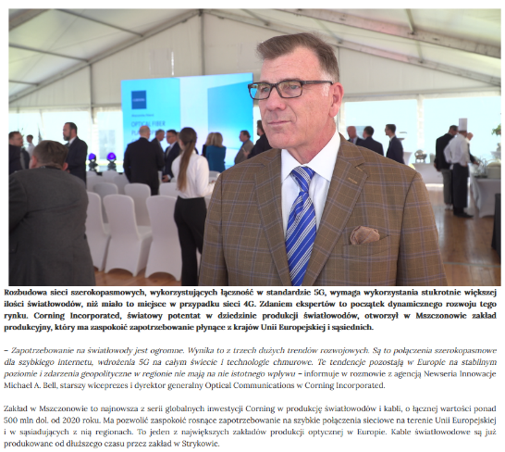
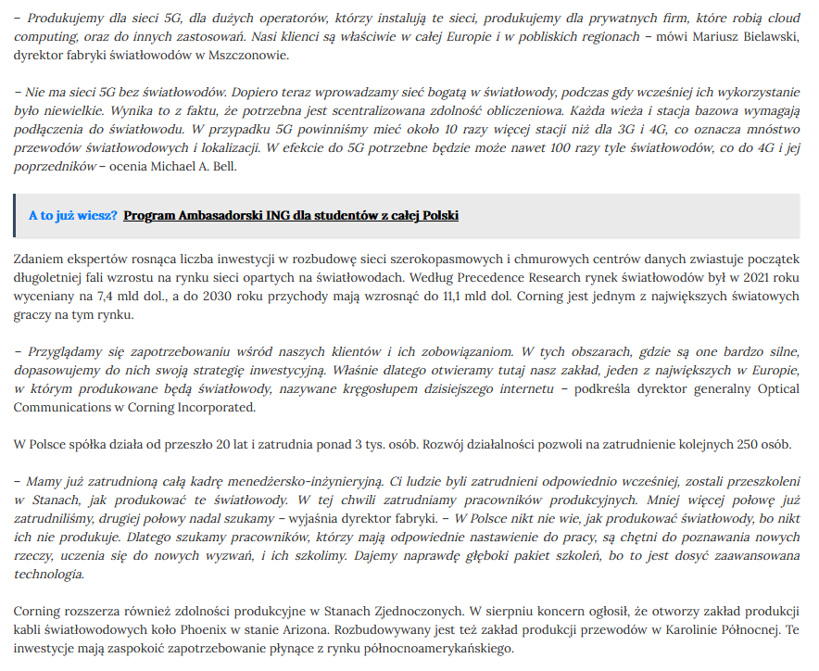

Date: 12 Sep 2022
Media: biuro-maklerskie.pl
Media circulation: N/A
Article title: Expansion of 5G networks will drive demand for fiber optics. Their new factory in Mszczonów will serve Europe's largest customers
Link: https://www.biuro-maklerskie.pl/rozbudowa-sieci-5g-napedzi-popyt-na-swiatlowody-ich-nowa-fabryka-w-mszczonowie-obsluzy-najwiekszych-odbiorcow-w-europie/
Print screen:
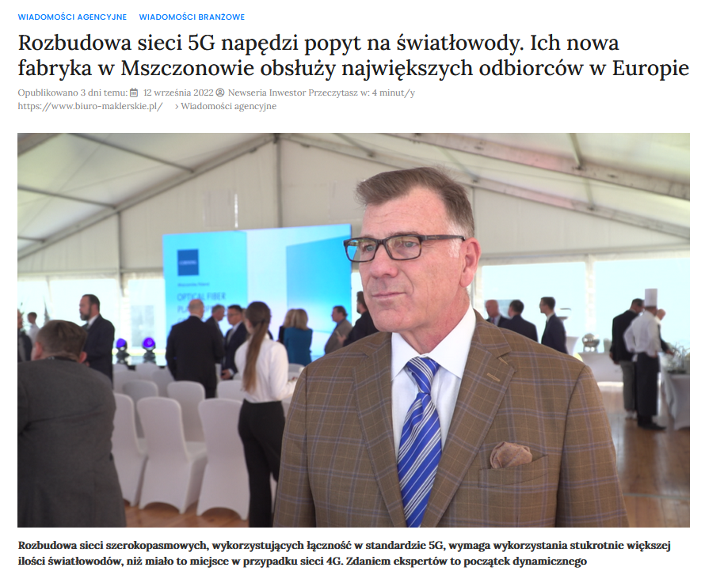
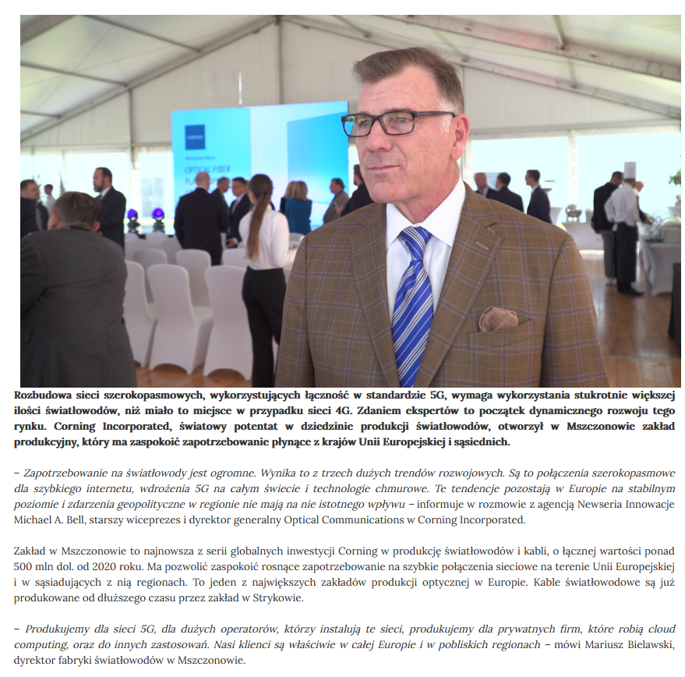
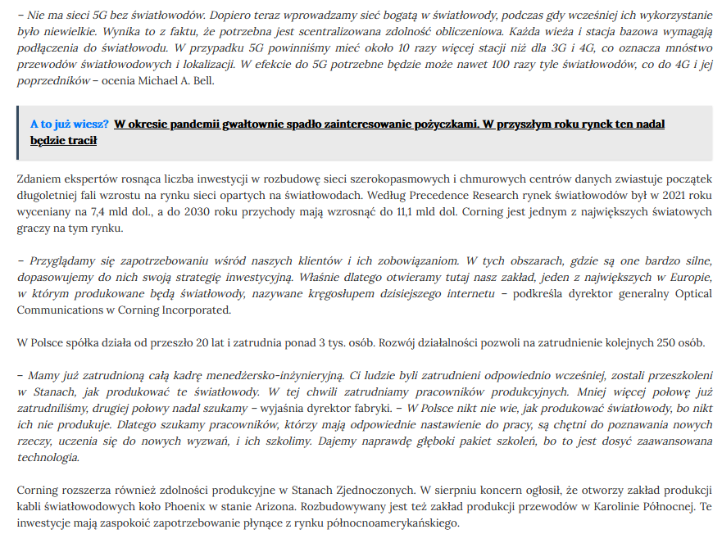

Date: 12 Sep 2022
Media: doplata.pl
Media circulation: N/A
Article title: Expansion of 5G networks will drive demand for fiber optics. Their new factory in Mszczonów will serve Europe's largest customers
Link: https://www.doplata.pl/rozbudowa-sieci-5g-napedzi-popyt-na-swiatlowody-ich-nowa-fabryka-w-mszczonowie-obsluzy-najwiekszych-odbiorcow-w-europie/
Print screen:
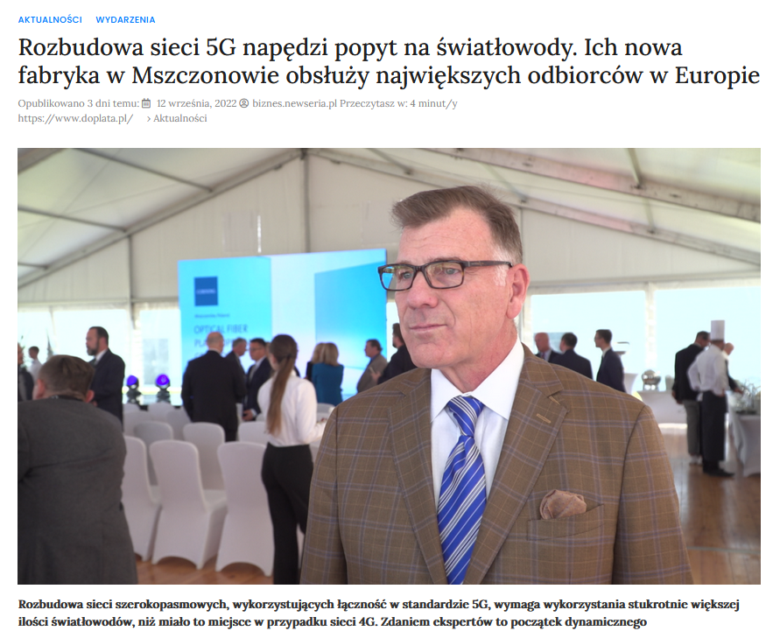
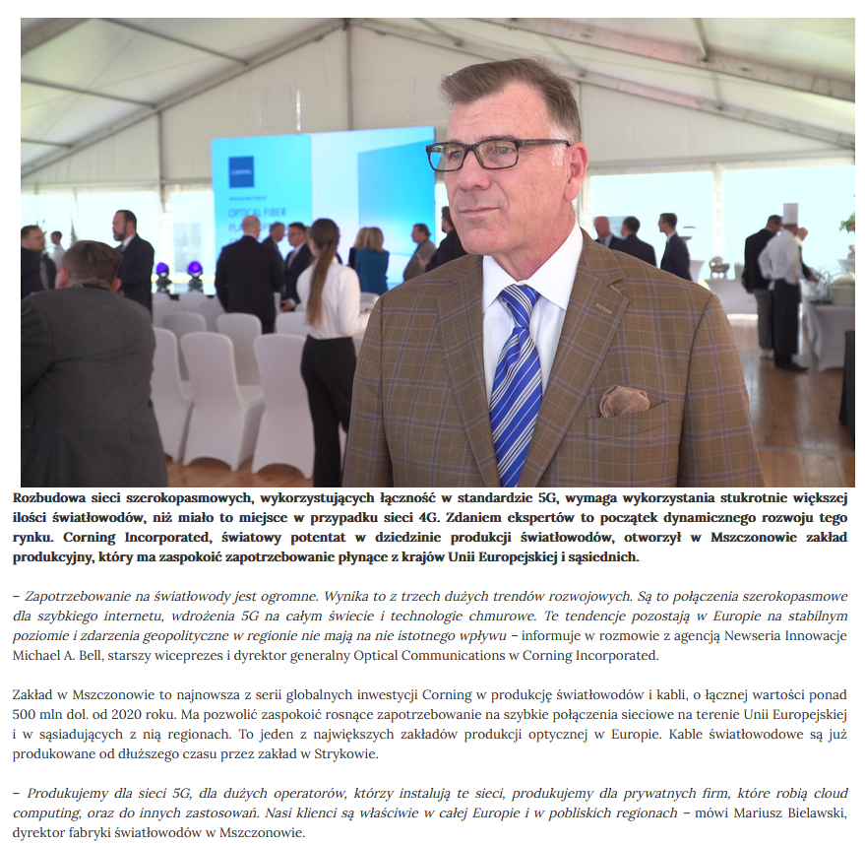
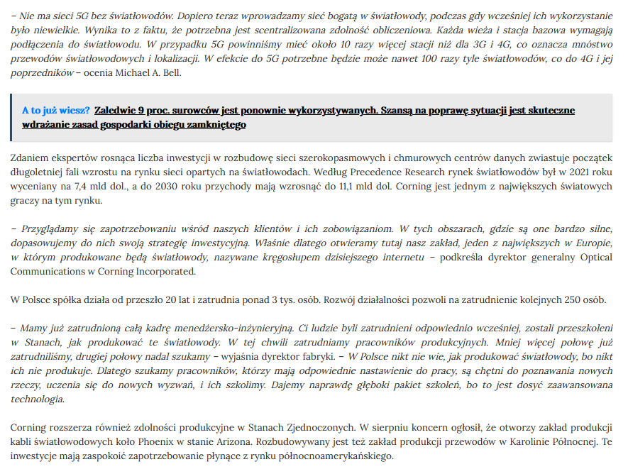

Date: 12 Sep 2022
Media: pozyczamy.pl
Media circulation: N/A
Article title: Expansion of 5G networks will drive demand for fiber optics. Their new factory in Mszczonów will serve Europe's largest customers
Link: https://www.pozyczamy.pl/rozbudowa-sieci-5g-napedzi-popyt-na-swiatlowody-ich-nowa-fabryka-w-mszczonowie-obsluzy-najwiekszych-odbiorcow-w-europie/
Print screen:
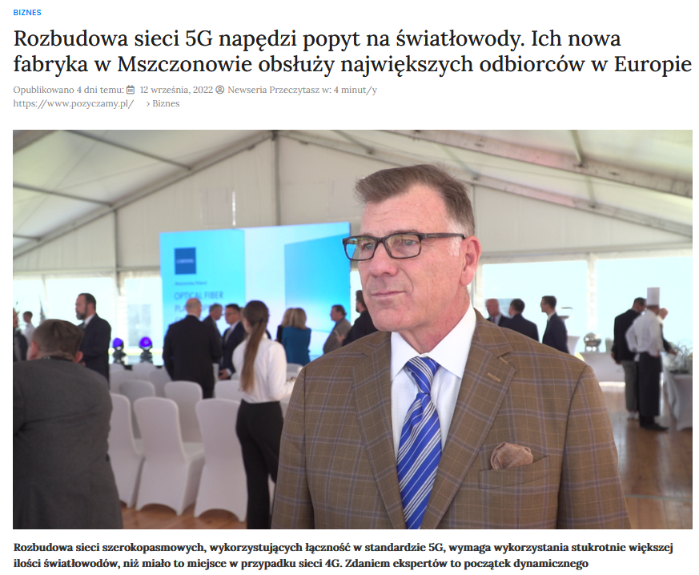
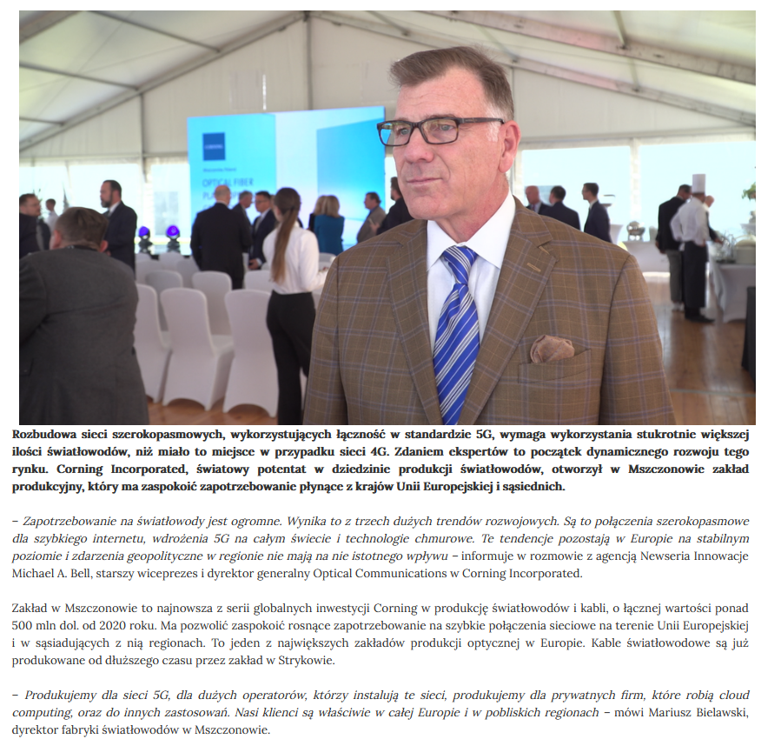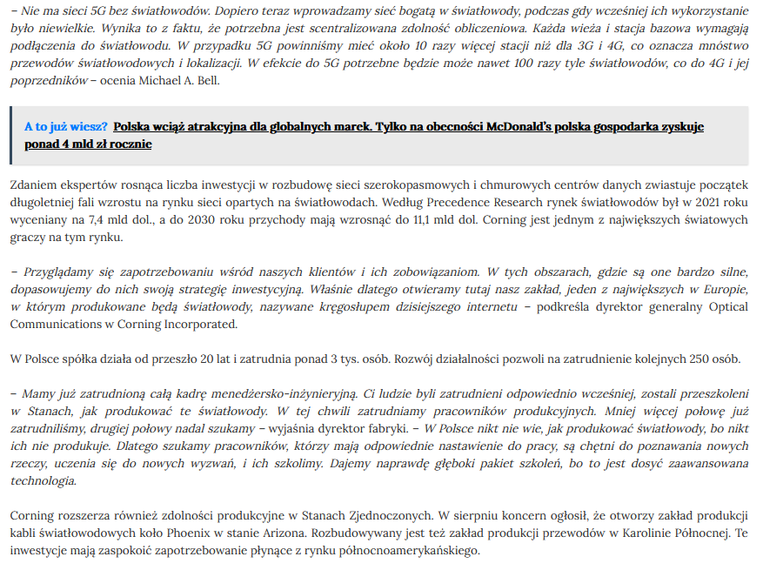

Date: 12 Sep 2022
Media: ex-p.pl
Media circulation: NA
Article title: Expansion of 5G networks will drive demand for fiber optics. Their new factory in Mszczonów will serve Europe's largest customers
Link: https://www.ex-p.pl/2022/09/12/rozbudowa-sieci-5g-napedzi-popyt-na-swiatlowody-ich-nowa-fabryka-w-mszczonowie-obsluzy-najwiekszych-odbiorcow-w-europie/
Print screen:
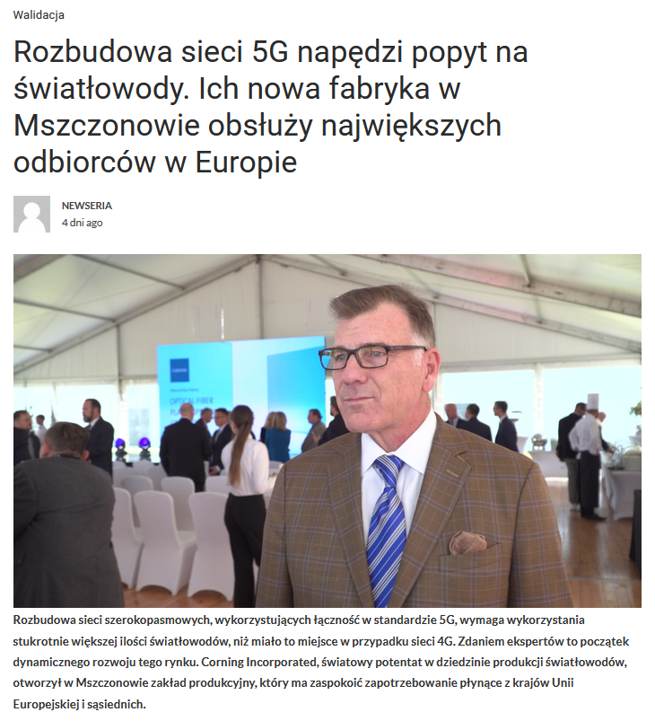
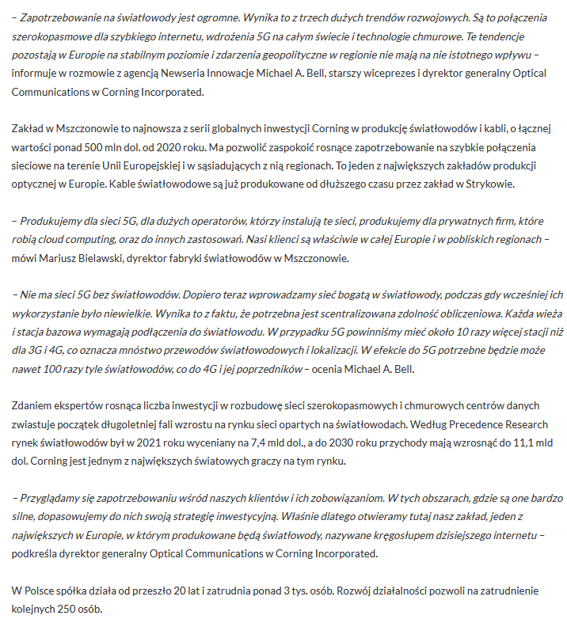

Date: 12 Sep 2022
Media: priot24.net
Media circulation: N/A
Article title: Expansion of 5G networks will drive demand for fiber optics. Their new factory in Mszczonów will serve Europe's largest customers
Link: http://www.patriot24.net/video-rozbudowa-sieci-5g-napedzi-popyt-na-swiatlowody-ich-nowa-fabryka-w-mszczonowie-obsluzy-najwiekszych-odbiorcow-w-europie,30666
Print screen:
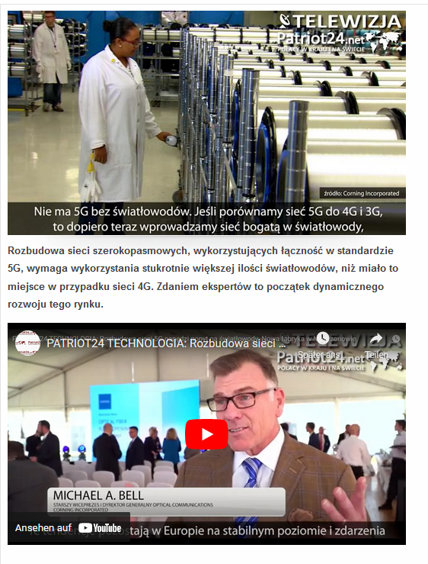
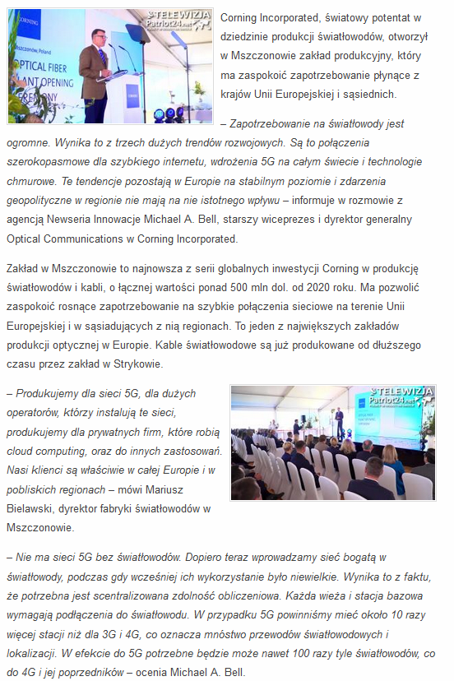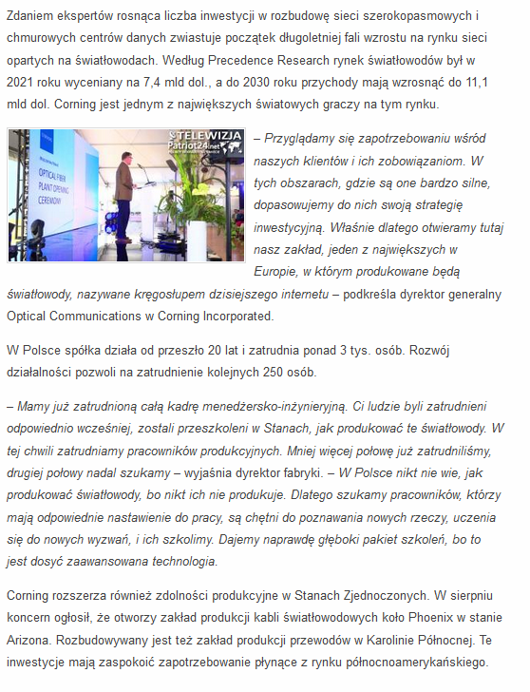

Date: 12 Sep 2022
Media: kontoemerytalne.pl
Media circulation: N/A
Article title: Expansion of 5G networks will drive demand for fiber optics. Their new factory in Mszczonów will serve Europe's largest customers
Link: https://www.kontoemerytalne.pl/rozbudowa-sieci-5g-napedzi-popyt-na-swiatlowody-ich-nowa-fabryka-w-mszczonowie-obsluzy-najwiekszych-odbiorcow-w-europie/
Print screen:
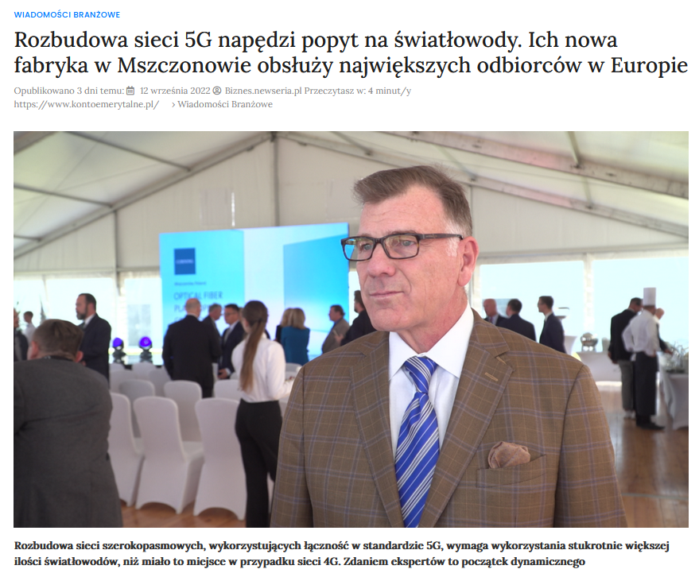
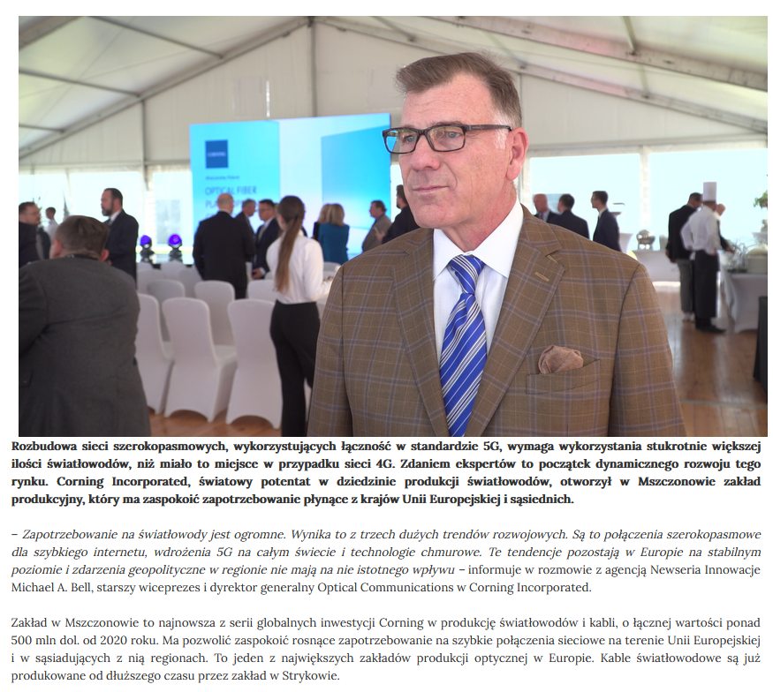

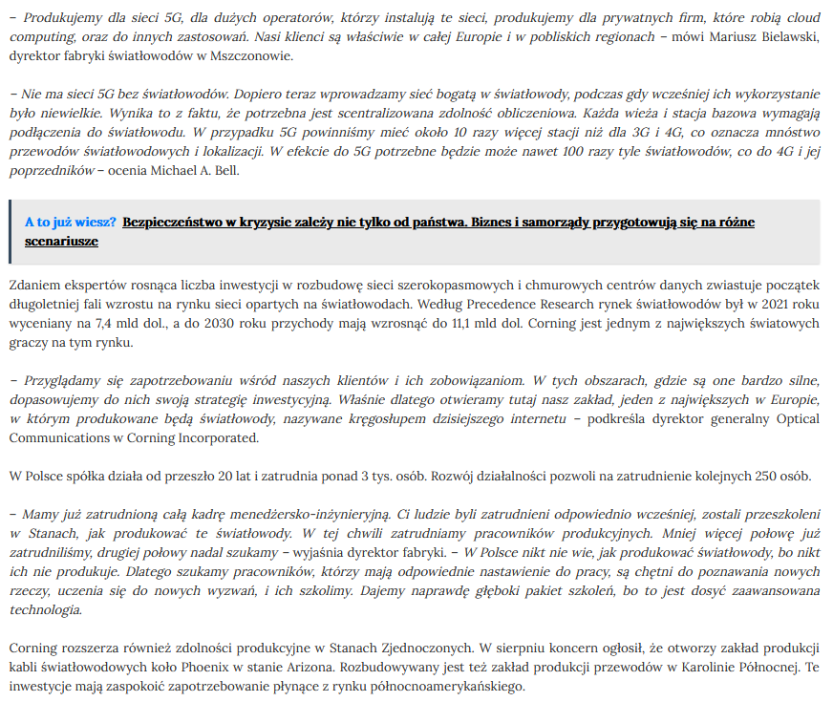

Date: 12 Sep 2022
Media: dostawcy-internetu.pl
Media circulation: 60.200 (monthly visitor traffic)
Article title: Expansion of 5G networks will drive demand for fiber optics. Their new factory in Mszczonów will serve Europe's largest customers
Link: https://www.dostawcy-internetu.pl/aktualnosci/1/20657/Rozbudowa-sieci-5G-napedzi-popyt-na-swiatlowody--Ich-nowa-fabryka-w-Mszczonowie-obsluzy-najwiekszych-odbiorcow-w-Europie.html
Print screen:
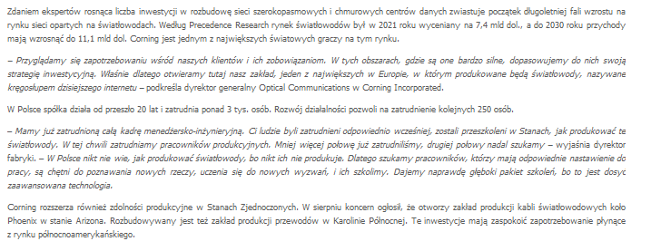

Date: 12 Sep 2022
Media: apq.pl
Media circulation: N/A
Article title: Expansion of 5G networks will drive demand for fiber optics. Their new factory in Mszczonów will serve Europe's largest customers
Link: http://apq.pl/rozbudowa-sieci-5g-napedzi-popyt-na-swiatlowody-ich-nowa-fabryka-w-mszczonowie-obsluzy-najwiekszych-odbiorcow-w-europie/
Print screen:
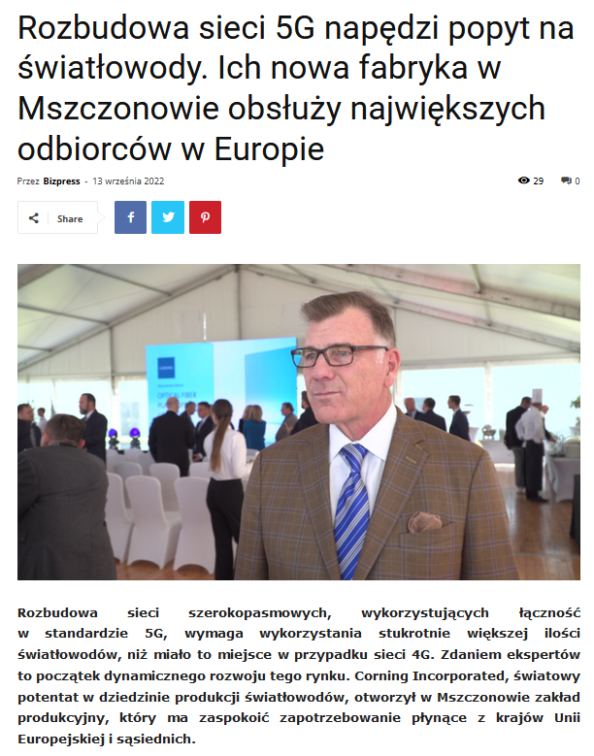
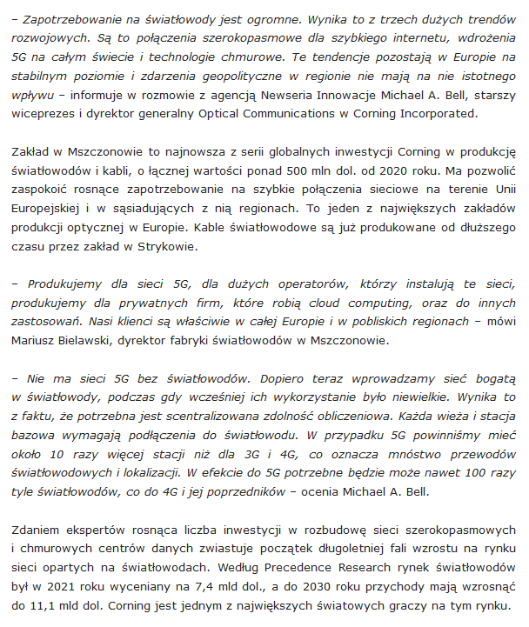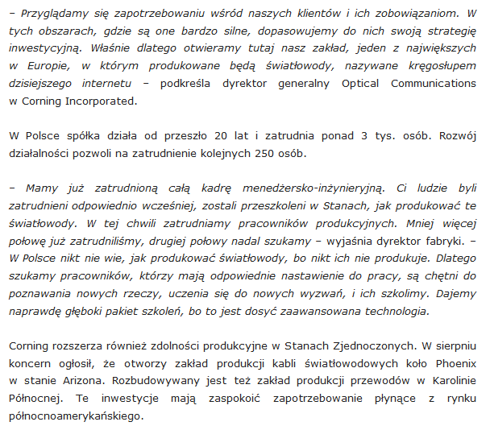
Date: 12 Sep 2022
Media: grabaty.pl
Media circulation: N/A
Article title: Expansion of 5G networks will drive demand for fiber optics. Their new factory in Mszczonów will serve Europe's largest customers
Link: https://grabaty.pl/rozbudowa-sieci-5g-napedzi-popyt-na-swiatlowody-ich-nowa-fabryka-w-mszczonowie-obsluzy-najwiekszych-odbiorcow-w-europie/
Print screen:
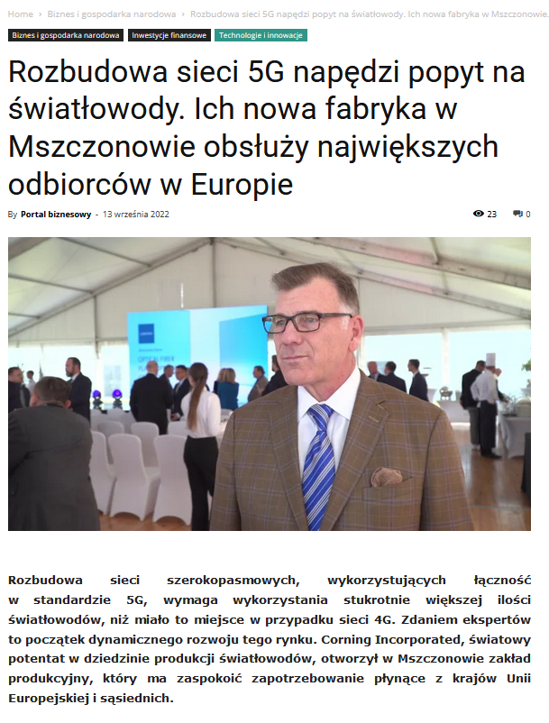
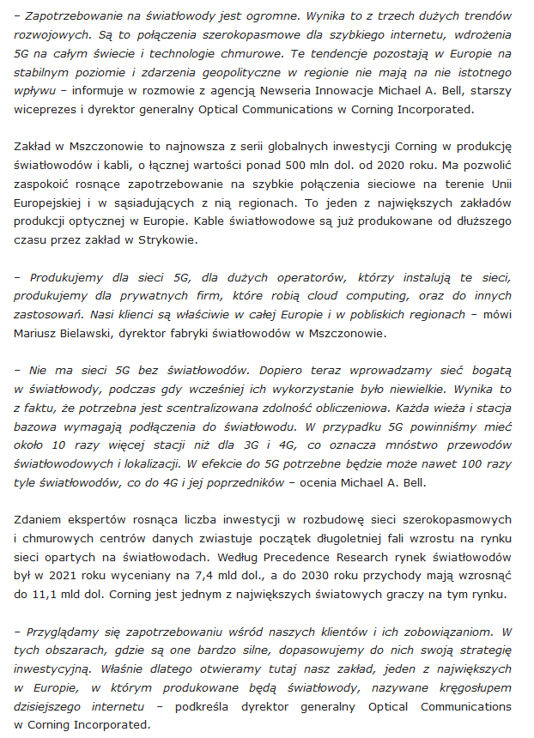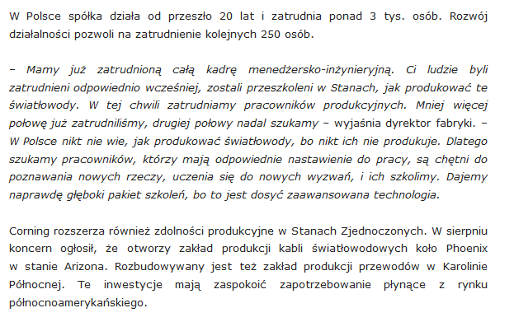
Date: 12 Sep 2022
Media: hvacpr.pl
Media circulation: N/A
Article title: Expansion of 5G networks will drive demand for fiber optics
Link: https://hvacpr.pl/wiadomosci/rozbudowa-sieci-5g-napedzi-popyt-na-swiatlowody
Print screen:
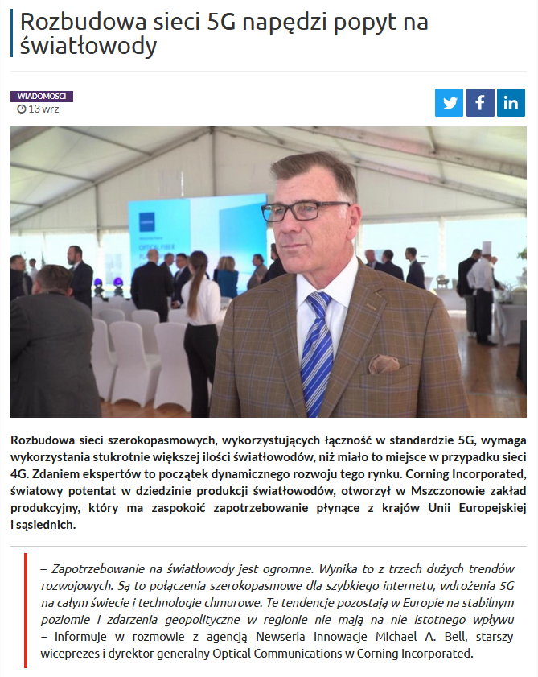
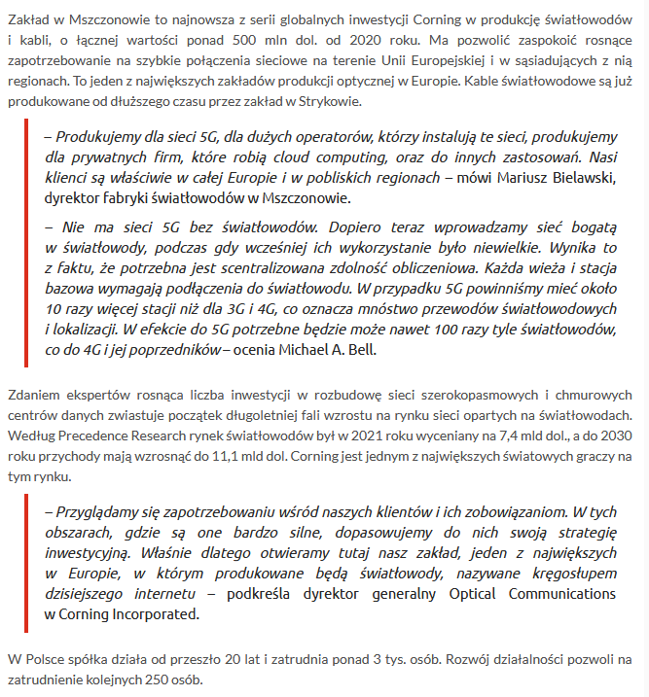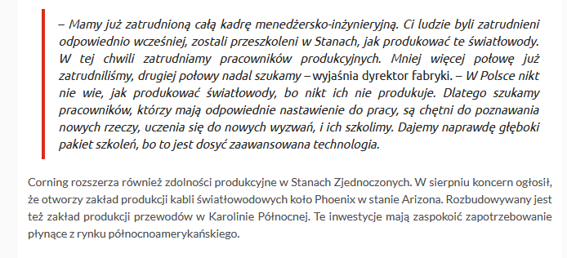

Date: 12 Sep 2022
Media: glowny-mechanik.pl
Media circulation: 10.900 (monthly visitor traffic)
Article title: Expansion of 5G networks will drive demand for fiber optics. Their new factory in Mszczonów will serve Europe's largest customers
Link: https://glowny-mechanik.pl/2022/09/13/rozbudowa-sieci-5g-napedzi-popyt-na-swiatlowody-ich-nowa-fabryka-w-mszczonowie-obsluzy-najwiekszych-odbiorcow-w-europie/?sfw=pass1663049297
Print screen:
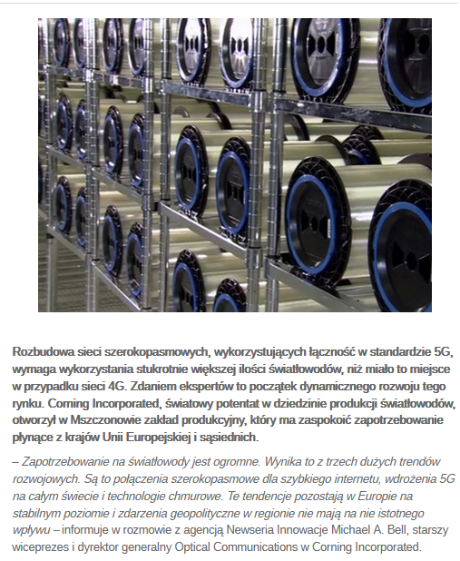
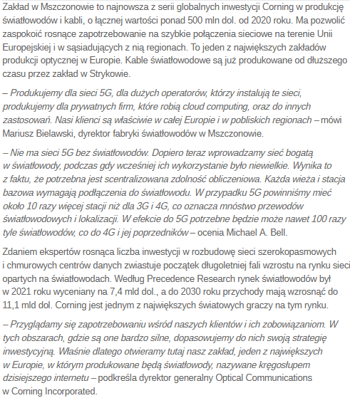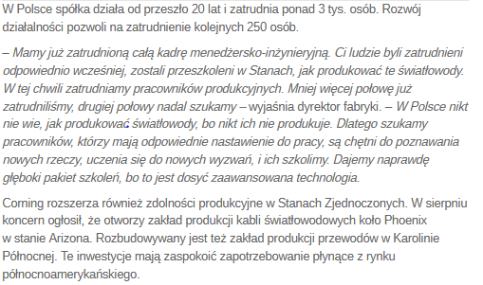

Date: 8 Sep 2022
Media: facebook.com InvestMap.pl Warszawa
Media circulation: 2.123 Followers
Article title: U.S. company Corning Incorporated will open a huge fiber optics factory in Mszczonów near Warsaw
Link: https://www.facebook.com/permalink.php?story_fbid=2293497107484017&id=895128757320866
Print screen:
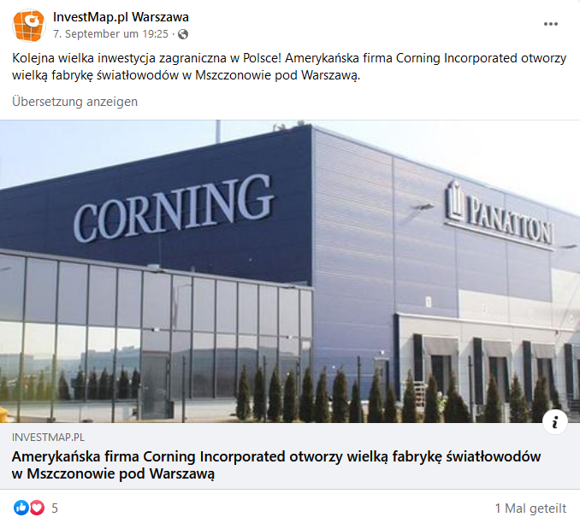

Date: 8 Sep 2022
Media: facebook.com Głos Żyrardowa i Okolicy
Media circulation: 12.682 Followers
Article title: U.S. company Corning Incorporated will open a huge fiber optics factory in Mszczonów near Warsaw
Link: https://www.facebook.com/GlosZyrardowaIOkolicy/posts/pfbid0XkJobnU9jxTUgJmztSgMa8HrGP3GKSNg3exftaNi9ebiZZ9jaAvhbAaAgscBxPBEl
Print screen:

Date: 8 Sep 2022
Media: facebook.com Radio Bogoria
Media circulation: 6.941 Followers
Article title: Literally moments ago, the official opening of Europe's most modern fiber optics factory took place in Mszczonów. The U.S.-based Corning company has created more than 200 jobs for skilled workers. (ts)
Link: https://www.facebook.com/RadioBogoria/posts/pfbid02QdvrfHgznVsgVMsXqkd9DZuCFRySGdhPrMPQYThg98AS91jXod4LfFLDM3fBVzhgl
Print screen:
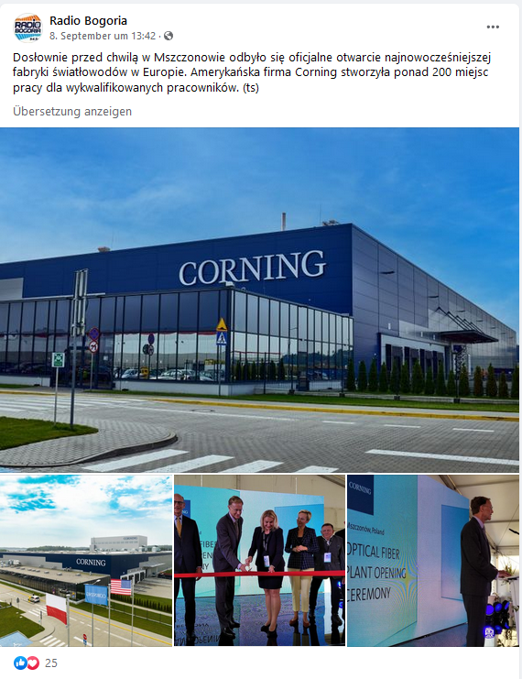

Date: 8 Sep 2022
Media: facebook.com TELEPOLIS.PL
Media circulation: 16.537 Followers
Article title: One of the European Union's largest fiber optics plants has been built in Mszczanów near Warsaw
Link: https://www.facebook.com/telepolispl/posts/pfbid0rxgqjonSpjt8kG8kH3xnawCf6wEJVePdx53mVGXSdNhK8XhDzt6AokxZ6kvrS8Ufl
Print screen:

Date: 8 Sep 2022
Media: facebook.com Życie Żyrardowa
Media circulation: 20.720 Followers
Article title: Half a billion dollars invested in Mszczonow landCorning Incorporated, which is on the list of America's largest Fortune 500 companies, opened today
Link: https://www.facebook.com/zyciezyrardowa/posts/pfbid02YtAFxmg67aYKx3WasJp7a7uiukaCVULrUFsUwLC72wGsfGgapUd5wU657wTXxnLpl
Print screen:
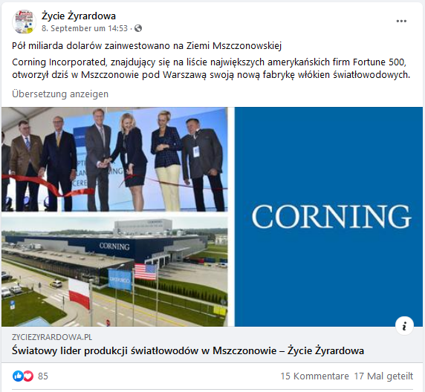

Date: 8 Sep 2022
Media: facebook.com wGospodarce.pl
Media circulation: 19.665 Follower
Article title: Corning Incorporated has opened an optical fiber manufacturing plant in Mszczonów to meet the growing demand for high-speed network connections in Europe
Link: https://www.facebook.com/permalink.php?story_fbid=6198885116793567&id=392825617399575
Print screen:
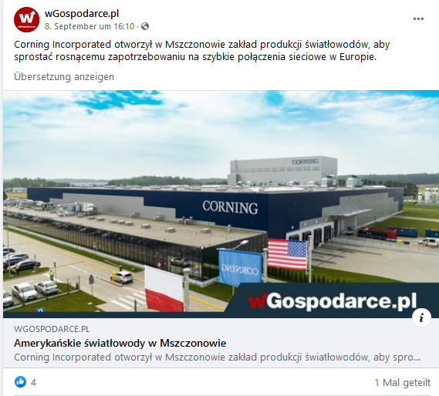

Date: 8 Sep 2022
Media: facebook.com Grodzisk News
Media circulation: 18.441 Followers
Article title: Corning has set up a plant in Mszczonów to meet the growing demand for high-speed network connections in Europe....
Link: https://www.facebook.com/GrodziskNews/posts/pfbid02fSRvKhJSY8aDgxzKLjr1ZNx9quz6R1NPVzWneZjgXjH3JkwcnJWbnhmY2n7vi3iql
Print screen:
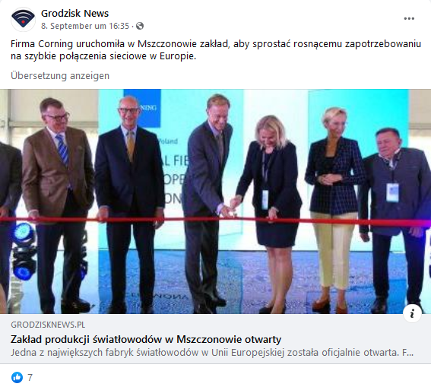

Date: 8 Sep 2022
Media: facebook.com Grodzisk News
Media circulation: 18.441 Followers
Article title: Corning has set up a plant in Mszczonów to meet the growing demand for high-speed network connections in Europe....
Link: https://www.facebook.com/GrodziskNews/posts/pfbid02fSRvKhJSY8aDgxzKLjr1ZNx9quz6R1NPVzWneZjgXjH3JkwcnJWbnhmY2n7vi3iql
Print screen:
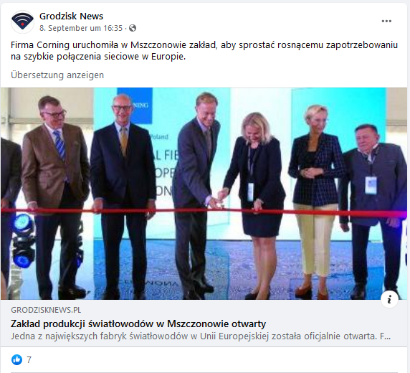

Date: 8 Sep 2022
Media: twitter.com TELKO.in
Media circulation: 1.854 Followers
Article title: Corning has officially opened a new fiber-optic production facility located in Mszczonów, Poland. The manufacturer hopes it will allow it to meet the growing demand for cables in the European Union and neighboring regions.
Link: https://twitter.com/TELKO_in/status/1567961714787815428
Print screen:

Date: 9 Sep 2022
Media: linkedin.com Nowoczesny Przemysł
Media circulation: 2.479 Followers
Article title: A bespoke state-of-the-art factory has been built in Mszczonów, near Warsaw, for Corning Incorporated, the creator and world's leading manufacturer of low-loss optical fibers. (...)
Link: https://www.linkedin.com/posts/nowoczesny-przemys%C5%82_nowa-fabryka-dla-corning-incorporated-innowacyjnego-activity-6973884026625372160-UEXZ?utm_source=share&utm_medium=member_desktop
Print screen:
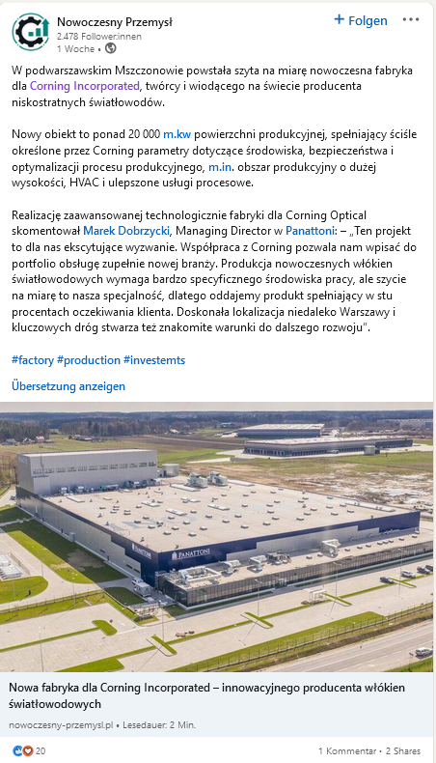

Date: 9 Sep 2022
Media: twitter.com ISBnews
Media circulation: 2.755 Followers
Article title: #Corning: 5G depends on fiber optics
Link: https://twitter.com/AgencjaISB/status/1568185716961677313
Print screen:

Date: 9 Sep 2022
Media: facebook.com Grojec24.net - informacyjny portal mieszkańców
Media circulation: 18.754 Followers
Article title: Among the largest fiber optics manufacturing facilities in the European Union, the facility is the latest in a series of Corning's global investments in fiber optics and cable manufacturing, totaling more than $500 million
Link: https://www.facebook.com/permalink.php?story_fbid=2011842022346328&id=138376889692860
Print screen:
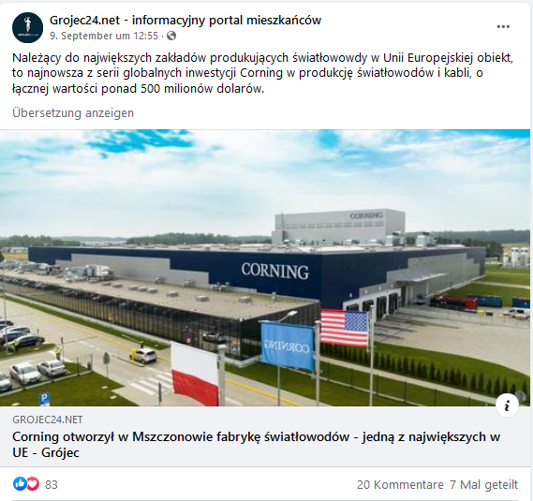

Date: 11 Sep 2022
Media: twitter.com Radek Gmyrek
Media circulation: 861 Followers
Article title: The ribbon is cut! Corning’s new optical manufacturing plant in Mszczonów, Poland is officially open and ready to meet the demand for high-speed connectivity in the European Union and beyond.
Link: https://twitter.com/RadekGmyrek1/status/1568724599537287168
Print screen:
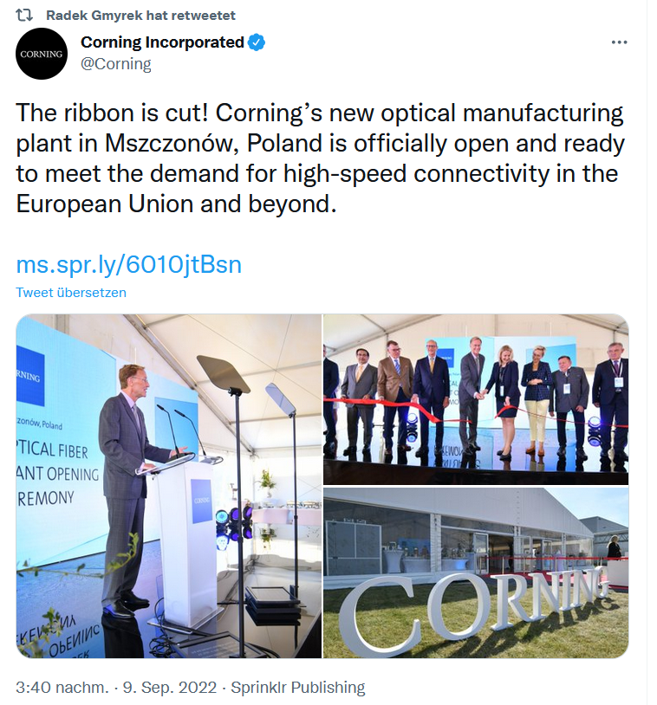

Date: 11 Sep 2022
Media: twitter.com Radek Gmyrek
Media circulation: 861 Followers
Article title: Corning’s state-of-the-art plant in Poland is our latest investment in fiber and cable manufacturing global infrastructure totaling more than $500 million since 2020. http://ms.spr.ly/6015jsBvT
Link: https://twitter.com/RadekGmyrek1/status/1568923694793392128
Print screen:

Date: 11 Sep 2022
Media: facebook.com Dzieje się w Warszawie
Media circulation: 242.342 Followers
Article title: Expansion of 5G networks will drive demand for fiber optics. New factory in Mszczonów
Link: https://www.facebook.com/dziejesiewwarszawie/posts/pfbid0Led7MG4VvoFx3fzDnKLkWe7psPAS6vCygR5PMj6XDJxA7eU19J9iRVGKPFmDk8nMl
Print screen:

Date: 12 Sep 2022
Media: youtube.com Patriot24.TV
Media circulation: 22.700 Followers
Article title: Expansion of 5G networks will drive demand for fiber optics. New factory in Mszczonów
Link: https://www.youtube.com/watch?v=OW3x5OywYME
Print screen:
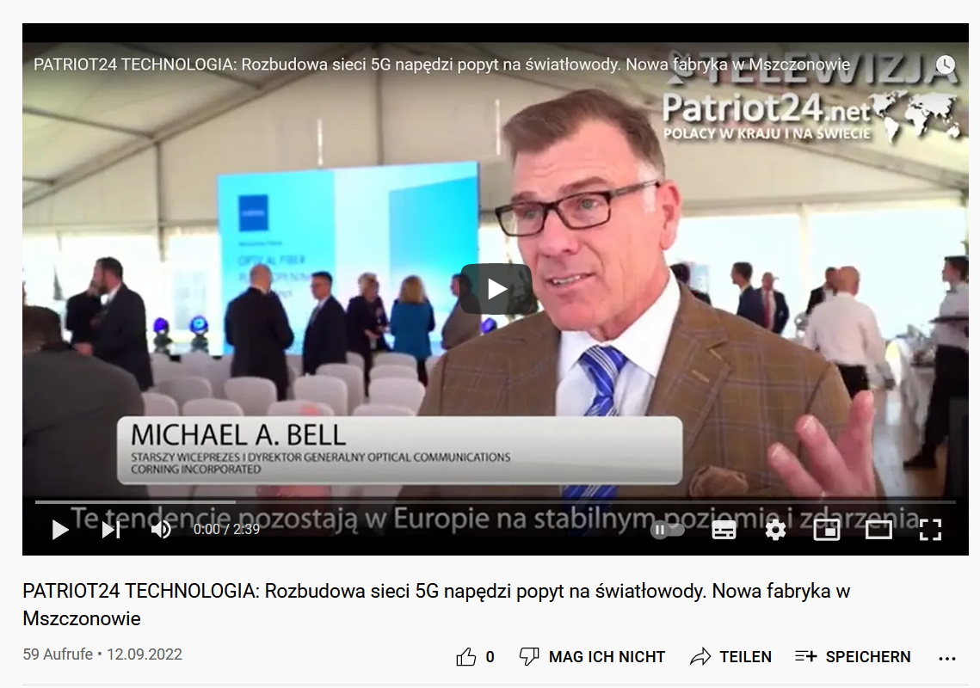

Date: 12 Sep 2022
Media: linkedin.com Agencja informacyjna NEWSERIA
Media circulation: 1,600 Followers
Article title: Expansion of 5G networks will drive demand for fiber optics. Their new factory in Mszczonów will serve Europe's largest customers. (...)
Link: https://www.linkedin.com/posts/agencja-informacyjna-newseria_agjwiatagkowody-corning-inwestycje-activity-6975000165480845312-RwtQ?utm_source=share&utm_medium=member_desktop
Print screen:
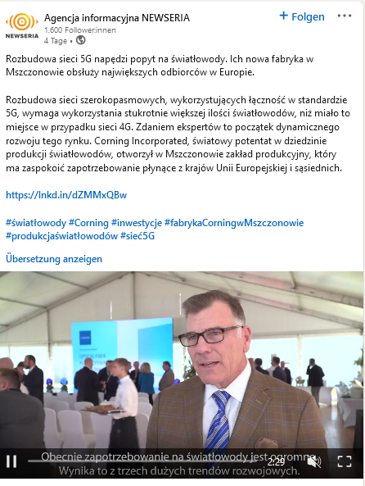

Date: 12 Sep 2022
Media: twitter.com Newseria Biznes
Media circulation: 2.867 Followers
Article title: Expansion of 5G networks will drive demand for fiber optics. Their new factory in Mszczonów will serve Europe's largest customers.
Link: https://twitter.com/Newseria_Biznes/status/1569234452517093376
Print screen:
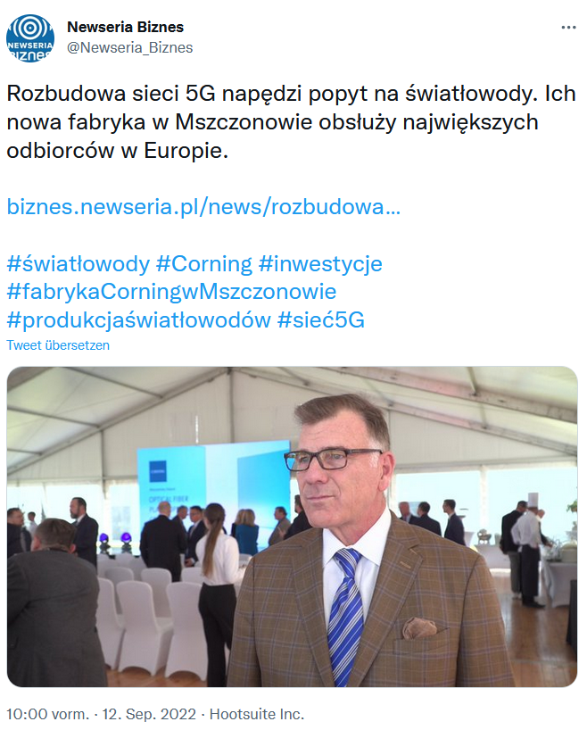

Date: 12 Sep 2022
Media: twitter.com Newseria Innowacje
Media circulation: 373 Followers
Article title: Expansion of 5G networks will drive demand for fiber optics. Their new factory in Mszczonów will serve Europe's largest customers.
Link: https://twitter.com/InnowacjeN/status/1569234764896378880
Print screen:

Date: 12 Sep 2022
Media: facebook.com Newseria Biznes
Media circulation: 2.917 Followers
Article title: Expansion of 5G networks will drive demand for fiber optics.
Link: https://www.facebook.com/watch/?v=5311625368945409
Print screen:
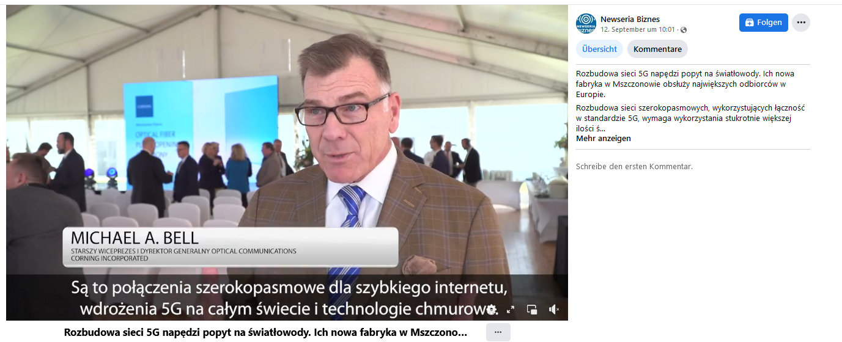

Date: 12 Sep 2022
Media: twitter.com Piotr Mieczkowski
Media circulation: 1.055 Followers
Article title: The head of Corning (US, fiber optics company) indicates that Europe needs to be more independent in the fiber optics supply chain. They just opened a factory in PL (outlay of 500 million usd, 250 people). 30% of the market they want to serve.
Link: https://twitter.com/piotrmiecz/status/1569334169586798593
Print screen:
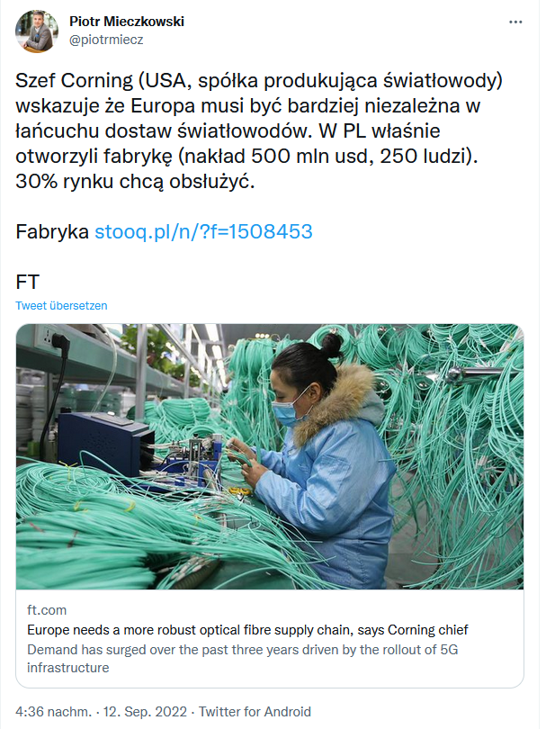

Date: 12 Sep 2022
Media: twitter.com Błażej
Media circulation: 391 Followers
Article title: The head of Corning (US, fiber optics company) indicates that Europe needs to be more independent in the fiber optics supply chain. They just opened a factory in PL (outlay of 500 million usd, 250 people). 30% of the market they want to serve.
Link: https://twitter.com/bpaskal/status/1569344493903544320
Print screen:
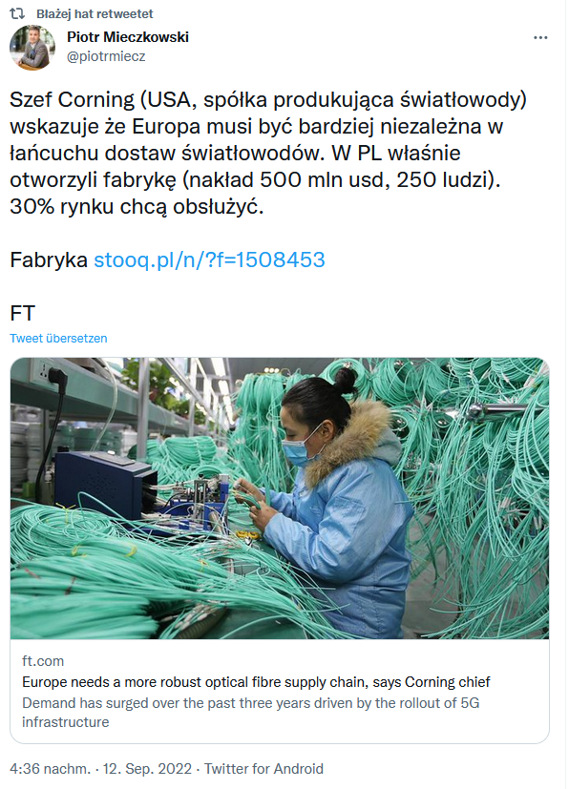

Date: 12 Sep 2022
Media: twitter.com andrzej cyran
Media circulation: 932 Followers
Article title: The doors are open at Corning’s new optical fiber manufacturing plant in Mszczonów, Poland. The plant will help meet the growing demand for high-speed connectivity across Europe and surrounding regions. Learn more: http://ms.spr.ly/6016jSheg.
Link: https://twitter.com/andrajos1975/status/1569366741972652033
Print screen:
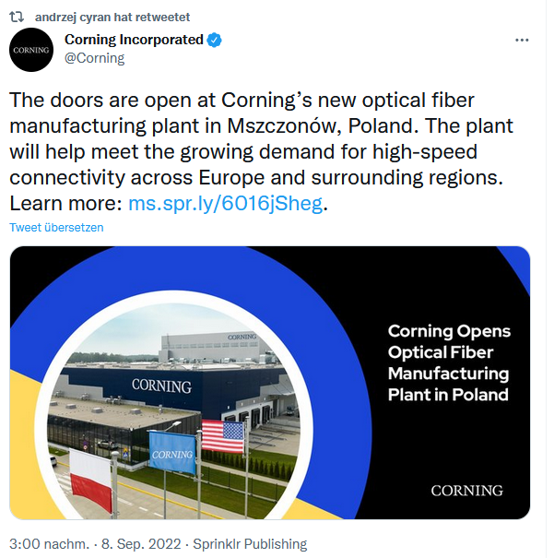

Date: 12 Sep 2022
Media: facebook.com Newseria Biznes
Media circulation: 3.077 Followers
Article title: Expansion of 5G networks will drive demand for fiber optics
Link: https://www.facebook.com/watch/?v=5311625368945409
Print screen:

Date: 13 Sep 2022
Media: mobo.blog
Media circulation: N/A
Article title: Expansion of 5G networks will drive demand for fiber optics. Their new factory in Mszczonów will serve Europe's largest customers
Link: https://mobo.blog/news/pl/news398740.html
Print screen:
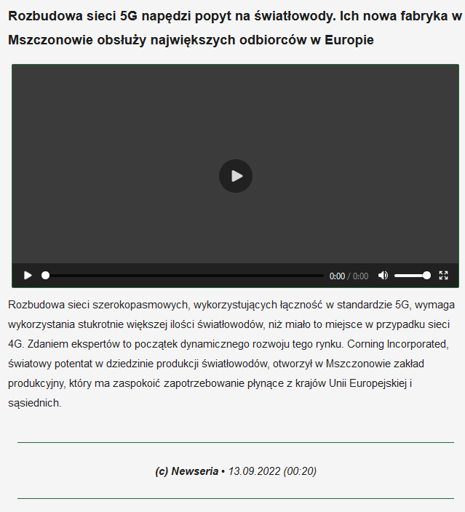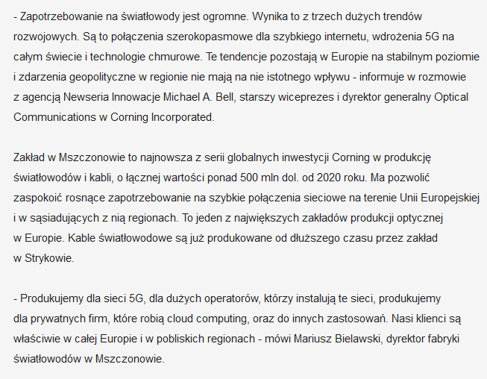
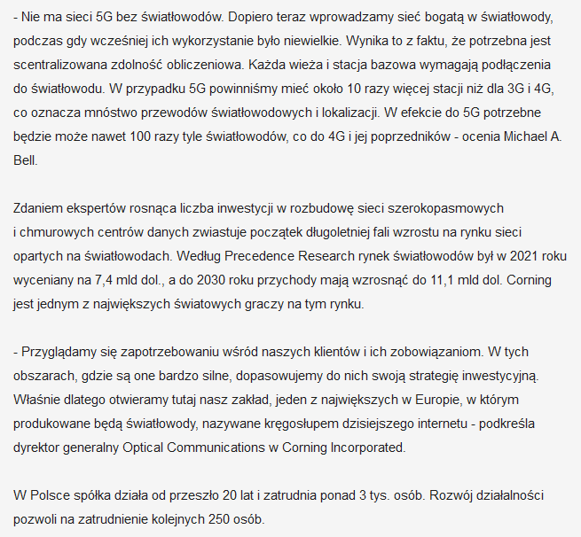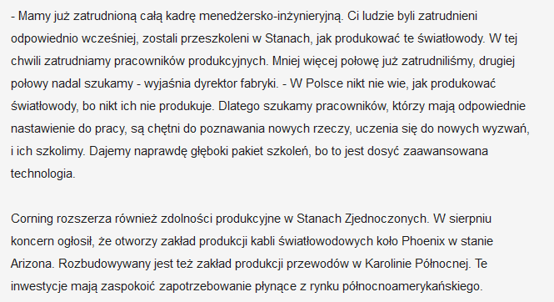

Date: 13 Sep 2022
Media: facebook.com dostawcy-internetu.pl
Media circulation: 413 Followers
Article title: Expanding broadband networks using 5G connectivity requires a hundred times more fiber optics…
Link: https://www.facebook.com/dostawcy.internetu/posts/pfbid025nX1TQvXneCUGfP7PZLeqKzyoNbDMcgidGpvieUTXDAj6Wg46mNoP6DsWEKE1FSel
Print screen:
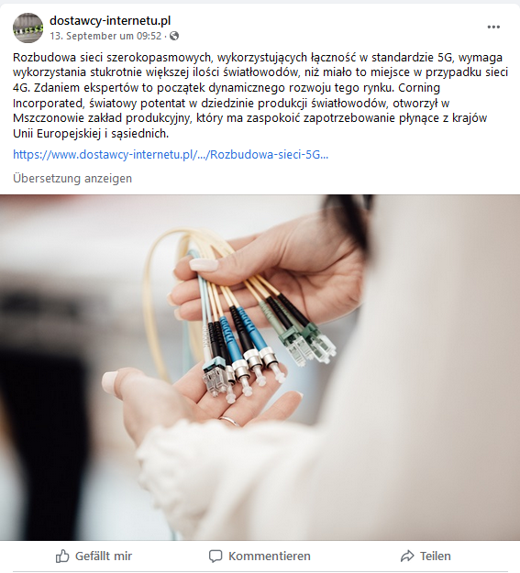

Market: France
Date: 07 Sep 2022
Media: Global security mag
Media circulation: 149,379 (monthly visitor traffic)
Article title: Corning opens optical fiber production facility in Poland
Link: https://www.globalsecuritymag.fr/Corning-ouvre-une-usine-de,20220908,129616.html
Print screen:
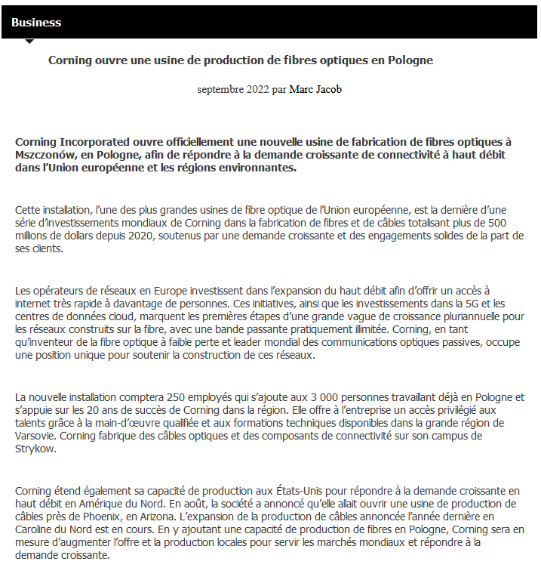

Date: 08 Sep 2022
Media: Animasoft
Media circulation: N/A
Article title: Corning Opens Optical Fiber Production Plant In Poland To Meet Growing Demand For Broadband Connectivity In Europe
Link: http://www.animasoft.com/communiques-de-press/46694/corning-ouvre-une-usine-de-production-de-fibres-optiques-en-pologne-pour-repondre-a-la-demande-croissante-de-connectivite-a-haut-debit-en-europe
Print screen:
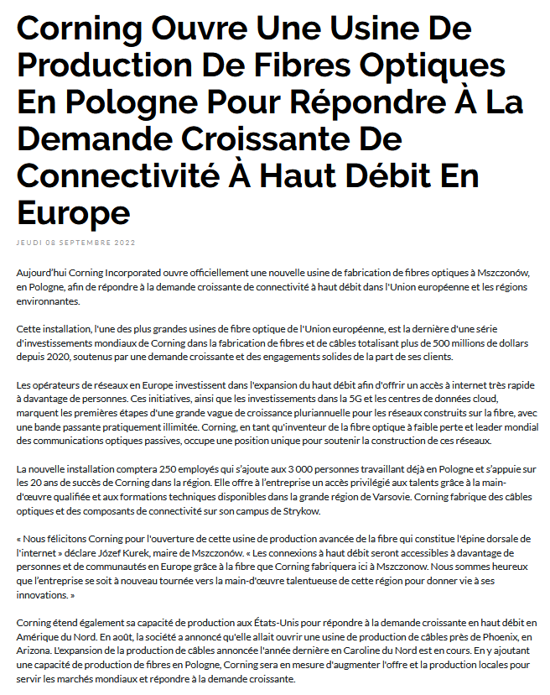
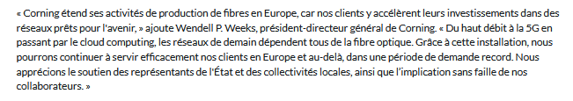
Date: 08 Sep 2022
Media: Electronique-Newsmag
Media circulation: N/A
Article title: Corning opens fiber optic production facility in Poland to meet growing demand for high-speed connectivity in Europe
Link: http://electronique-newsmag.com/communiques-de-press/46694/corning-ouvre-une-usine-de-production-de-fibres-optiques-en-pologne-pour-repondre-a-la-demande-croissante-de-connectivite-a-haut-debit-en-europe
Print screen:
Date: 08 Sep 2022
Media: IA-Newsmag
Media circulation: N/A
Article title: Corning Opens Optical Fiber Production Plant In Poland To Meet Growing Demand For Broadband Connectivity In Europe
Link: http://ia-newsmag.com/communiques-de-press/46694/corning-ouvre-une-usine-de-production-de-fibres-optiques-en-pologne-pour-repondre-a-la-demande-croissante-de-connectivite-a-haut-debit-en-europe
Print screen:

Date: 08 Sep 2022
Media: InfoDSI
Media circulation: 1.606
Article title: Corning Opens Optical Fiber Production Plant In Poland To Meet Growing Demand For Broadband Connectivity In Europe
Link: http://infodsi.com/communiques-de-press/46694/corning-ouvre-une-usine-de-production-de-fibres-optiques-en-pologne-pour-repondre-a-la-demande-croissante-de-connectivite-a-haut-debit-en-europe (link might not work)
Print screen:
Date: 08 Sep 2022
Media: IT Channel Info
Media circulation: N/A
Article title: Corning Opens Optical Fiber Production Plant In Poland To Meet Growing Demand For Broadband Connectivity In Europe
Link: http://www.itchannel.info/communiques-de-press/46694/corning-ouvre-une-usine-de-production-de-fibres-optiques-en-pologne-pour-repondre-a-la-demande-croissante-de-connectivite-a-haut-debit-en-europe
Print screen: (link might not work)
Date: 08 Sep 2022
Media: ITR Games
Media circulation: N/A
Article title: Corning Opens Optical Fiber Production Plant In Poland To Meet Growing Demand For Broadband Connectivity In Europe
Link: https://itrgames.com/communiques-de-press/46694/corning-ouvre-une-usine-de-production-de-fibres-optiques-en-pologne-pour-repondre-a-la-demande-croissante-de-connectivite-a-haut-debit-en-europe
Print screen:

Date: 08 Sep 2022
Media: ITR Innovation
Media circulation: N/A
Article title: Corning Opens Optical Fiber Production Plant In Poland To Meet Growing Demand For Broadband Connectivity In Europe
Link: https://itrinnovation.com/communiques-de-press/46694/corning-ouvre-une-usine-de-production-de-fibres-optiques-en-pologne-pour-repondre-a-la-demande-croissante-de-connectivite-a-haut-debit-en-europe
Print screen:

Date: 08 Sep 2022
Media: ITR Manager
Media circulation: N/A
Article title: Corning Opens Optical Fiber Production Plant In Poland To Meet Growing Demand For Broadband Connectivity In Europe
Link: http://www.itrmanager.com/communiques-de-press/46694/corning-ouvre-une-usine-de-production-de-fibres-optiques-en-pologne-pour-repondre-a-la-demande-croissante-de-connectivite-a-haut-debit-en-europe (link might not work)
Print screen:
Date: 08 Sep 2022
Media: ITR Mobiles
Media circulation: 4.666
Article title: Corning Opens Optical Fiber Production Plant In Poland To Meet Growing Demand For Broadband Connectivity In Europe
Link: https://itrmobiles.com/communiques-de-press/46694/corning-ouvre-une-usine-de-production-de-fibres-optiques-en-pologne-pour-repondre-a-la-demande-croissante-de-connectivite-a-haut-debit-en-europe
Print screen:
Date: 08 Sep 2022
Media: ITR News
Media circulation: 7.999
Article title: Corning Opens Optical Fiber Production Plant In Poland To Meet Growing Demand For Broadband Connectivity In Europe
Link: https://itrnews.com/communiques-de-press/46694/corning-ouvre-une-usine-de-production-de-fibres-optiques-en-pologne-pour-repondre-a-la-demande-croissante-de-connectivite-a-haut-debit-en-europe (link might not work)
Print screen:
Date: 08 Sep 2022
Media: ITR Software
Media circulation: 74.690
Article title: Corning Opens Optical Fiber Production Plant In Poland To Meet Growing Demand For Broadband Connectivity In Europe
Link: http://www.itrsoftware.com/communiques-de-press/46694/corning-ouvre-une-usine-de-production-de-fibres-optiques-en-pologne-pour-repondre-a-la-demande-croissante-de-connectivite-a-haut-debit-en-europe
Print screen:
Date: 08 Sep 2022
Media: L'Entreprise Connectée
Media circulation: N/A
Article title: Corning Opens Optical Fiber Production Plant In Poland To Meet Growing Demand For Broadband Connectivity In Europe
Link: https://lentrepriseconnectee.com/communiques-de-press/46694/corning-ouvre-une-usine-de-production-de-fibres-optiques-en-pologne-pour-repondre-a-la-demande-croissante-de-connectivite-a-haut-debit-en-europe
Print screen:
Date: 08 Sep 2022
Media: L a Vie Numerique
Media circulation: N/A
Article title: Corning Opens Optical Fiber Production Plant In Poland To Meet Growing Demand For Broadband Connectivity In Europe
Link: http://www.lavienumerique.com/communiques-de-press/46694/corning-ouvre-une-usine-de-production-de-fibres-optiques-en-pologne-pour-repondre-a-la-demande-croissante-de-connectivite-a-haut-debit-en-europe
Print screen:
Date: 08 Sep 2022
Media: Tendances IT
Media circulation: N/A
Article title: Corning Opens Optical Fiber Production Plant In Poland To Meet Growing Demand For Broadband Connectivity In Europe
Link: https://tendancesit.com/communiques-de-press/46694/corning-ouvre-une-usine-de-production-de-fibres-optiques-en-pologne-pour-repondre-a-la-demande-croissante-de-connectivite-a-haut-debit-en-europe
Print screen:
Date: 08 Sep 2022
Media: Cloud Newsmag
Media circulation: N/A
Article title: Corning Opens Optical Fiber Production Plant In Poland To Meet Growing Demand For Broadband Connectivity In Europe
Link: https://cloud-newsmag.com/communiques-de-press/46694/corning-ouvre-une-usine-de-production-de-fibres-optiques-en-pologne-pour-repondre-a-la-demande-croissante-de-connectivite-a-haut-debit-en-europe
Print screen:
Date: 08 Sep 2022
Media: Security NewsMag
Media circulation: N/A
Article title: Corning Opens Optical Fiber Production Plant In Poland To Meet Growing Demand For Broadband Connectivity In Europe
Link: https://security-newsmag.com/communiques-de-press/46694/corning-ouvre-une-usine-de-production-de-fibres-optiques-en-pologne-pour-repondre-a-la-demande-croissante-de-connectivite-a-haut-debit-en-europe
Print screen:

Date: 10 Sep 2022
Media: Industry Mag
Media circulation: 14,726 (monthly visitor traffic)
Article title: Corning opens optical fiber production facility in Poland
Link: http://www.industrie-mag.com/article33467.html
Print screen:
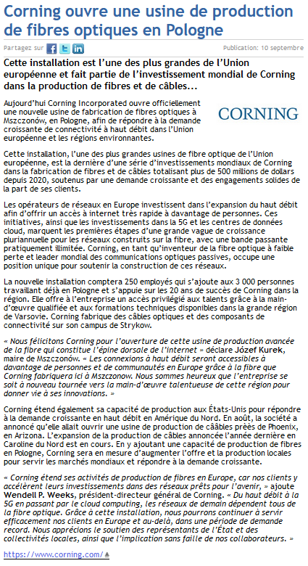
Date: 11 Sep 2022
Media: Les actualités.news
Media circulation: 253,520 (monthly visitor traffic)
Article title: Europe needs a more robust fiber supply chain, says Corning chief
Link: https://lesactualites.news/affaires/leurope-a-besoin-dune-chaine-dapprovisionnement-en-fibre-optique-plus-robuste-declare-le-chef-de-corning/
Print screen:
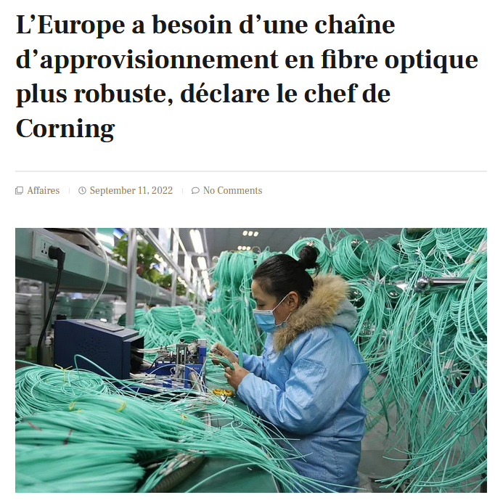
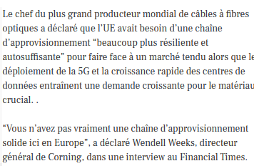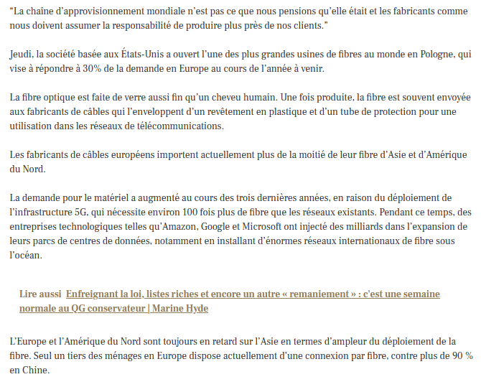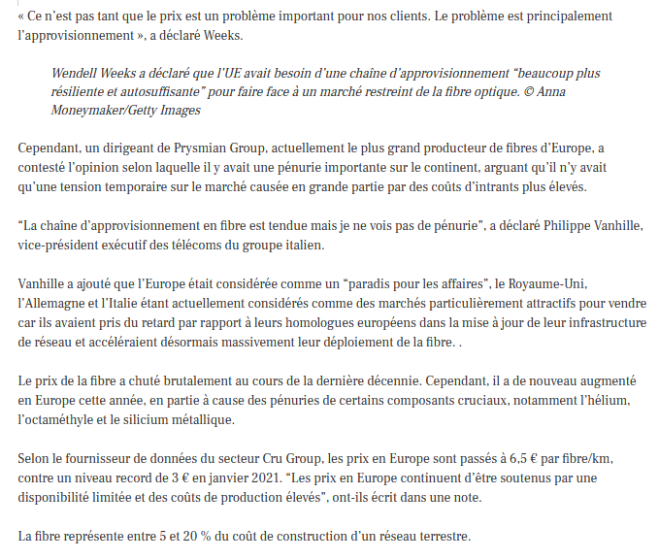

Date: 12 Sep 2022
Media: Pei France
Media circulation: 13,453 (monthly visitor traffic)
Article title: Corning opens fiber optics plant in Poland
Link: https://www.pei-france.com/article/corning-ouvre-une-usine-de-fibres-optiques-en-pologne/
Print screen:
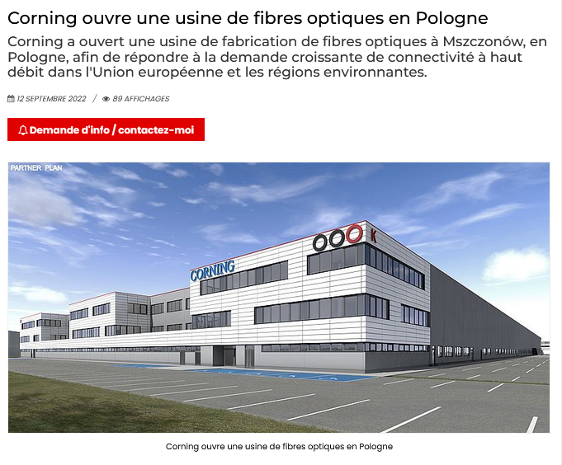
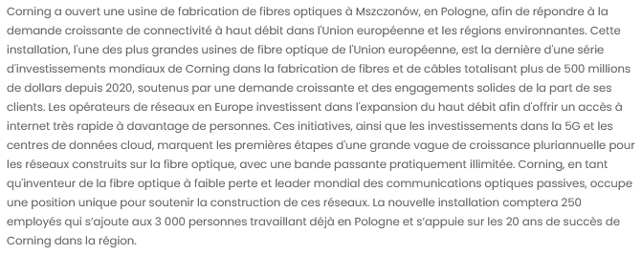
Date: 12 Sep 2022
Media: Datacenter Magazine
Media circulation: 13,453 (monthly visitor traffic)
Article title: Corning opens optical fiber production facility in Poland
Link: https://datacenter-magazine.fr/corning-ouvre-une-usine-de-production-de-fibres-optiques-en-pologne/#:~:text=15%20septembre%202022-,Corning%20ouvre%20une%20usine%20de%20production%20de%20fibres%20optiques%20en,de%20fibres%20et%20de%20c%C3%A2bles.
Print screen:
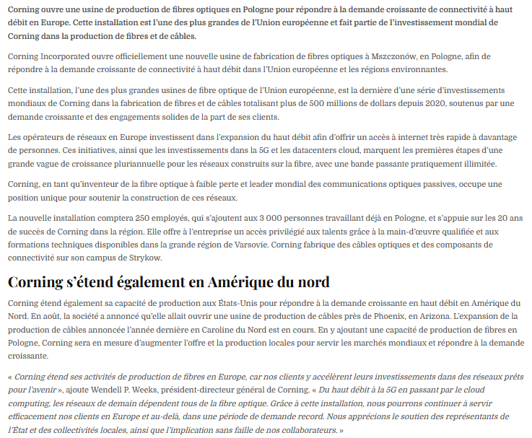

Market: UK
Date: 09 Sep 2022
Media: Cable Technology News
Media circulation: 6,000 (monthly visitor traffic)
Article title: Corning opens optical fibre manufacturing plant in Poland
Link: https://www.cabletechnologynews.co.uk/corning-opens-optical-fibre-manufacturing-plant-in-poland/
Print screen:
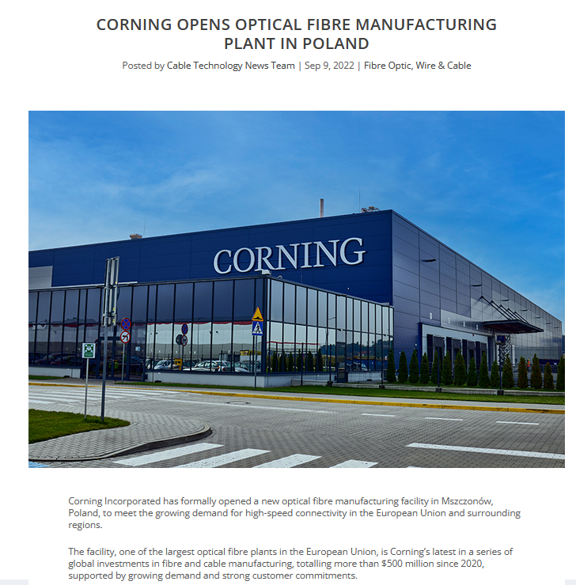
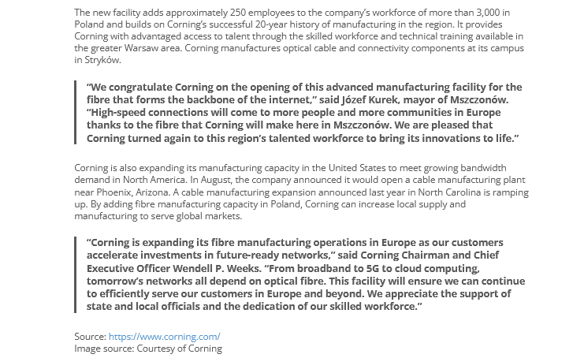

Date: 09 Sep 2022
Media: Data Centre Solutions
Media circulation: 10,000 (monthly visitor traffic)
Article title: Corning opens optical fibre manufacturing plant in Poland
Link https://datacentre.solutions/news/64094/corning-opens-optical-fibre-manufacturing-plant-in-poland
Print screen:
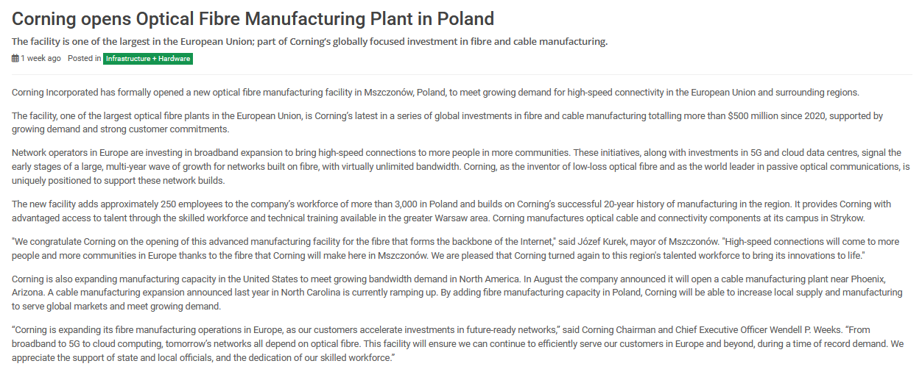

Date: 11 Sep 2022
Media: Financial Times
Media circulation: 7.000.000 (monthly visitor traffic)
Article title: Europe needs a more robust optical fibre supply chain, says Corning chief
Link: https://www.ft.com/content/33197e36-b2c9-4c96-8dc7-60446f7abd6c
Print screen:
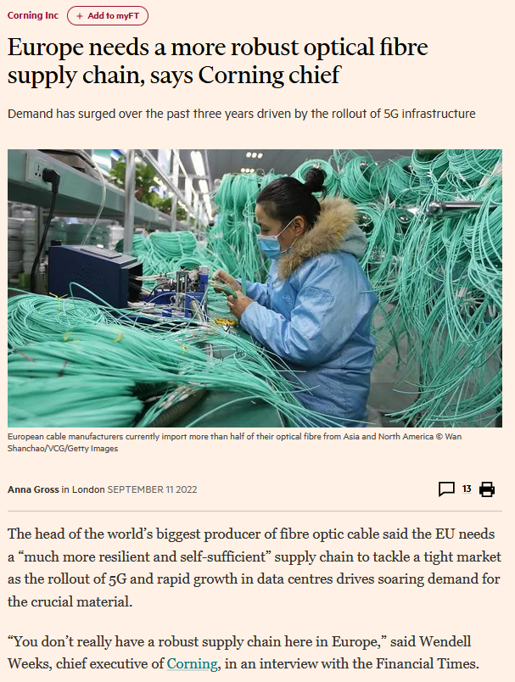
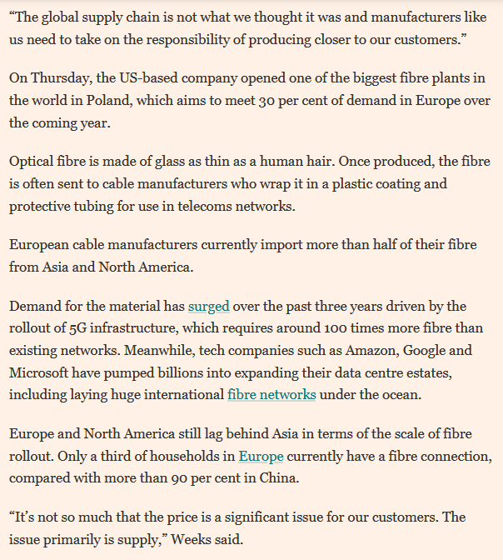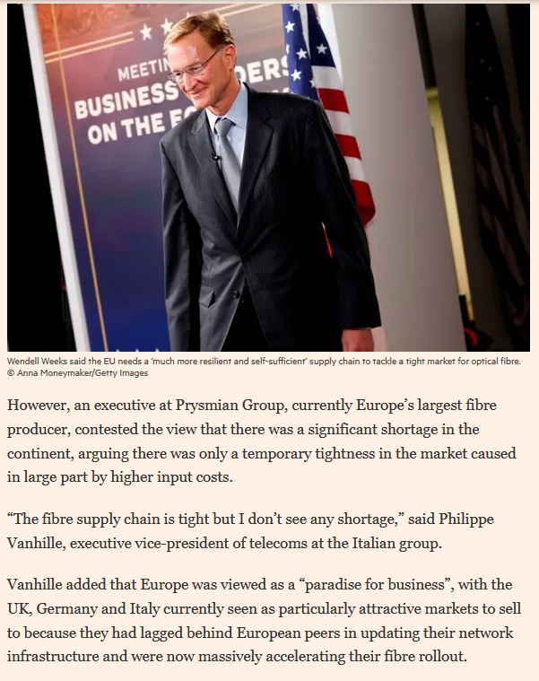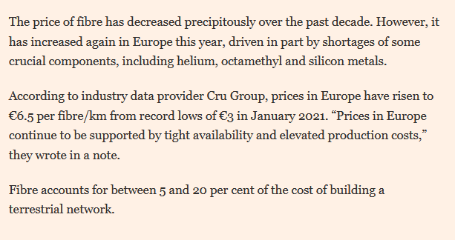

Date: 12 Sep 2022
Media: Mobile Europe
Media circulation: 20,000 (monthly visitor traffic)
Article title: European ‘paradise’ as fibre roll out keeps going gang busters
Link: https://www.mobileeurope.co.uk/european-paradise-as-fibre-roll-out-keeps-going-gang-busters/
Print screen:
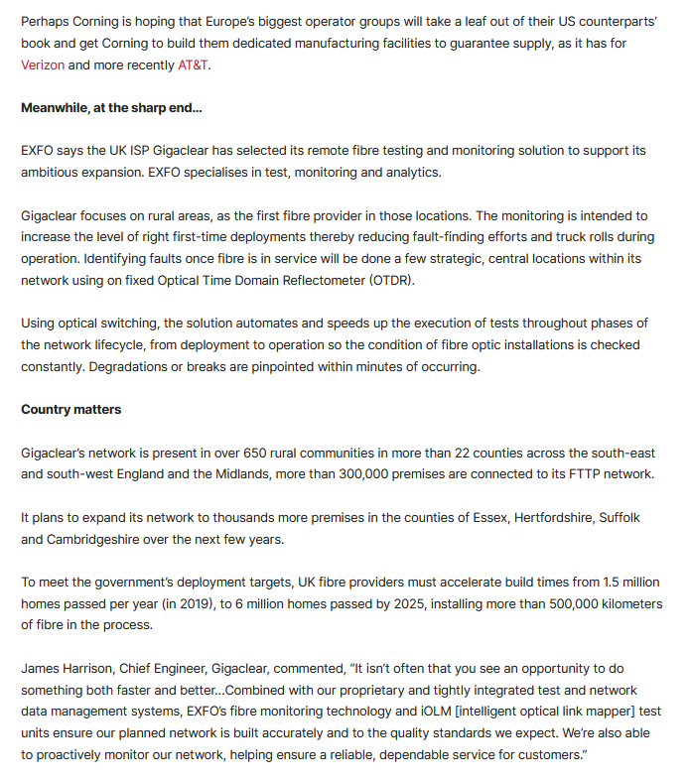

Date: 12 Sep 2022
Media: Digitalisation World
Media circulation: 4,000 (monthly visitor traffic)
Article title: Corning opens Optical Fibre Manufacturing Plant in Poland
Link: https://digitalisationworld.com/news/64094/corning-opens-optical-fibre-manufacturing-plant-in-poland
Print screen:
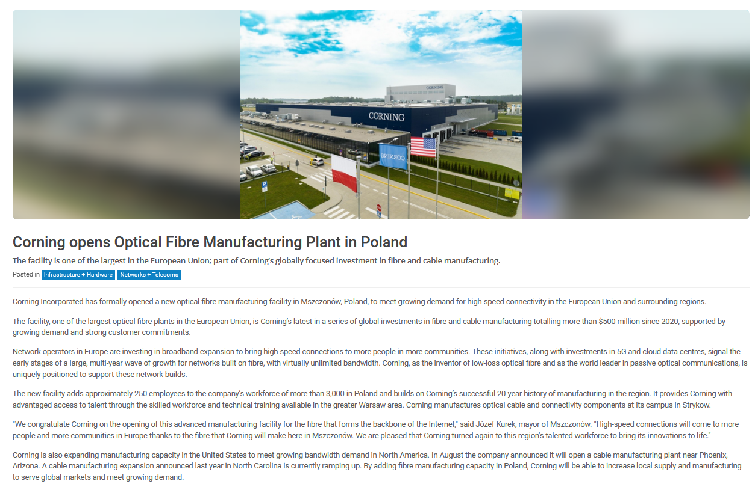

Date: 15 Sep 2022
Media: Glass Worldwide
Media circulation: 5,000 (monthly visitor traffic)
Article title: Corning opens optical fibre manufacturing plant in Poland
Link http://www.glassworldwide.co.uk/industry-announcements/corning-opens-optical-fibre-plant-poland
Print screen:
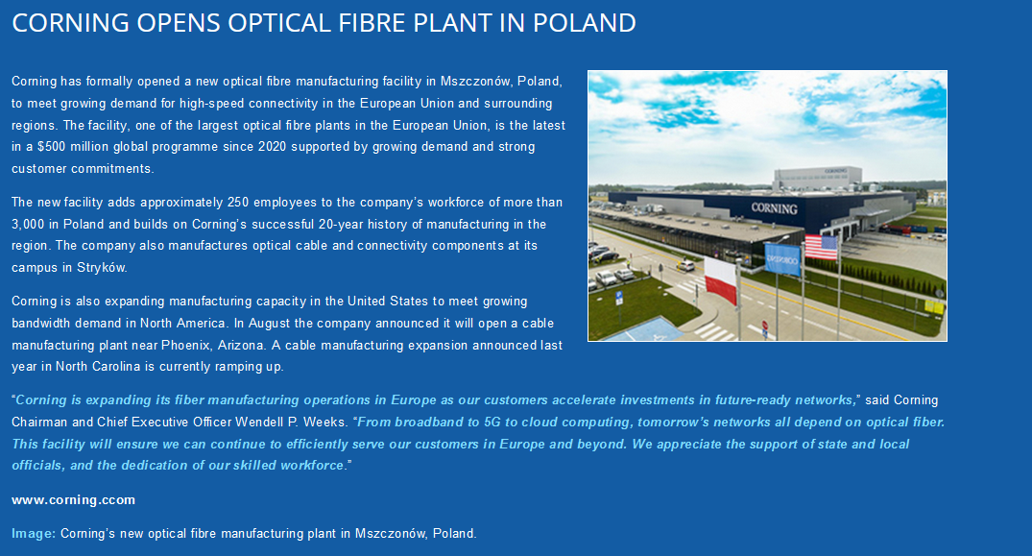

Market: Germany
Date: 08 Sep 2022
Media: Cable!vision
Media circulation: 4.500 (monthly visitor traffic)
Article title: Corning opens fibre optic manufacturing plant in Poland
Link: https://www.cablevision-europe.de/_rubric/detail.php?rubric=Markt%2BUnternehmen&nr=18058
Print screen:
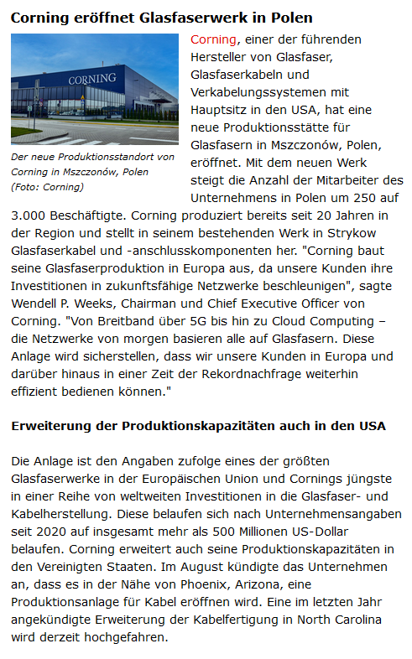

Date: 08 Sep 2022
Media: Cable!vision Newsletter
Media circulation: 750 (Subscribers)
Article title: Corning opens fibre optic manufacturing plant in Poland
Link: https://www.cablevision-europe.de/_rubric/detail.php?rubric=Markt%2BUnternehmen&nr=18058
Print screen:
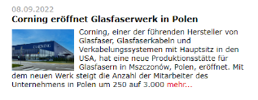

Date: 11 Sep 2022
Media: Germanic News
Media circulation: N/A
Article title: Europe needs a more robust fiber optic supply chain, says Corning boss
Link: https://germanic.news/europa-brauche-eine-robustere-glasfaser-lieferkette-sagt-corning-chef/
Print screen:
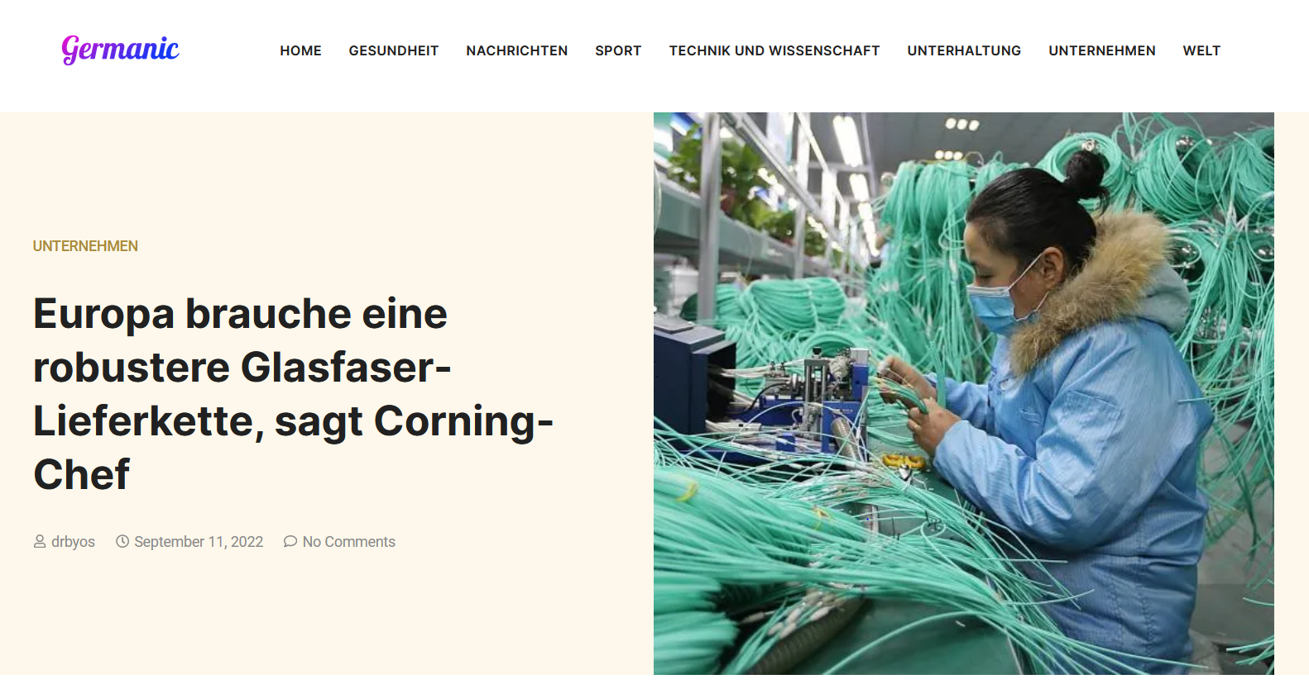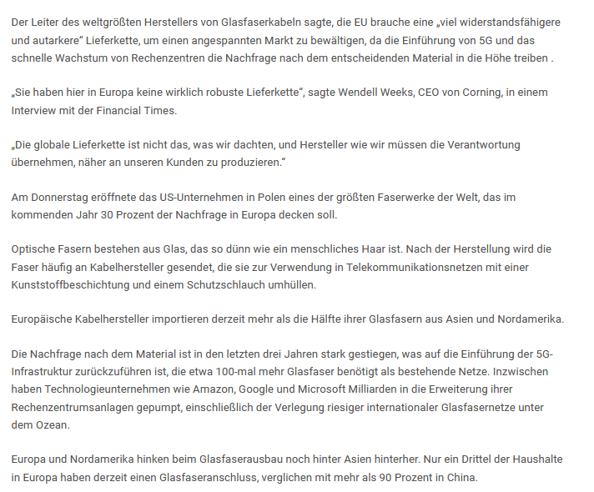
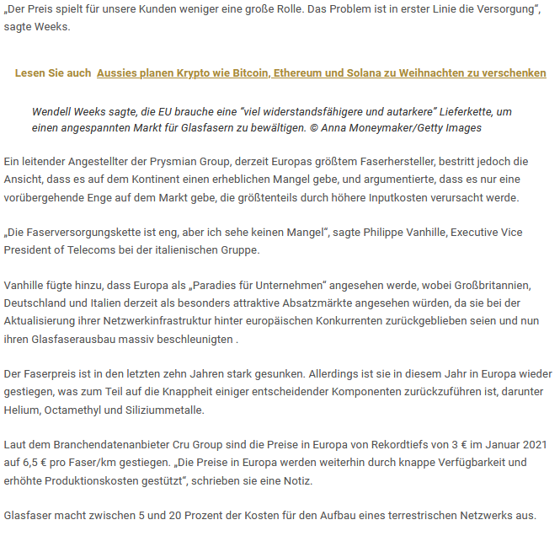

Date: 13 Sep 2022
Media: LANline
Media circulation: 35.000 (monthly visitor traffic)
Article title: Corning opens fibre optic manufacturing plant in Poland: Investment in fibre and cable production
Link: https://www.lanline.de/verkabelung/investitionen-in-faser-und-kabelherstellung.254743.html
Print screen:
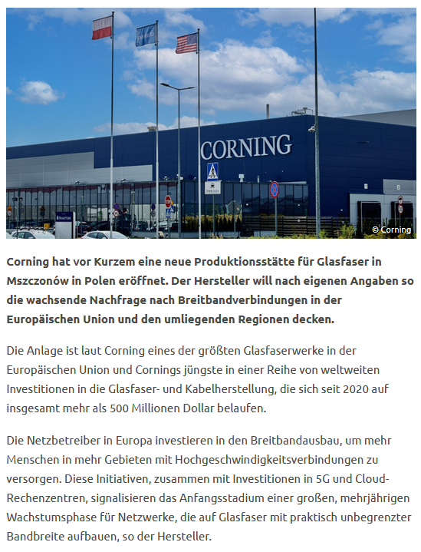
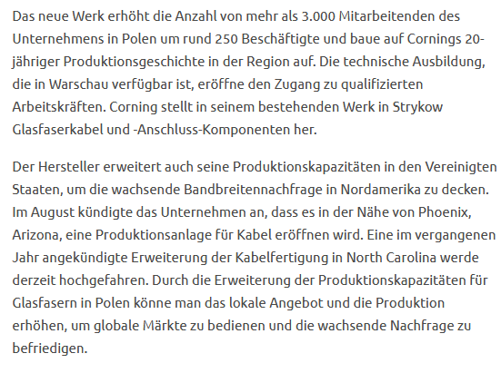

Market: USA
Date: 08 Sep 2022
Media: Weny News
Media circulation: N/A
Article title: Corning Inc. Opens New Optical Fiber Plant
Link: https://www.weny.com/story/47251942/corning-inc-opens-new-optical-fiber-plant
Print screen:
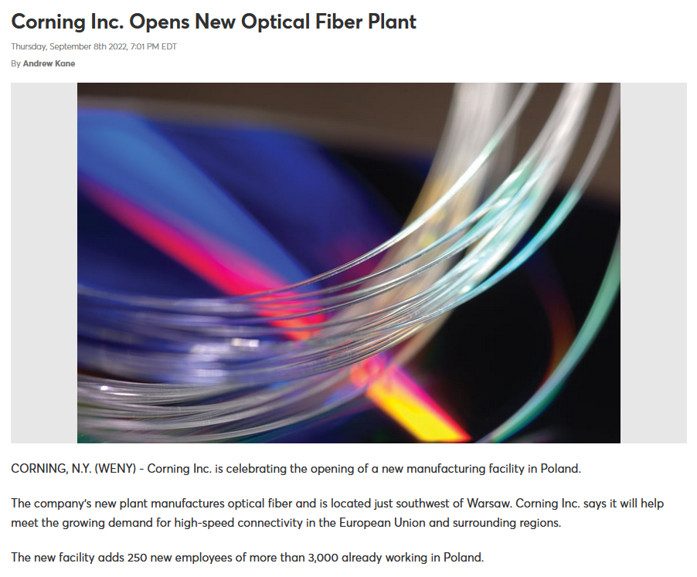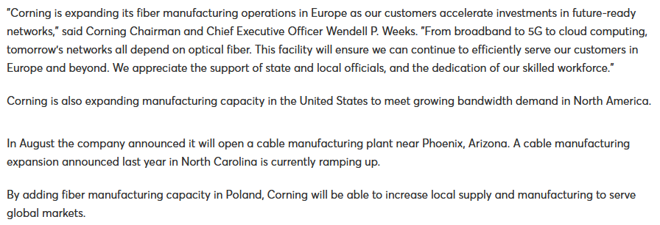

Date: 08 Sep 2022
Media: Weny News
Media circulation: N/A
Article title: Corning Inc. Opens New Optical Fiber Plant
Link: https://playvideo.bulletinintelligence.com/e3596099f597474eb0edc143011045d9?pubid=corning
Print screen:
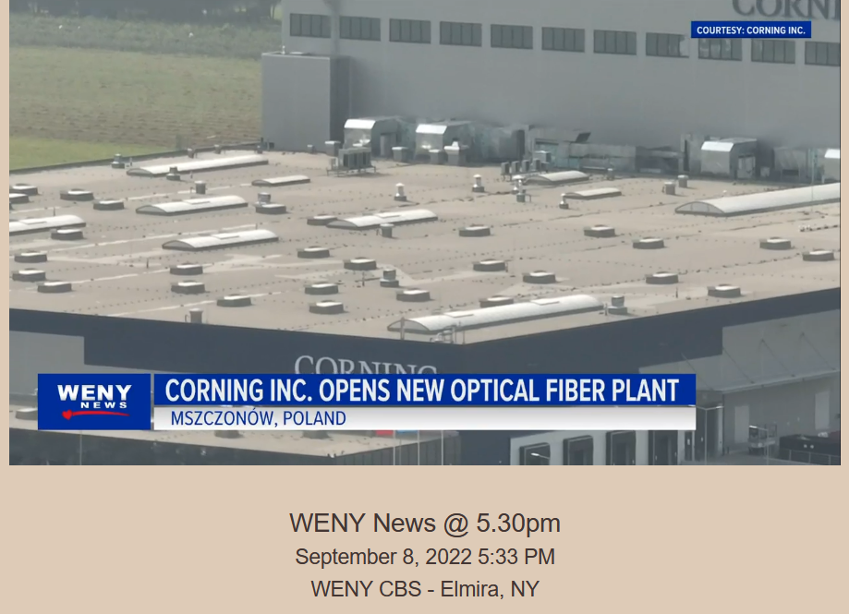

Date: 08 Sep 2022
Media: Lightwave
Media circulation: 159.900 (monthly visitor traffic)
Article title: Corning opens fiber production facility in Poland
Link: https://www.lightwaveonline.com/fttx/cables-enclosures/article/14282479/corning-opens-fiber-production-facility-in-poland
Print screen:
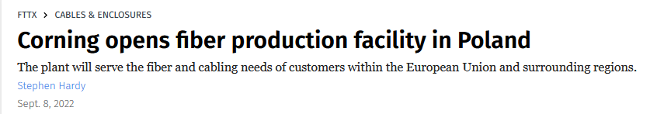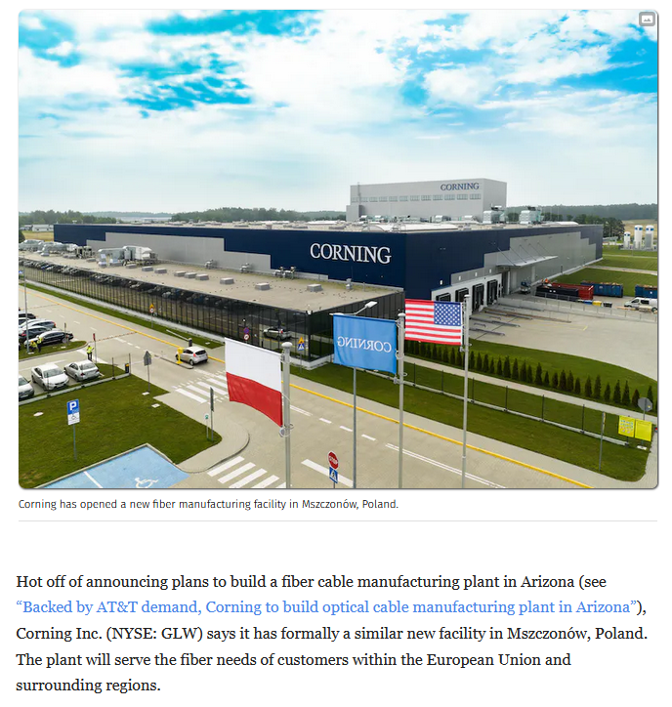
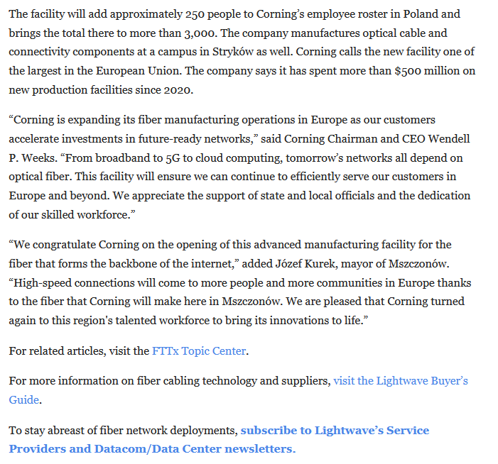

Date: 09 Sep 2022
Media: Nasdaq
Media circulation: N/A
Article title: Corning (GLW) Boosts Fiber Output in EU With Poland Facility
Link: https://www.nasdaq.com/articles/corning-glw-boosts-fiber-output-in-eu-with-poland-facility?amp
Print screen:
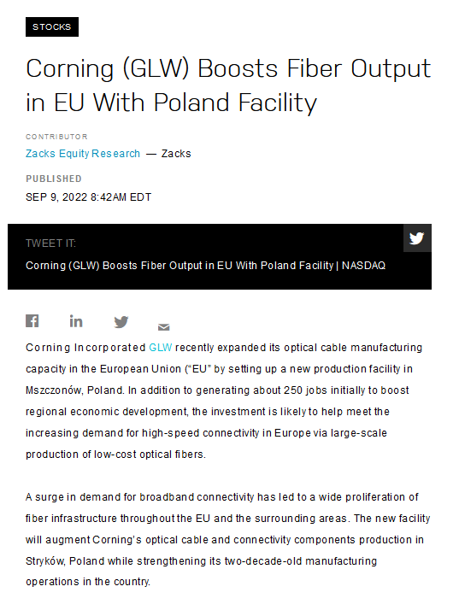
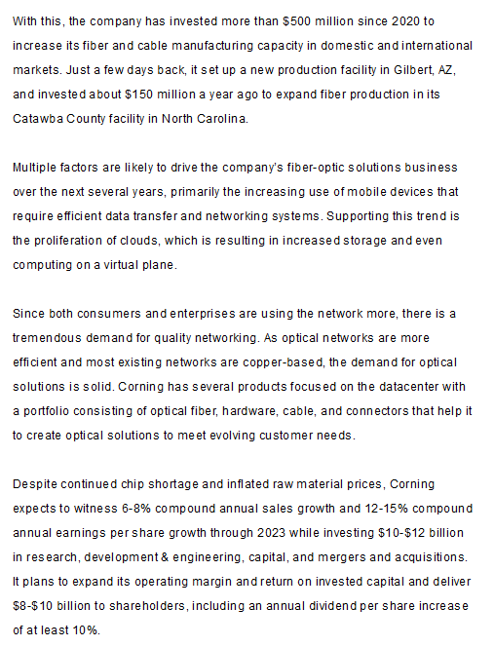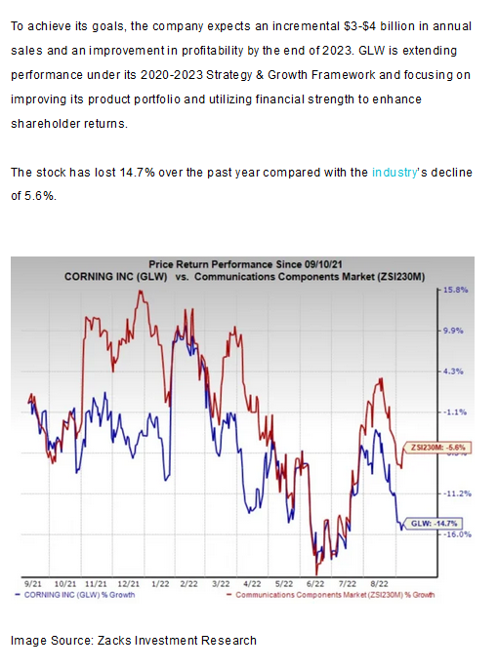
Date: 09 Sep 2022
Media: Optics.org
Media circulation: 30.000 (monthly visitor traffic)
Article title: Corning opens optical fiber manufacturing plant in Poland
Link: https://optics.org/news/13/9/15
Print screen:
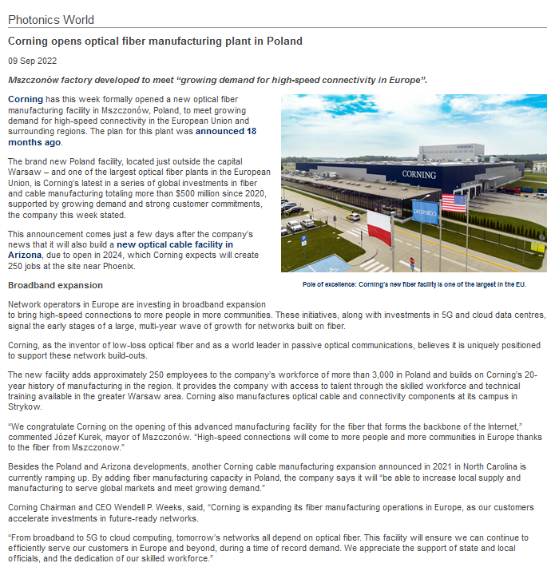

Date: 09 Sep 2022
Media: Telecompaper
Media circulation: 30.000 (monthly visitor traffic)
Article title: Corning opens optical fibre manufacturing plant in Poland
Link: https://www.telecompaper.com/news/corning-opens-optical-fibre-manufacturing-plant-in-poland--1436742
Print screen:
